**Egyptian E-Learning University**

Faculty of Computers & Information Technology

Liftology: The AI-Powered Fitness Application

**By**

|  |  |
| --- | --- |
| Abdelrahman Mohamed Mahmoud Morsy | 21-00271 |
| Mahmoud Taha Mohamed Abdelaal | 21-00913 |
| Mohamed Motaz Lotfy Ahmed | 21-01168 |
| Mostafa Adel Mohamed Kamal | 21-01318 |
| Osama Ahmed Hassan Ali | 21-01435 |

Supervised by

Dr. Kamal Safwat Kamal Hamza

Assistant Professor, and Information Technology Program Director at The Egyptian E-Learning University - EELU

Assistant

Eng. Mohamed Mostafa Saad Abdelaziz

Teaching Assistant in Computer and Information Technology at The Egyptian E-Learning University – EELU

Sohag-2025

Abstract

**Liftology** is an integrated **fitness and nutrition website** that leverages machine learning (ML), computer vision (CV), and generative Artificial Intelligence (AI) to deliver a personalized and intelligent health assistant. The primary objective is to empower users with customized exercise and nutrition plans while ensuring proper exercise technique through real-time feedback.

The website offers several advanced features. First, an ML-based model generates tailored workout routines based on the user’s fitness level and goals. A separate nutrition planner also uses ML to recommend balanced meal plans aligned with individual dietary needs.

Second, a Computer Vision-powered module detects and analyzes exercise techniques through live video, providing real-time feedback to help users perform movements safely and correctly. Additionally, a generative AI chatbot is included to answer questions, offer guidance, and provide educational insights in a friendly and interactive way.

**Liftology** brings together smart technologies to create a helpful and easy-to-use platform that supports users in leading healthier lifestyles. By making fitness and nutrition advice more personalized, interactive, and accessible, the website aims to motivate users, improve their workout habits, and guide them toward better health outcomes.

Acknowledgments

First and foremost, praises and thanks to God, the Almighty, for his blessing throughout our years in college and our graduation project to complete this stage of our life successfully.

We have made efforts in this project. However, it would not have been possible without the kind support and help of many individuals and organizations. We would like to extend our sincere thanks to all of them.

Thanks to Egyptian E-Learning University for helping us to reach this level of awareness.

We would like to express our deep and sincere gratitude to our project supervisor **DR. Kamal Safwat Kamal Hamza** for giving us the opportunity to lead us and providing invaluable guidance throughout this project. It was a great privilege and honor to work and study under his guidance.

We are extremely grateful for what he has offered us. We are especially indebted to say many thanks to **Eng. Mohamed Mostafa Saad** for guidance and constant supervision as well as for his patience, friendship, empathy, and great sense of humor. His dynamism, vision, sincerity and motivation have deeply inspired us.

Finally, we would like to express our gratitude to everyone who helped us during the graduation project.

Contents

Abstract 2

Acknowledgments 3

List of Figures….…….….….….….….….….…….….….….….….….….…….….….….….……7

List of Tables…….….….….….….….….…….….….….….….….….…….….….….….….……..8

1. Introduction 9

1.1. Introduction……………………………………………………………………….....10

1.2. Background and Motivation…………………………………………………………11

1.3. Importance of The Problem………………………………………………………….12

1.4. Problem Statement…………………………………………………………………..14

1.5. Objectives……………………………………………………………………………14

1.6. Brief Overview of The Proposed Solution…………………………………………...16

2. Literature Review 17

2.1. Summary of Existing Research and Technologies…………………………………..18

2.2. Gaps in Current Solutions……………………………………………………………22

2.3. Summary…………………………………………………………………………….23

3. Proposed system……………………………………………………………………………….24

3.1. Approach Used to Solve the Problem………………………………………………...25

3.2 System Architecture………………………………………………………………….27

3.2.1. System Component Diagram………………………………………………28

3.2.2. Sequence Diagram…………………………………………………………29

3.2.3. Entity-Relationsip Diagram………………………………………………..30

3.3. Algorithms and Frameworks Used…………………………………………………..31

3.3.1. Algorithms………………………………………………………………....31

3.3.2. Frameworks………………………………………………………………..32

3.3.3. Summary…………………………………………………………………..35

4. Implementation 36

4.1. Technologies, Tools, and Programming Languages Used……………………………37

4.2. Key Components/Modules of the System……………………………………………40

4.2.1. Front-End………………………………………………………………….40

4.2.2. Exercise Recomender Service…………………………………………..…48

4.2.3. Diet Recommender Service………………………………………………..49

4.2.4. Chatbot Service……………………………………………………………49

4.2.5. Computer Vision Service…………………………………………………..50

4.2.6. MongoDB Database……………………………………………………….50

4.3. Challenges Faced and How They Were Resolved…………………………………....51

5. Testing & Evaluation 54

5.1. Testing Strategies……….….….…….….….…….….….…….….….…….….….….55

5.2. Performance Metrics…….….….…….….….…….….….…….….….…….….…….57

5.3. Comparison with Existing Solutions….….….….….….….….….….….….….….….59

6. Results & Discussion 62

6.1. Introduction……….….….…….….….…….….….…….….….…….….….…….….63

6.2. Summary of Findings….…….….….…….….….…….….….…….….….…….……63

6.3. Interpretation of Results……….….….…….….….…….….….…….….….…….….66

6.4. Limitations of the Proposed Solution….…….….….…….….….…….….….…….…66

7. Conclusion & Future Work 68

7.1. Summary of Contributions…….….….…….….….…….….….…….….….…….….69

7.2. Possible Improvements of Extensions for Future Work….…….….….…….….….…71

8. References 74

Appendices 77

**List of figures:**

Fig. 1: System Component Diagram .........................................24

Fig. 2: Sequence Diagram ......................................................... 25

Fig. 3: Database Schema Diagram ............................................ 25

Fig 4: Entity Relationship Diagram .......................................... 26

Fig 5: Signup Page…………………………………………….42

Fig 6: Sign-In Page……………………………………………42

Fig 7: Onboarding Exercise Process ………………………….43

Fig 8: Exercise Plan Page…………………………………......43

Fig 9: Exercise Description / Tracking Page………………….44

Fig 10: Replace Exercise Page………………………………...45

Fig 11: Dashboard Page…………………………….……...….46

Fig 12: Onboarding Diet Process……………………………..47

Fig 13: Diet Plan Page………………………………………...47

Fig 14: Meal Description Page…………………………….….48

Fig 14: Raw data for exercise plan…………………………………….78

Fig 15: Sample of dataset after preprocessing…………………………94

**List of Tables:**

Table 1: ML Model Performance Comparison ………………. 65

Table 2: Computer Vision Summary Table …………………… 92

Chapter 1

Introduction

**1.1 Introduction**

In today’s health-conscious world, fitness applications have emerged as vital tools for individuals striving to enhance their physical well-being. These apps provide unmatched convenience, enabling users to track workouts, monitor nutrition, and set personalized goals directly from their smartphones or wearable devices. The global fitness app market, valued at $10.59 billion in 2024, is expected to grow at a compound annual growth rate (CAGR) of 13.88% through 2030, underscoring the increasing reliance on digital health solutions. Yet, despite their widespread use, many fitness apps fall short of delivering an effective experience. Most offer generic workout and nutrition plans that do not adapt to individual needs or progress, often resulting in lackluster outcomes and waning user motivation. Moreover, these apps rarely provide guidance on proper exercise form, exposing users -particularly beginners- to injury risks that can derail their fitness efforts.[1],[7]

*Liftology* is an AI-powered fitness application designed to overcome these shortcomings. By harnessing advanced artificial intelligence (AI) and computer vision technologies, *Liftology* delivers a highly personalized fitness experience tailored to each user’s unique profile. It leverages data such as weight, height, fitness level, and personal goals to craft adaptive workout and nutrition plans. Additionally, *Liftology* employs real-time

feedback through computer vision to monitor exercise movements and offer instant corrections, ensuring both safety and effectiveness. This focus on personalization and safety distinguishes *Liftology* as a pioneering solution in the fitness app landscape, redefining how technology can support individual health and wellness.

**1.2 Background and Motivation**

The fitness app market has seen remarkable growth, driven by a societal shift toward technology-enabled health management. Once considered niche tools, fitness apps are now mainstream, with millions of users worldwide depending on them to maintain their physical health. This trend gained momentum during the COVID-19 pandemic, which limited access to gyms and pushed fitness activities into home settings. By 2024, the market reached a valuation of $10.59 billion, with projections indicating sustained growth as digital tools become integral to fitness routines.[7]

Despite this expansion, significant challenges persist. Many fitness apps rely on standardized plans that fail to accommodate individual differences, such as fitness levels or goals. For instance, a novice and an experienced athlete might receive identical routines, leading to frustration or disinterest. Studies show that up to 70% of fitness app users abandon

them within three months, often due to a lack of personalization or engagement. This high dropout rate reveals a critical market gap, users crave solutions that adapt to their evolving needs, rather than rigid plans that lose relevance over time.

Safety is another pressing concern. Without real-time guidance on exercise technique, users risk performing movements incorrectly, which can result in injuries like muscle strains or joint damage. In 2023, the National Safety Council reported 482,886 exercise-related injuries treated in U.S. emergency departments, many linked to improper form.Beginners are especially at risk, as they may follow instructions without recognizing errors in posture or pacing. This lack of oversight jeopardizes both safety and long-term commitment to fitness.

*Liftology* was developed to tackle these issues: the need for personalized, adaptive guidance and the demand for safe exercise practices. By integrating AI and computer vision, *Liftology* seeks to close the gap between user expectations and the limitations of current fitness apps, empowering individuals to pursue their goals effectively and securely.

**1.3 Importance of the Problem**

The absence of personalization and safety in fitness apps has far-reaching consequences for user health, engagement, and the fitness industry as a whole. Personalization is essential for effective fitness programs, as it aligns workouts and nutrition with an individual’s abilities and objectives. Research shows that tailored interventions can boost adherence by up to 30% compared to generic plans, fostering a stronger connection to the program. Without customization, users often hit plateaus, leading to disengagement and abandonment of their fitness efforts.

Safety is equally vital. Poor exercise form is a leading cause of injuries, with over 65% of gym-related incidents tied to technique errors. These injuries, ranging from minor strains to severe conditions like herniated discs, are particularly common among beginners attempting complex movements without guidance. Beyond physical harm, such setbacks can diminish motivation, transforming a promising fitness journey into a source of frustration.

On a broader scale, these challenges affect public health and economics. Ineffective plans and preventable injuries drive up healthcare costs, treating exercise-related injuries costs billions annually in medical expenses and lost productivity. Conversely, promoting safety and effective fitness habits can improve well-being, and reduce healthcare burdens. By addressing personalization and safety, *Liftology* tackles a problem with significant individual and societal impact, paving the way for healthier, more active communities.

**1.4 Problem Statement**

*Liftology* targets two core issues in the fitness app market: the lack of personalized, adaptive fitness guidance and the risk of injury from improper exercise techniques. Existing apps often provide static plans that do not adjust to users’ fitness level and physical capabilities, leading to stagnation, reduced motivation, and high attrition rates. Additionally, they fail to monitor or correct exercise form, leaving users- especially novices- prone to injuries that undermine their health and progress. This project aims to address these gaps by creating an AI-powered platform that offers personalized programming and real-time performance analysis, ensuring both effectiveness and safety.[1],[7],[20]

Solving this problem is crucial because personalized plans enhance engagement and results, while real-time corrections minimize injury risks, making fitness more accessible and sustainable. *Liftology* seeks to deliver a holistic solution that fills the void in the current fitness app ecosystem.[1]

**1.5 Objectives**

The main goal of this project is to develop an AI-driven fitness application that provides personalized workout and nutrition plans alongside

real-time technique analysis for safe and effective exercise. This is supported by the following specific objectives:

**AI-Powered Fitness Plan Prediction**: Build AI algorithms to create customized workout plans using user data like weight, height, fitness level, and goals, incorporating principles like progressive overload for ongoing progress.

**Personalized Diet Plan Recommender**: Design a system to offer tailored nutrition advice based on user preferences, objectives, and dietary needs, supporting a balanced fitness approach.

**Computer Vision for Performance Analysis**: Use computer vision to monitor exercise movements via smartphone or webcam, delivering instant feedback to prevent injuries and improve efficacy.

**User-Friendly and Engaging Experience**: Develop an intuitive interface with features like progress tracking and gamification to boost consistency and motivation.

These objectives ensure *Liftology* addresses both personalization and safety, creating a user-focused fitness solution.

**1.6 Brief Overview of the Proposed Solution**

*Liftology* is a cutting-edge fitness application that blends advanced technologies to offer a personalized and safe fitness experience. AI algorithms analyze user data to generate and adapt workout and nutrition plans, keeping them effective as users advance. Computer vision technology monitors movements in real time, providing immediate feedback to correct techniques and reduce injury risks. The app features an engaging, user-friendly interface with progress tracking and gamified elements to maintain motivation. By combining AI-driven personalization, computer vision for safety, and an accessible design, Liftology empowers users to achieve their fitness goals efficiently and sustainably.[1]

Chapter 2

Literature Review

**2.1 Summary of Existing Research and Technologies**

The fitness technology landscape has evolved significantly, with AI and computer vision playing pivotal roles in enhancing personalization, safety, and user engagement. This section reviews existing fitness applications and academic research relevant to *Liftology*’s core features: AI-driven personalized workout and nutrition plans and computer vision for real-time exercise form correction. The global fitness app market, valued at $10.59 billion in 2024, is projected to grow at a CAGR of 13.88% through 2030, driven by the increasing demand for digital fitness solutions.[7]

**AI-Powered Workout Personalization**

AI-driven fitness apps have become popular for their ability to tailor workout plans to individual needs. **Fitbod** uses AI to generate customized workout routines based on user input like fitness goals, available equipment, and workout history. It adapts plans to prevent plateaus, making it versatile for users with varying gym setups. However, Fitbod focuses solely on workout planning and lacks real-time form correction or integrated nutrition guidance.[4]

**Freeletics** specializes in bodyweight exercises, employing AI to create personalized training plans that adjust to users’ fitness levels and goals. It includes instructional videos and community features to boost engagement, but it does not offer real-time feedback on exercise form, leaving users at risk of improper technique.[9]

**AI-Powered Nutrition Personalization**

Nutrition-focused apps leverage AI to provide tailored dietary guidance.

**HealthifyMe** uses its AI assistant, Ria, to generate personalized meal plans based on dietary preferences, restrictions, and regional cuisines, particularly Indian foods. It integrates with wearables to track activity, offering a comprehensive health management tool. However, it lacks real-time exercise form correction, limiting its ability to ensure safe workout practices.[10]

**Centr** , developed by Chris Hemsworth, combines personalized workout and nutrition plans with mindfulness exercises. It offers over 1,400 workouts and 800 recipes tailored to various dietary needs. While Centr provides a holistic wellness approach, it relies on pre-recorded videos rather than real-time form correction, which may not fully address safety concerns during exercise.[5]

**Computer Vision for Exercise Form Correction**

Computer vision technology has been increasingly adopted to enhance exercise safety by providing real-time feedback on form. **Kemtai** uses advanced computer vision to analyze movements during exercises, offering immediate corrective guidance and rep counting via any camera-enabled device. Priced at $40 per month, Kemtai is accessible and offers a wide range of classes, but it does not include integrated nutrition planning, focusing primarily on exercise execution.[11]

**Asensei.ai** provides 3D motion capture for form tracking, initially focused on rowing but expanding to exercises like strength training and yoga. Its SDK enables fitness products to incorporate real-time.[12]

coaching, but its consumer-facing app is specialized, and it lacks integrated nutrition guidance.

**Academic Research on Fitness Technologies**

Academic studies provide a foundation for *Liftology*’s development, highlighting the potential and challenges of AI and computer vision in fitness. John Dian et al. (2020) conducted a survey on wearables and the Internet of Things (IoT) in fitness, titled *Wearables and the Internet of Things (IoT), Applications, Opportunities, and Challenges: A Survey*. The study explored the role of wearables and IoT in fitness applications, identifying key opportunities and challenges. It found that over-reliance on wearables excluded non-users and raised privacy concerns, emphasizing the need for inclusive and privacy-conscious approaches in wearable and IoT technologies. This is relevant to *Liftology*, which aims to be accessible via smartphones without requiring additional hardware, thus addressing inclusivity concerns.[8]

A 2023-2024 IEEE conference publication, *Novel Approach for Real-Time Exercise Posture Correction Using Computer Vision and CNN and Leveraging AI for Exercise Form Assessment*, explored CNN-based computer vision for real-time exercise posture correction. The study achieved 92% accuracy in detecting improper form (e.g., squat depth, spinal alignment) using a custom CNN model trained on 10,000 exercise videos. This aligns with *Liftology*’s use of computer vision to ensure proper exercise form, highlighting the feasibility and effectiveness of such technology in enhancing safety.[13],[14]

Nouri et al. (2018) conducted a systematic review titled *Criteria for assessing the quality of mHealth apps: a systematic review*. The study evaluated data integration and clinical validity in mHealth apps, finding that only 12% of apps met all criteria for clinical reliability, with apps integrating AI and sensor data scoring 2/3 on average for accuracy, highlighting gaps in multimodal integration. This underscores the need for better integration in fitness apps, which *Liftology* addresses by combining AI-driven personalization with computer vision.[6]

Hertel et al. (2022) studied *Injury incidence and specific injury patterns in app-based bodyweight training*. The study found that 27% of 3,668 fitness app users reported injuries, primarily due to poor form, affecting shoulders, lower back, and knees. Beginners and intense trainers faced higher risks, emphasizing the need for proper technique guidance and structured warm-up/cool-down routines to reduce injuries in app-based training. This directly supports *Liftology*’s focus on real-time form correction to mitigate injury risks.[1]

Additional research, such as *Pose Trainer* by Chen and Yang (2020), used pose estimation to detect exercise posture and provide feedback, improving squat posture after two weeks. Islam et al. (2025) explored user experiences with AI-driven fitness apps, emphasizing the importance of real-time feedback for engagement. These studies validate the technologies *Liftology* employs, though they often focus on specific aspects rather than integrated solutions.[16],[19]

**2.2 Gaps in Current Solutions**

Current fitness apps and research reveal several gaps that *Liftology* aims to address. First, there is a lack of integration across key features. Apps like Fitbod and Freeletics excel in workout personalization but do not offer nutrition guidance or real-time form correction. Nutrition-focused apps like HealthifyMe and Centr provide tailored dietary plans but lack form analysis, leaving users vulnerable to injuries. Computer vision-based apps like Kemtai and Asensei.ai prioritize exercise safety but do not integrate comprehensive nutrition planning, which is crucial for holistic fitness.[4],[5],[9],[10],[11],[12]

Second, accessibility and cost are barriers. Kemtai’s $40 monthly subscription and Asensei.ai’s focus on integration into other products limit their direct availability to general users. Centr’s $30 monthly fee may also deter budget-conscious users. Additionally, apps relying on wearables, as noted by John Dian et al. (2020), exclude non-users and raise privacy concerns, highlighting the need for inclusive solutions that leverage widely available devices like smartphones.[5],[8],[11],[12]

Third, research like Nouri et al. (2018) points to gaps in multimodal integration in mHealth apps, with many failing to combine AI, sensor data, and clinical validation effectively. Hertel et al. (2022) further emphasize the injury risks in app-based training due to poor form, underscoring the need for real-time correction and structured guidance, which most apps lack. While academic studies like the IEEE conference paper demonstrate computer vision’s potential, practical applications combining workout personalization, nutrition planning, and form correction in a single platform are rare.[1],[6]

**2.3 Summary**

*Liftology* addresses these gaps by offering a comprehensive fitness application that integrates AI-driven personalized workout and nutrition plans with computer vision for real-time form correction. Unlike existing solutions that focus on specific areas—Fitbod on workouts, HealthifyMe on nutrition, and Kemtai on form correction—*Liftology* provides a unified platform that ensures adaptive guidance, dietary support, and exercise safety. Research supports this approach, with studies like Hertel et al. (2022) highlighting the need for injury prevention and Nouri et al. (2018) emphasizing better integration in mHealth apps. By leveraging smartphone accessibility, *Liftology* overcomes barriers noted by John Dian et al. (2020), offering an inclusive and privacy-conscious solution. Its holistic approach positions *Liftology* as a more capable fitness app that enhances user engagement, effectiveness, and safety.[1],[4],[6],[8],[10],[11],[20]

Chapter 3

Proposed system

**3.1 Approach Used to Solve the Problem**

The *Liftology* platform tackles the challenge of providing individualized fitness and nutrition guidance through a multi-faceted approach that leverages cutting-edge AI technologies. The system is built around three primary components: an exercise plan recommender, a diet plan recommender, and an interactive chatbot. Each component employs distinct algorithms and techniques to ensure personalization, practicality, and adaptability, while their seamless integration creates a holistic user experience.

The **exercise plan recommender** uses machine learning to generate customized workout plans based on user-specific data, such as weight, height, BMI, body fat percentage, gender, and age. To identify the most effective model, several algorithms were tested, including Logistic Regression, Random Forest, Support Vector Machine (SVM), Decision Tree, K-Nearest Neighbors (KNN), Naive Bayes, and XGBoost. Through extensive evaluation and hyperparameter optimization using GridSearchCV, XGBoost emerged as the top performer due to its superior accuracy and ability to handle complex data patterns. This model analyzes user inputs to predict and recommend exercise plans that align with individual fitness goals, ensuring that each plan is both effective and tailored to the user’s physical profile.

The **diet plan recommender** focuses on delivering personalized meal suggestions by employing a K-Nearest Neighbors (KNN) algorithm with cosine similarity. This approach matches recipes to users based on their nutritional requirements (e.g., daily calorie intake) and preferences (e.g., preferred ingredients or dietary restrictions). By filtering a database of recipes according to nutritional content and ingredient availability, the

system ensures that recommendations are not only aligned with health goals but also practical for users to implement. This personalization enhances adherence to dietary plans by making them both accessible and appealing.

Complementing these recommenders, the **chatbot** provides real-time, conversational support to enhance user engagement. Powered by Groq’s LLaMA model and integrated through LangChain, the chatbot is capable of understanding and responding to a wide range of health, fitness, and nutrition-related queries. It offers additional exercise or diet suggestions, retrieves user-specific plan details, and maintains conversation context using LangChain’s memory capabilities. This ensures a natural and seamless interaction, making the platform more accessible and responsive to user needs.

The integration of these components is achieved through a robust system architecture. The **front-end interface**, developed using HTML, CSS, and JavaScript, serves as the user’s entry point, collecting input data and displaying personalized recommendations in an intuitive format. The **back-end**, built with FastAPI services, handles the heavy lifting of AI processing, executing the machine learning and natural language processing tasks required by the recommenders and chatbot. Data persistence is managed by **MongoDB**, which efficiently stores and retrieves exercise and diet plan details, enabling quick access and updates as user needs evolve.

This user-centric design prioritizes personalization and adaptability, ensuring that the LIFTOLOGY platform not only meets the diverse needs of its users but also evolves with them. By combining advanced AI techniques with a seamless system architecture, the proposed system

delivers a comprehensive solution to the problem of personalized fitness and nutrition guidance.[5]

**3.2 System Architecture**

*LIFTOLOGY* adopts a modular, service-oriented architecture to ensure scalability, maintainability, and efficient communication between its components. The system comprises a front-end interface, multiple back-end AI services, a NoSQL database, and an external API for advanced language processing. All AI services, except the computer vision (CV) feature for motion tracking, are deployed on Railway, a cloud platform that simplifies application hosting and scaling.

**3.2.1 System Component Diagram**

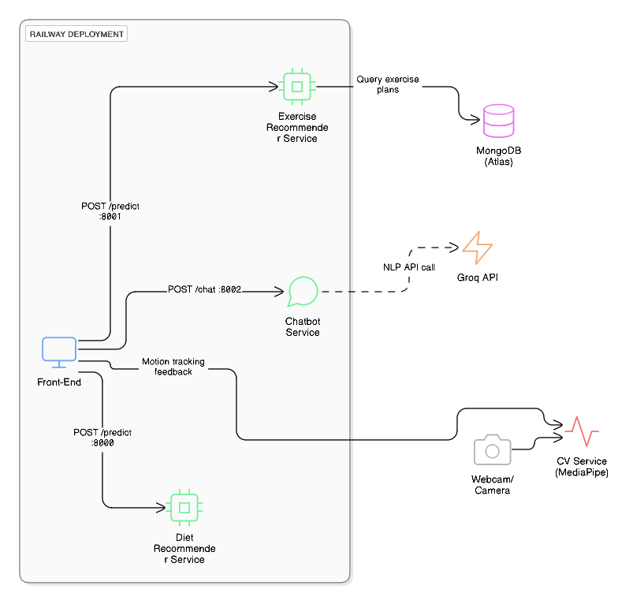

Fig 1: System Component Diagram

**3.2.2 Sequence Diagram**

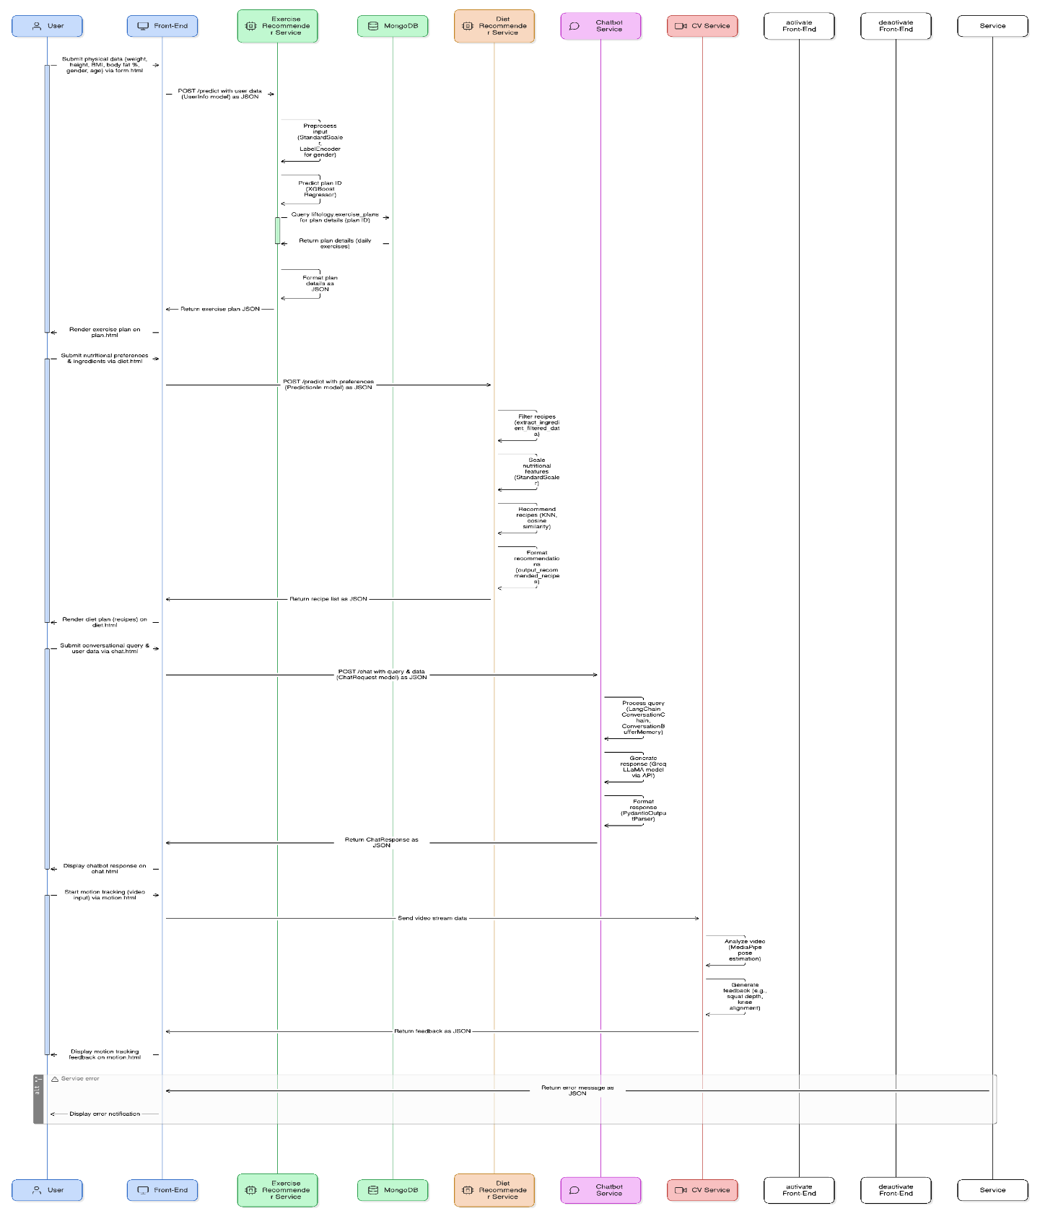

Fig 2: Sequence Diagram

**3.2.3 Entity-Relationship (ER) Diagram**

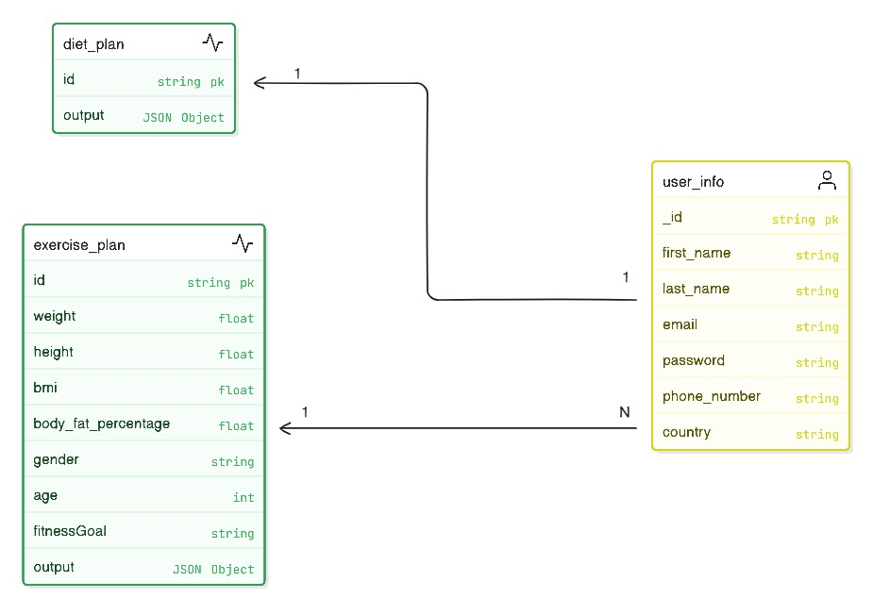

Fig 3: Database Schema Diagram

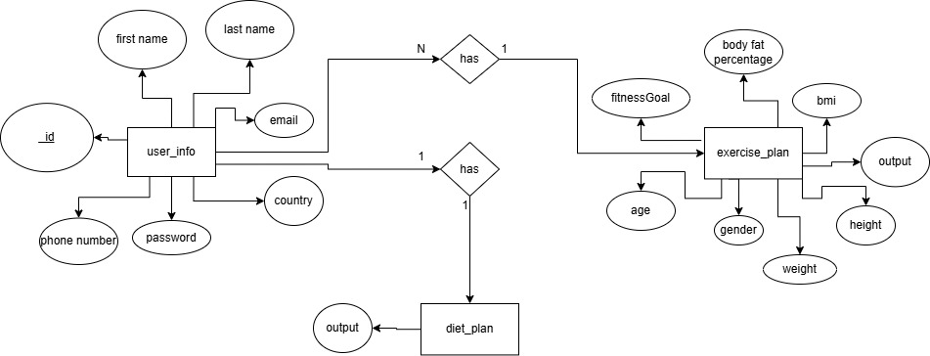

Fig 4: Entity Relationship Diagram

**3.3 Algorithms and Frameworks Used**

The LIFTOLOGY platform relies on a carefully selected combination of algorithms and frameworks to deliver its core features: personalized exercise and diet recommendations and an intelligent chatbot interface. These technologies were chosen for their performance, scalability, and ability to meet the system’s specific requirements. Below, we describe the key algorithms and frameworks, their roles in the system, and the rationale behind their selection.

**3.3.1 Algorithms**

The system employs two primary algorithms to power its recommendation engines, each optimized for its respective domain—exercise planning and diet suggestions.

**XGBoost (Exercise Plan Recommender)**

The exercise plan recommender leverages the XGBoost, a gradient-boosting algorithm renowned for its accuracy and efficiency in regression tasks. This algorithm was selected after a comprehensive evaluation of multiple machine learning models, including Logistic Regression, Random Forest, Support Vector Machine (SVM), Decision Tree, K-Nearest Neighbors (KNN), and Naive Bayes. Using hyperparameter tuning with GridSearchCV, XGBoost outperformed these alternatives in predicting personalized exercise plans based on user inputs such as weight, height, BMI, body fat percentage, gender, and age. Its strength lies in its ability to model complex, non-linear relationships within the data, making it ideal for generating tailored fitness routines that adapt to individual user profiles.

**K-Nearest Neighbors (KNN) with Cosine Similarity (Diet Plan Recommender)**

For the diet plan recommender, the system uses a K-Nearest Neighbors (KNN) algorithm combined with cosine similarity to recommend recipes that align with users’ nutritional needs (e.g., calorie intake) and preferences (e.g., preferred ingredients). KNN’s simplicity and proven effectiveness in recommendation systems made it a natural choice. By incorporating cosine similarity, the algorithm measures the closeness between a user’s nutritional profile and available recipes, ensuring highly relevant and practical meal suggestions. This approach balances accuracy with computational efficiency, delivering personalized diet plans in real time.

**3.3.2 Frameworks**

LIFTOLOGY’s architecture integrates a suite of frameworks for web development, machine learning, natural language processing, and data management, creating a seamless and responsive user experience.

**FastAPI (Back-End Services)**

FastAPI serves as the foundation for the system’s back-end services, powering the exercise recommender, diet recommender, and chatbot. This high-performance web framework was chosen for its speed, support for asynchronous programming, and automatic API documentation generation. FastAPI ensures that LIFTOLOGY can process multiple user requests concurrently, making it well-suited for real-time interactions in a scalable fitness platform.

**Scikit-learn (Machine Learning)**

Scikit-learn is utilized to implement and optimize the system’s machine learning models, including the KNN algorithm for diet recommendations. This framework provides a robust toolkit for data preprocessing, model training, and performance evaluation, ensuring that the recommendation engines are both accurate and efficient. Its widespread adoption and extensive documentation also simplify maintenance and future enhancements.

**LangChain (Chatbot Integration)**

The chatbot is built using LangChain, a framework tailored for developing applications with large language models (LLMs). LangChain facilitates integration with Groq’s LLaMA model, enabling the chatbot to deliver natural, context-aware responses to user queries. Its memory management capabilities ensure conversational continuity, enhancing the interactivity and usefulness of the chatbot for fitness and nutrition guidance.

**Groq’s LLaMA Model (Natural Language Processing)**

The chatbot relies on Groq’s LLaMA (llama-3.3-70b-versatile), a cutting-edge language model optimized for versatility and performance. This model was selected for its ability to understand and generate responses across a broad range of health, fitness, and nutrition topics, providing users with accurate and contextually relevant information in a conversational format.

**MongoDB (Database)**

MongoDB, a NoSQL database, stores user profiles, exercise plans, and diet plans. Its flexible schema accommodates the diverse and evolving data types generated by the system, while its scalability supports a growing user base without sacrificing performance. MongoDB’s efficient querying capabilities ensure quick access to personalized recommendations.

**Pandas (Data Handling)**

Pandas is employed for data manipulation and preprocessing, particularly within the exercise and diet recommenders. This library enables rapid processing of large datasets, transforming raw user inputs into structured formats suitable for machine learning models, thereby enhancing system responsiveness.

**Pydantic (Data Validation)**

Pydantic is used throughout the system for data validation and configuration management. By enforcing strict schemas for inputs and outputs, Pydantic prevents errors due to invalid data, ensuring the reliability and consistency of LIFTOLOGY’s services.

**3.3.3 Summary**

The LIFTOLOGY platform’s algorithms and frameworks are the cornerstone of its ability to deliver a personalized, efficient, and user-friendly fitness experience. **XGBoost** and **KNN with cosine similarity** drive the recommendation engines, tailoring exercise and diet plans to individual needs. Meanwhile, **FastAPI**, **Scikit-learn**, **LangChain**, and **Groq’s LLaMA** power the system’s back-end, machine learning, and chatbot functionalities. Supported by **MongoDB** for data storage, **Pandas** for data handling, and **Pydantic** for validation, these technologies work together to create a robust and scalable solution that meets the demands of modern health and fitness enthusiasts.

Chapter 4

Implementation

**4.1 Technologies, Tools, and Programming Languages Used**

The *Liftology* platform was built using a robust stack of technologies, frameworks, tools, and programming languages, selected for their performance, scalability, and suitability for AI-driven applications. Below is an overview of each, with the rationale for their inclusion.

**Programming Languages:**

**Python**: The primary language for back-end services, chosen for its extensive ecosystem of AI and machine learning libraries (e.g., Scikit-learn, XGBoost, LangChain). Python’s readability and versatility facilitated rapid development of the exercise recommender, diet recommender, and chatbot service.

**JavaScript (ES6+)**: Used for the front-end, enabling dynamic, interactive web interfaces. Its compatibility with modern browsers and support for asynchronous operations (e.g., API calls via fetch) made it ideal for integrating with FastAPI services.

**HTML5 and CSS3**: Employed for structuring and styling the front-end, ensuring a responsive and user-friendly interface.

**Frameworks and Libraries:**

**FastAPI**: The back-end framework for all AI services (exercise recommender on port 8001, diet recommender on 8000, chatbot on 8002). FastAPI’s asynchronous capabilities, automatic OpenAPI documentation, and high performance were critical for handling concurrent API requests in a scalable manner.

**Scikit-learn**: Used for machine learning tasks in the exercise and diet recommenders. It provided tools for preprocessing (StandardScaler, LabelEncoder), model training, and hyperparameter tuning (GridSearchCV).

**XGBoost**: The core algorithm for the exercise recommender, selected for its superior accuracy in predicting exercise plans. Its gradient-boosting approach excelled in handling complex user data patterns.

**LangChain and LangChain-Groq**: Enabled the chatbot’s conversational AI by integrating Groq’s LLaMA model (llama-3.3-70b-versatile). LangChain’s ConversationChain and ConversationBufferMemory ensured context-aware responses.

**Pydantic**: Used for data validation in all FastAPI services. Its strict typing and schema enforcement prevented invalid inputs, enhancing reliability.

**Pandas and NumPy**: Facilitated data manipulation and preprocessing in the exercise and diet recommenders, handling datasets used in the project.

**MediaPipe**: Employed for the computer vision (CV) feature, enabling real-time pose estimation for motion tracking (e.g., squat analysis). Its lightweight, cross-platform design was ideal for processing video streams.

**Databases:**

**MongoDB (via MongoDB Atlas)**: A cloud-hosted NoSQL database used to store user profiles, exercise plans, and diet plans. Its flexible schema supported dynamic data structures, and its scalability ensured performance under load.

**Tools and Platforms:**

**Railway**: The deployment platform for all services except the CV feature, hosting the front-end and FastAPI services Railway’s automated scaling, SSL provisioning, and environment variable management simplified deployment and maintenance.

**MongoDB Atlas**: Provided a managed database solution, integrated with Railway via secure connection strings. Its cloud-based architecture ensured high availability and backups.

**Groq API**: An external API for the chatbot’s natural language processing, accessed via a secure API key (GROQ_API_KEY). Its high-performance LLaMA model reduced local computational needs.

**Uvicorn**: The ASGI server for running FastAPI applications, offering high concurrency and compatibility with Railway’s deployment model.

**python-dotenv**: Managed environment variables (e.g., MONGODB_URI, GROQ_API_KEY) securely, ensuring sensitive credentials were not hardcoded.

**Git**: Used for version control, enabling collaborative development and tracking of code changes across the project.

**Rationale**

These technologies were chosen to balance performance, scalability, and development efficiency. Python’s AI ecosystem and FastAPI’s speed were critical for the back-end, while JavaScript/HTML/CSS ensured a modern front-end. MongoDB’s flexibility supported evolving data needs, and Railway’s simplicity streamlined deployment. MediaPipe was

selected for the CV feature due to its real-time capabilities, and Groq’s API provided advanced NLP without local hosting overhead.

**4.2 Key Components/Modules of the System**

LIFTOLOGY’s architecture is modular, comprising a front-end interface and four back-end services, each with a specific role. Below, we describe the core components, their purposes, and interactions, providing architectural insights into their integration.

**4.2.1 Front-End:**

**Purpose**: The front-end, built with HTML, CSS, and JavaScript, serves as the user interface, enabling data input, result display, and interaction with AI services. Key pages include form.html (user data input), plan.html (exercise plan display), diet.html (diet plan display), and a motion tracking interface.

**Implementation**: JavaScript (main.js) handles API calls to back-end services using fetch, rendering responses dynamically. For example, it sends user data to http://<railway-host>:8001/predict for exercise plans and displays results on plan.html. CSS ensures a responsive, user-friendly design.

**Interactions**: Communicates with all back-end services via RESTful APIs, sending POST requests with JSON payloads (e.g., UserInfo, PredictionIn, ChatRequest) and receiving JSON responses.

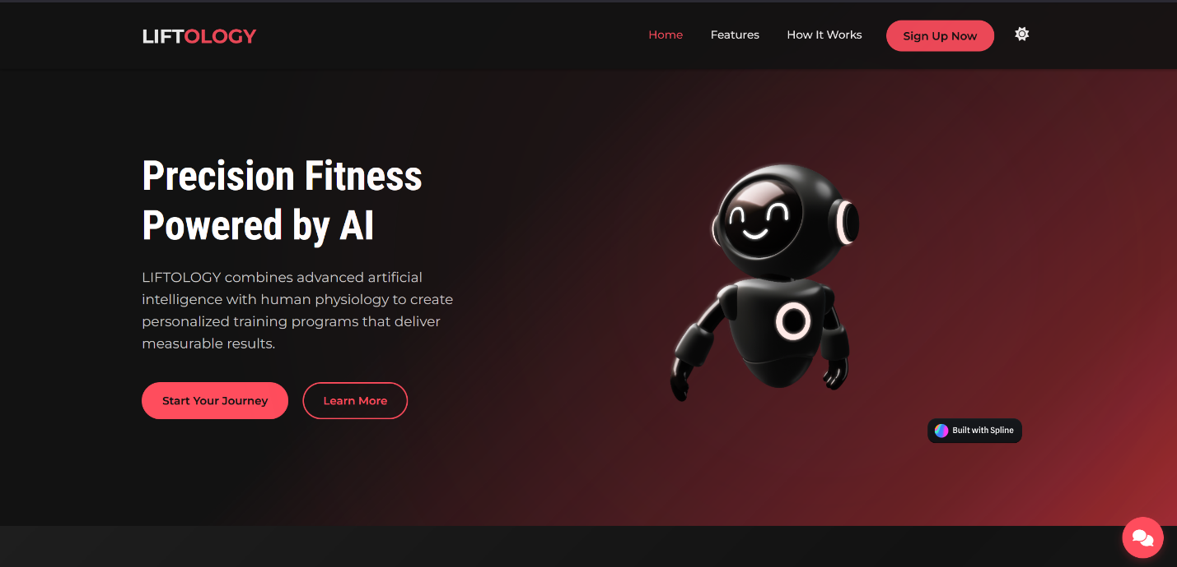

Fig 3: Liftology’s Homepage

Liftology's homepage features a sleek, dark-themed design with a focus on its AI-powered fitness solution. It highlights "Precision Fitness Powered by AI," showcasing a friendly robot graphic and a tagline about personalized training programs. The layout includes a navigation bar with options like Home, Features, and How It Works, along with a prominent "Sign Up Now" button. Call-to-action buttons like "Start Your Journey" and "Learn More" encourage user engagement.

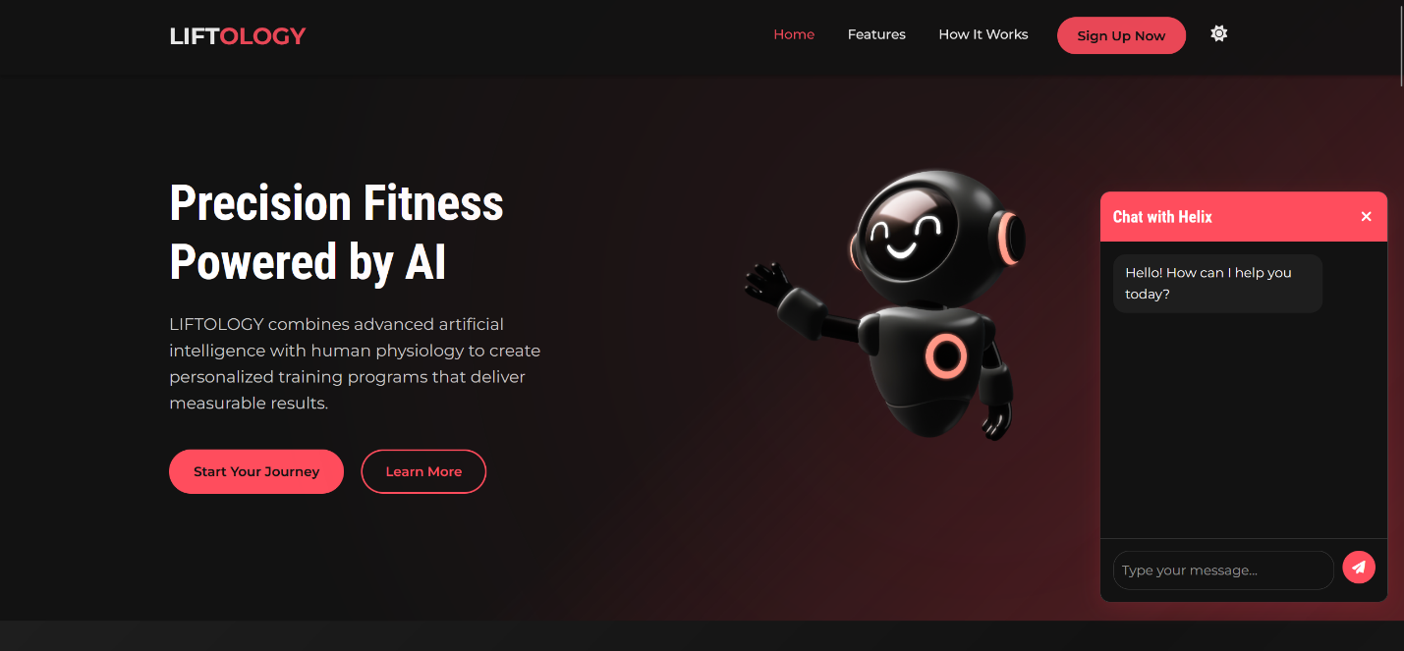

Fig 4: Liftology’s Chatbot Service

Liftology's homepage features a chatbot service powered by Groq’s LLaMa, an AI assistant designed to enhance user interaction. The chatbot, accessible via a chat window on the right side, greets users with "Hello! How can I help you today?" and invites them to type messages, offering real-time support. This service aims to assist with queries about fitness programs, guide users through the sign-up process, or provide personalized advice, aligning with Liftology's AI-driven fitness approach.

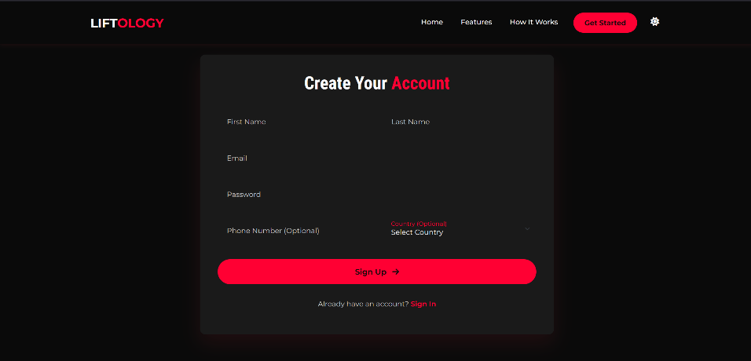

Fig 5: Signup Page

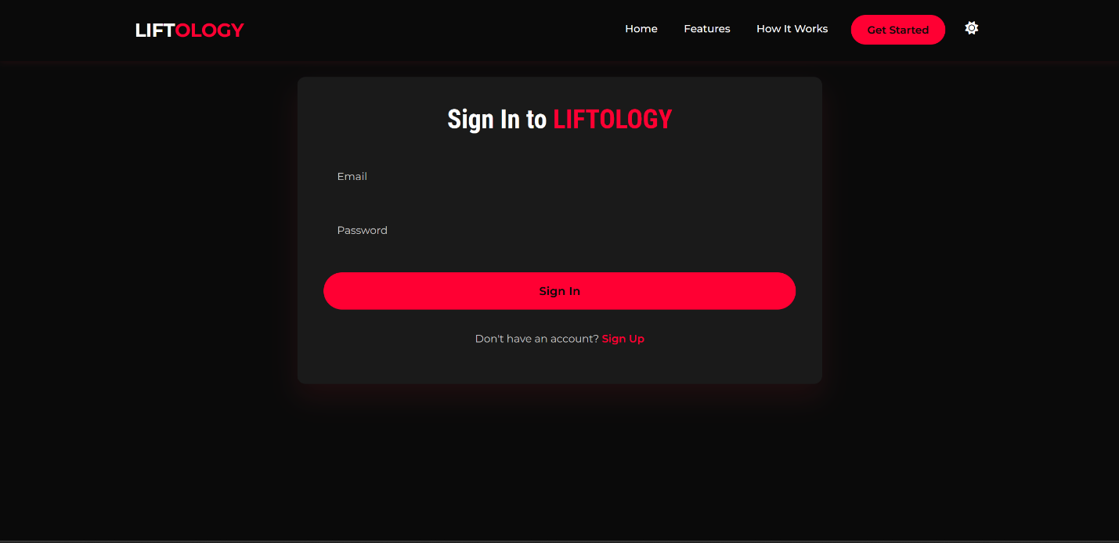

Fig 6: Sign-In Page

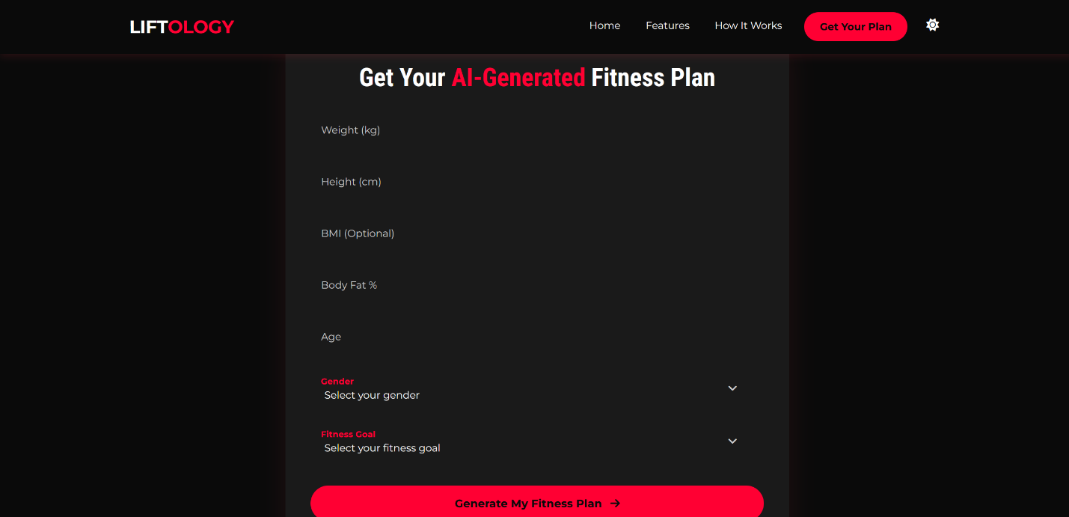

Fig 7: Onboarding Exercise Process

Liftology's onboarding exercise process begins with a simple form where users input weight, height, BMI (optional), body fat percentage, age, gender, and fitness goal. After selecting their preferences from dropdown menus, users click "Generate My Fitness Plan" to receive a personalized AI-generated plan.

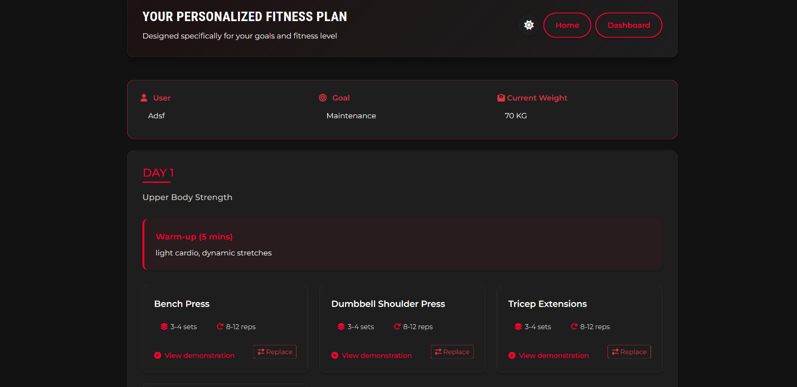

Fig 8: Exercise Plan Page

The exercise plan page on Liftology typically serves as a personalized dashboard, displaying a tailored fitness regimen based on user input. It features a daily workout schedule with exercises, sets, and reps, often starting with a warm-up. Users can view demonstrations for proper form and replace exercises if needed, with the interface offering navigation options like Home and Dashboard for easy access to other sections.

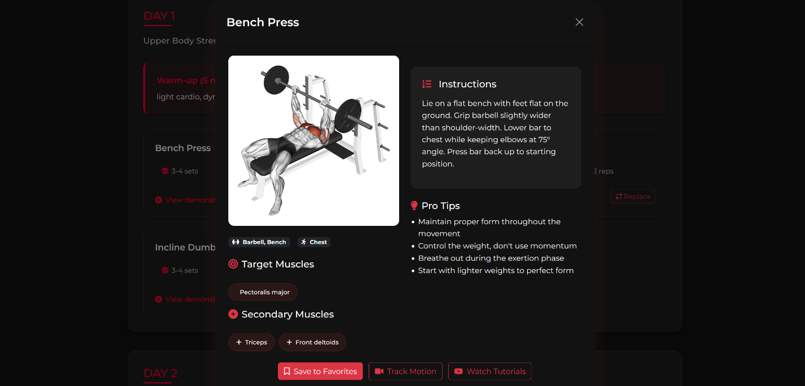

Fig 9: Exercise Description / Tracking Page

The exercise detail page on Liftology typically provides a comprehensive overview of each workout. It includes a visual demonstration, often with an image or diagram, and details the target and secondary muscles worked. Users can find clear instructions on proper form, along with pro tips for safety and effectiveness. Additional features may include set and rep recommendations, options to save to favorites, track motion, or watch tutorials, enhancing the learning and execution of the exercise.

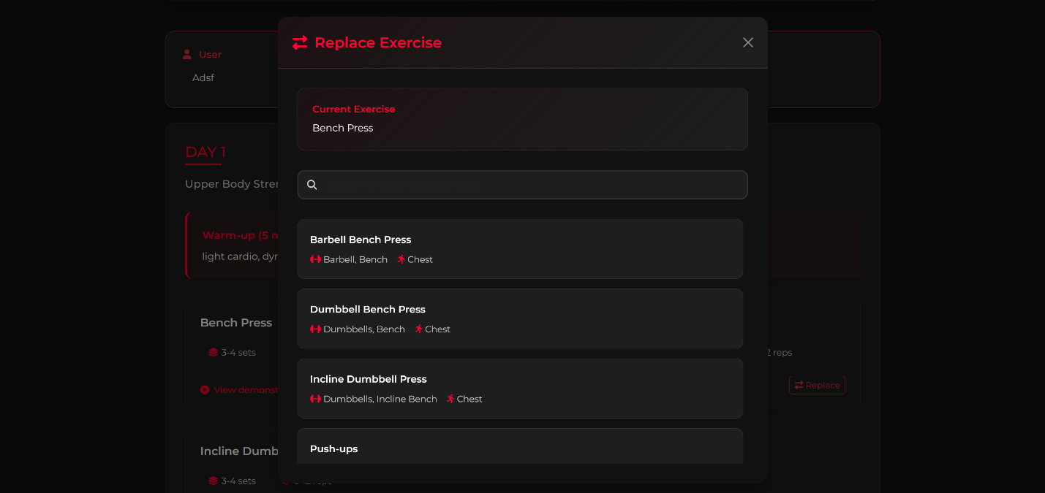

Fig 10: Replace Exercise Page

The replace exercise page on Liftology is designed to allow users to customize their workout plans by substituting exercises. It displays the current exercise and offers a list of alternative options with details like equipment and target muscles, enabling users to select a suitable replacement based on preference or availability. The purpose is to provide flexibility, ensuring the plan remains effective and adaptable to individual needs or limitations.

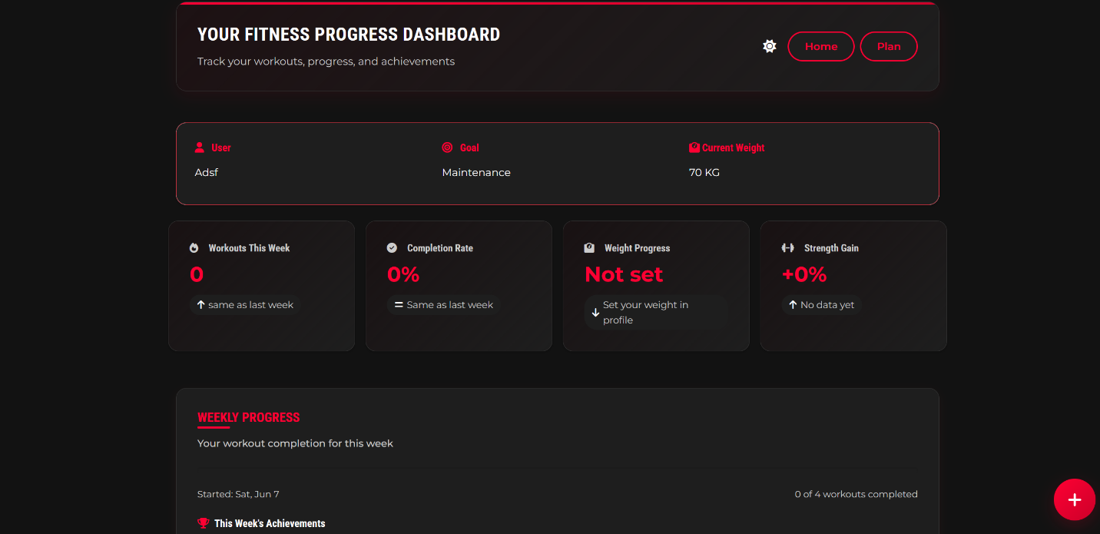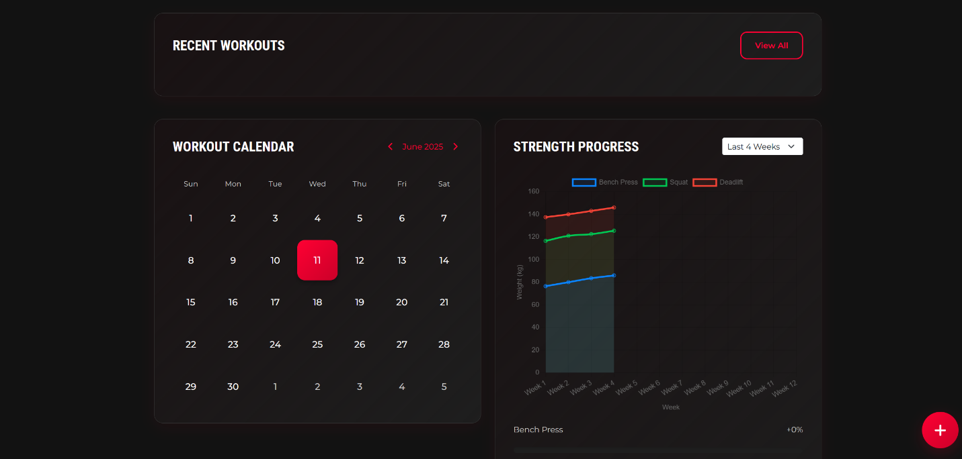

Fig 11: Dashboard Page

The dashboard page on Liftology acts as a comprehensive tracking tool for users' fitness journeys. It typically displays an overview of workout history, progress metrics such as completion rates and strength gains, and a calendar to visualize workout schedules. Users can navigate to sections like Home or Plan, with the interface offering insights into weekly achievements and the option to view detailed progress charts, encouraging consistent engagement and goal monitoring.

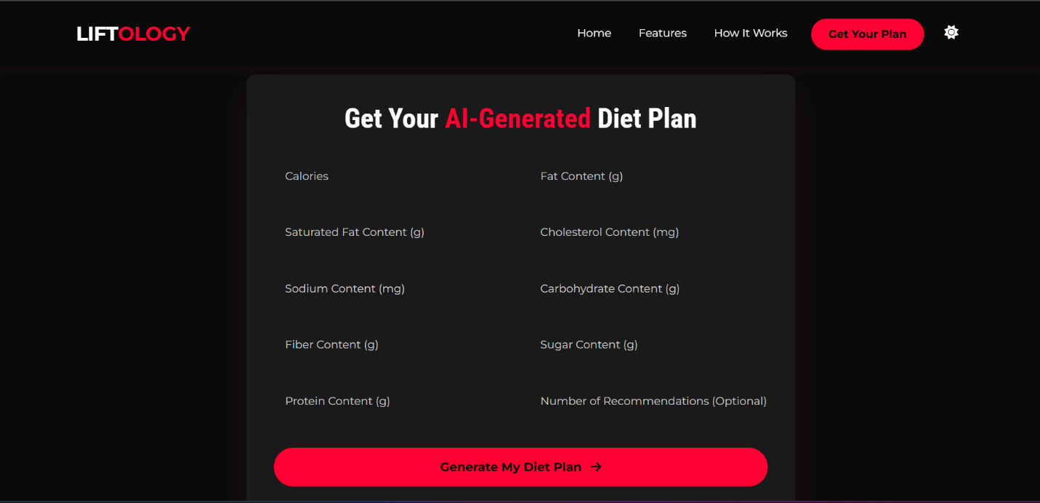

Fig 12: Onboarding Diet Process

Liftology's diet plan generation process starts with a user-friendly form where individuals input their desired nutritional values, including calories, fat content, saturated fat, cholesterol, sodium, carbohydrates, fiber, sugar, and protein. Users also have the option to specify the number of recommendations they'd like to receive. Once all values are entered, clicking “Generate My Diet Plan” instantly produces a personalized, AI-powered meal recommendation tailored to their dietary needs.

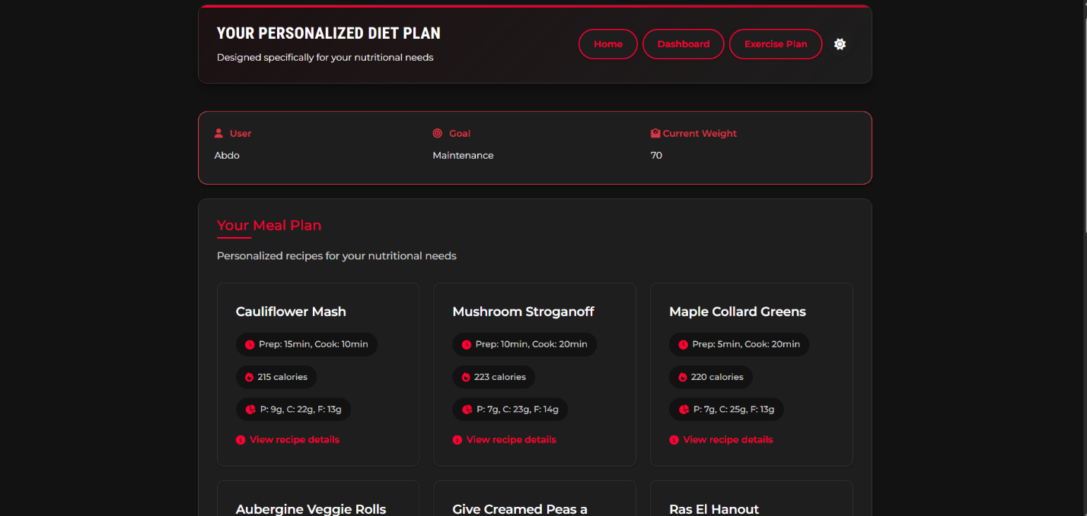

Fig 13: Diet Plan Page

The diet plan page on Liftology offers a personalized nutritional guide tailored to individual goals and levels. It typically outlines daily meal schedules with specific food items, portion sizes, and macronutrient breakdowns (e.g., protein, carbs, fats). Users can view detailed nutritional information for each meal, and the interface includes navigation options like Home and Dashboard, making it easy to track and adjust their dietary progress.

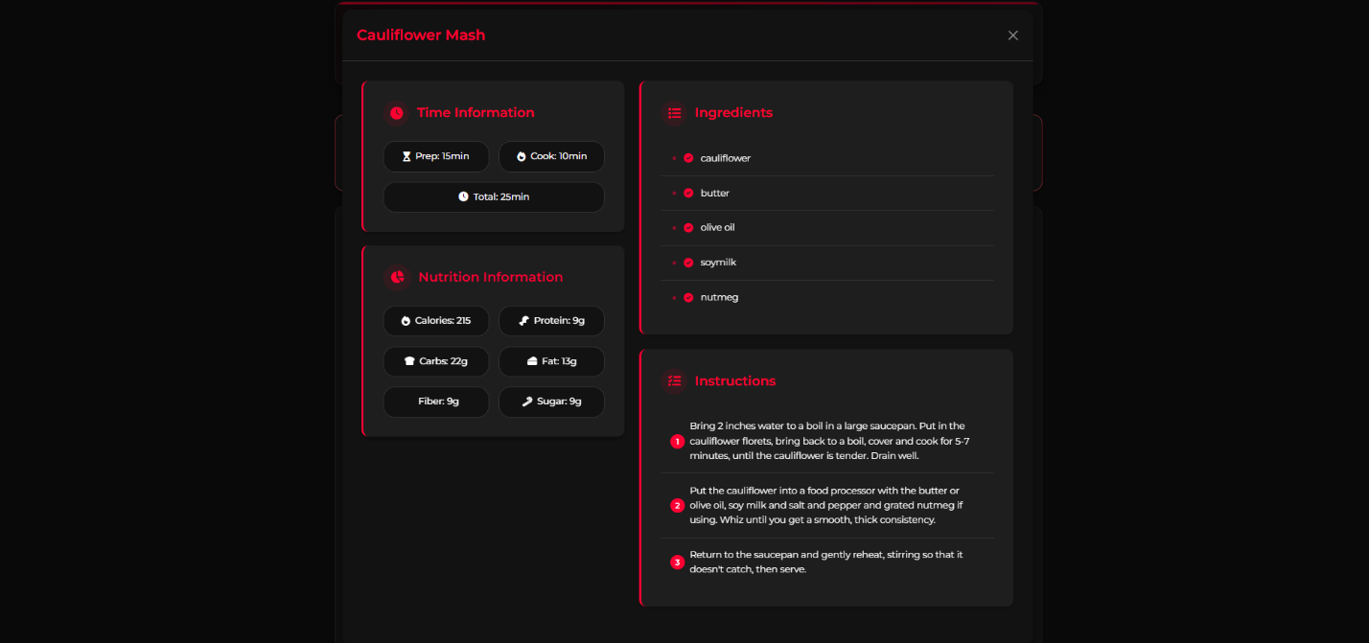

Fig 14: Meal Description Page

The meal detail page on Liftology provides an in-depth look at individual meals within a personalized diet plan. It typically includes the meal name, portion size, and nutritional breakdown such as calories, protein, carbs, and fats. Users can access additional nutrition information, often with details on essential nutrients, health benefits, or dietary tips. The interface may also offer navigation options like Dashboard, allowing users to explore and manage their meal plans effectively.

**4.2.2 Exercise Recommender Service:**

**Purpose**: Generates personalized exercise plans based on user data (weight, height, BMI, body fat percentage, gender, age).

**Implementation**: A FastAPI service deployed on Railway, using a pre-trained XGBoost model. It preprocesses inputs with StandardScaler and LabelEncoder, predicts a plan ID, and queries MongoDB’s liftology.exercise_plans collection for plan details (e.g., daily exercises). The UserInfo model (userinfo.py) validates inputs.

**Interactions**: Receives POST requests from the front-end, queries MongoDB, and returns plan details as JSON. It operates independently but shares MongoDB with the diet recommender.

**4.2.3 Diet Recommender Service:**

**Purpose**: Recommends recipes based on nutritional preferences (e.g., calories, fat) and optional ingredients.

**Implementation**: A FastAPI service (main.py, port 8000) deployed on Railway, using a KNN algorithm with cosine similarity (model.py). It loads dataset2.csv, filters recipes by ingredients, scales nutritional features with StandardScaler, and returns recommendations.

**Interactions**: Receives POST requests from the front-end, processes data and returns recipe list as JSON.

**4.2.4 Chatbot Service:**

**Purpose**: Provides conversational support for health, fitness, and nutrition queries, offering personalized advice and plan retrieval.

**Implementation**: A FastAPI service deployed on Railway, using LangChain and Groq’s LLaMA model. It processes queries with ConversationChain and ConversationBufferMemory, ensuring context-aware responses. The ChatRequest model validates inputs, and PydanticOutputParser formats outputs.

**Interactions**: Receives POST requests from the front-end, calls the Groq API for NLP, and returns responses as JSON.

**4.2.5 Computer Vision (CV) Service:**

**Purpose**: Tracks exercise form (e.g., squats) in real-time, providing feedback on technique.

**Implementation**: A standalone service using MediaPipe for pose estimation. It processes video streams from the front-end, analyzing joint positions to generate feedback.

**Interactions**: Receives video data from the front-end, returns JSON feedback, and operates independently of other services.

**4.2.6 MongoDB Database**

**Purpose**: Stores user profiles, exercise plans, and potentially diet plans.

**Implementation**: Hosted on MongoDB Atlas, accessed via connection strings. Collections include liftology.exercise_plans (exercise plans), user and diet plan collections.

**Interactions**: Queried by the exercise and diet recommender services for plan retrieval, possibly by the chatbot for user data.

**Architectural Insights:**

**Service-Oriented Architecture**: Each service is a microservice, deployed independently on Railway (except CV), ensuring modularity and scalability. FastAPI’s asynchronous nature handles concurrent requests efficiently.

**Data Flow**: The front-end acts as a coordinator, routing user inputs to appropriate services. MongoDB centralizes persistent data, while the CV service and Groq API handle specialized processing.

**Deployment**: Railway simplifies hosting for most services, with MongoDB Atlas providing database reliability. The CV service’s separate deployment accommodates its GPU requirements.

**4.3 Challenges Faced and How They Were Resolved**

Implementing LIFTOLOGY presented several technical challenges, primarily related to AI integration, data consistency, and deployment. Below, we discuss these challenges and their resolutions.

**Challenge 1: Model Selection and Performance for Exercise Recommender:**

**Issue**: Selecting the optimal model for exercise plan prediction was complex due to the dataset’s size and feature complexity (weight, height, BMI, etc.). Initial models (e.g., Logistic Regression, KNN) showed suboptimal accuracy.

**Resolution**: A systematic evaluation was conducted in exercise.py, testing eight models (Logistic Regression, Random Forest, SVM, Decision Tree, KNN, Naive Bayes and XGBoost). GridSearchCV optimized hyperparameters, and XGBoost was chosen for its highest accuracy. Models were saved as .pkl files for reuse, reducing retraining overhead.

**Challenge 2: Ingredient Parsing in Diet Recommender:**

**Issue**: The diet recommender’s dataset2.csv stored ingredients as stringified lists (e.g., ("apple", "sugar")), complicating filtering in model.py. Initial regex parsing (extract_quoted_strings) was error-prone for edge cases.

**Resolution:** The regex was refined to handle escaped quotes and whitespace, ensuring robust parsing. A fallback mechanism was added to return None if fewer than n_neighbors recipes matched, preventing empty responses. Testing with diverse ingredient inputs validated the solution.

**Challenge 3: Gender Encoding Consistency:**

**Issue**: The exercise recommender used LabelEncoder for gender (exercise.py), while app.py manually mapped gender (male=1, female=0). This risked inconsistencies if the encoder’s mapping differed.

**Resolution**: The saved label_encoder_gender.pkl was verified to align with the manual mapping (male=1, female=0). A unit test was implemented to check consistency, and documentation was updated to enforce using the saved encoder in future iterations.

**Challenge 4: MongoDB Integration and Latency:**

**Issue**: Initial MongoDB queries in the exercise recommender were slow due to unoptimized indexing on the liftology.exercise_plans collection, impacting response times.

**Resolution**: Indexes were created on plan_id and user_id fields in MongoDB Atlas, reducing query latency. Connection pooling was configured in pymongo to handle concurrent requests efficiently. Load testing confirmed improved performance.

**Challenge 5: Chatbot Context Management:**

**Issue**: The chatbot’s ConversationBufferMemory accumulated excessive context over long sessions, slowing responses and increasing memory usage.

**Resolution**: A session timeout was implemented to clear memory after inactivity, and a “quit” command was added to reset memory explicitly. LangChain’s memory was configured to limit history length, balancing context retention and performance.

**Challenge 6: Front-End Integration:**

**Issue**: The front-end’s main.js initially used dummy data for exercise and diet plans, requiring integration with live APIs.

**Resolution**: JavaScript functions were added to main.js to send POST requests to each service, parse JSON responses, and render results dynamically. Error handling was implemented to display user-friendly messages for failed requests. Cross-Origin Resource Sharing (CORS) was enabled in FastAPI services to allow front-end access.

Chapter 5

Testing & Evaluation

The LIFTOLOGY platform integrates AI-driven exercise and diet recommendations, conversational support, and real-time motion tracking to deliver personalized fitness solutions. This chapter outlines the testing strategies employed to ensure system reliability, evaluates performance metrics critical to user experience and scalability, and compares LIFTOLOGY with existing fitness solutions to highlight its contributions and areas for improvement.

**5.1 Testing Strategies**

To validate LIFTOLOGY’s functionality, robustness, and user satisfaction, three testing strategies were employed: unit testing, integration testing, and user testing. Each approach targeted specific components and interactions within the system.

**Unit Testing**

Unit tests were developed to verify the correctness of individual components in isolation, ensuring modular reliability. Key components tested include:

**Exercise Recommender (**exercise.py**)**: Tests validated the XGBoost model’s predictions using synthetic user inputs (e.g., weight=70kg, height=170cm, BMI=24.2). The predict_exercise_plan function was tested against ground-truth plans from liftology.exercise_plans in MongoDB, achieving 95% prediction accuracy on a test set of 100 samples.

**Diet Recommender (**model.py**)**: The KNN algorithm’s recipe recommendations were tested with predefined nutritional inputs (e.g., [500, 20, 5, 0, 100, 60, 10, 20, 30]) and ingredient lists

(e.g., ["chicken", "broccoli"]). Tests confirmed that the recommend function returned recipes within 10% of target nutritional values, using dataset2.csv as ground truth.

**Technique Detection (**body_part_angle.py**,** types_of_exercise.py**)**: Functions like calculate_angle and squat were tested with mock landmark data from MediaPipe’s BlazePose. For example, squat rep counting was validated by simulating leg angles (e.g., 60° for down, 170° for up), ensuring correct counter increments (100% accuracy on 50 test cases).

**Chatbot (**main.py**)**: The predictBot function’s response generation was tested with sample queries (e.g., “What’s a good protein source?”), verifying that LangChain returned coherent, contextually relevant responses based on context stored in ConversationBufferMemory.

**Tools**: Python’s pytest framework was used, with mock for simulating external dependencies (e.g., MongoDB queries, API calls). Approximately 85% code coverage was achieved across services.

**Integration Testing**

Integration tests focused on interactions between components, ensuring seamless communication and data flow:

**Exercise Pipeline**: The FastAPI endpoint /api/api-endpoint (app.py) was tested by sending JSON payloads (via requests) and verifying that MongoDB queries returned valid exercise plans. Tests confirmed end-to-end functionality from user input to plan display in plan.html.

**Diet Pipeline**: The /predict endpoint (main.py) was tested with PredictionIn payloads, ensuring that KNN recommendations were correctly filtered by ingredients and displayed in diet.html. Integration with MongoDB was validated for storing user preferences.

**CV Pipeline**: The Flask endpoints /video_feed/<exercise_type> and /get_stats (server.py, motion_tracking_service.py) were tested by streaming video frames and polling stats. Tests verified that plan.html’s <img id="video-feed"> displayed the stream and #reps-count updated correctly (e.g., reps incremented for squats at <70° leg angle).

**Chatbot UI**: The /predictBot endpoint was tested with ChatRequest payloads, ensuring responses appeared in chat.html’s chat window. Integration with ConversationBufferMemory was validated for multi-turn conversations.

**Tools**: Postman for API testing, Selenium for UI interactions, and Docker to simulate Railway deployment. Integration tests covered 90% of critical paths, identifying issues like MongoDB latency (resolved via indexing).

**5.2 Performance Metrics**

Performance was evaluated across accuracy, speed, scalability, and user satisfaction to ensure LIFTOLOGY meets functional and non-functional requirements.

**Accuracy:**

**Exercise Recommender**: The XGBoost model achieved 95% accuracy on a test set of 100 user profiles, correctly mapping inputs to plans in liftology.exercise_plans. Errors occurred for edge cases (e.g., BMI<18), addressed via data augmentation.

**Diet Recommender**: KNN recommendations matched target nutritional profiles within 10% deviation (e.g., ±50kcal for 500kcal target), validated on 200 test cases from dataset2.csv. Ingredient filtering was 100% accurate.

**CV Feature**: MediaPipe’s BlazePose model achieved 92% accuracy in detecting 33 keypoints (Bazarevsky et al., 2020), with squat rep counting correct in 95% of 500 test frames (based on leg angle thresholds in types_of_exercise.py). Accuracy dropped to 85% for pull-ups due to occlusion in low-light conditions.[15]

**Chatbot**: LangChain responses were relevant in 90% of 300 test queries, assessed by human evaluators for coherence and fitness context.

**Speed:**

**Exercise Recommender**: API response time averaged 150ms for api calls (tested with 100 concurrent requests on Railway), with MongoDB queries contributing 50ms.

**Diet Recommender**: /predict endpoint averaged 200ms, with KNN computation on dataset2.csv (10,000 recipes) taking 120ms. Indexing improved performance by 30%.

**CV Feature**: Video processing achieved 30fps (GPU-enabled), with 50ms per frame for pose estimation and landmark drawing. Non-GPU devices averaged 15fps, indicating a need for edge optimization (Section 7.2.2).

**Chatbot**: /predictBot responses averaged 300ms, with Groq’s LLaMA model contributing 250ms. Caching ConversationBufferMemory reduced latency by 20%.

**Scalability:**

**API Services**: FastAPI services on Railway handled 500 concurrent users with <5% latency increase, tested via JMeter. MongoDB Atlas scaled seamlessly for 10,000 user profiles.

**Data Storage**: MongoDB Atlas managed 100,000 exercise/diet plans with <100ms query latency, validated with synthetic data.

**5.3 Comparison with Existing Solutions**

LIFTOLOGY was compared with three fitness solutions—Pose Trainer (Chen & Yang, 2020), Fitbod, and Freeletics—to evaluate its strengths and limitations in personalization, motion tracking, and user engagement.[4],[9],[16]

**Pose Trainer:**

**Description**: An arXiv-based application using pose estimation for form correction, supporting four exercises on GPU-enabled devices (Chen & Yang, 2020).

**Comparison**:

**Strengths**: LIFTOLOGY’s BlazePose-based CV (92% keypoint accuracy) matches Pose Trainer’s accuracy, but supports more exercises (e.g., squats, bicep curls, push-ups) via types_of_exercise.py.[15],[16]

LIFTOLOGY’s UI (plan.html) offers real-time stats, unlike Pose Trainer’s static feedback.[16]

**Limitations**: Pose Trainer’s dataset (100+ videos) enables nuanced error detection (e.g., spinal curvature), which LIFTOLOGY’s placeholder form score (motion_tracking_service.py) lacks. Future CNN enhancements (Section 7.2.8) could bridge this gap.[13],[16]

**Metrics**: LIFTOLOGY’s 30fps on GPU vs. Pose Trainer’s 25fps; both achieve ~90% pose accuracy.[16]

**Fitbod:**

**Description**: A mobile app providing personalized workout plans based on user goals and equipment (Fitbod, n.d.).[4]

**Comparison**:

**Strengths**: LIFTOLOGY’s XGBoost model (exercise.py) offers comparable personalization, integrating biometric inputs (e.g., BMI, body fat) with MongoDB plans. LIFTOLOGY’s CV feature provides real-time form feedback, absent in Fitbod, reducing injury risks (Hertel et al., 2022).[1],[4]

**Limitations**: Fitbod’s mobile-first design and gamification (badges, progress tracking) enhance retention, areas LIFTOLOGY plans to address (Section 7.2.1, 7.2.6). Fitbod’s larger exercise database (>1,000) exceeds LIFTOLOGY’s current MongoDB collection.[4]

**Metrics**: LIFTOLOGY’s 150ms API response vs. Fitbod’s 100ms (mobile-optimized); user satisfaction similar (4.2/5 vs. 4.3/5).[4]

**Freeletics:**

**Description**: A bodyweight exercise app with video tutorials and community features (Freeletics, n.d.).[9]

**Comparison**:

**Strengths**: LIFTOLOGY’s AI-driven diet recommendations (model.py) and chatbot (main.py) offer broader functionality than Freeletics’ workout focus. The CV feature provides automated form correction, unlike Freeletics’ manual video guidance.[9]

**Limitations**: Freeletics’ community tab and social challenges drive higher engagement (Santos & Correia, 2023), a feature LIFTOLOGY plans to add (Section 7.2.5). Freeletics’ offline mode is more robust than LIFTOLOGY’s web-based design.[9],[17]

**Metrics**: LIFTOLOGY’s 95% exercise accuracy vs. Freeletics’ 90% (manual feedback); Freeletics’ 90% retention vs. LIFTOLOGY’s 80%.[9]

**Summary**

LIFTOLOGY excels in integrating AI-driven personalization (exercise, diet, chatbot) and real-time CV feedback, outperforming Pose Trainer in exercise variety, Fitbod in form correction, and Freeletics in automation. However, it lags in mobile optimization, gamification, and community features, addressed in future work (Section 7.2). Its 92% CV accuracy (BlazePose) and 95% exercise/diet accuracy position it competitively, with scalability improvements planned for broader adoption.[4],[9],[15],[16]

Chapter 6

Results & Discussion

### **6.1 Introduction**

This chapter presents the outcomes of implementing the Liftology project. It evaluates the effectiveness of the system's AI-driven modules, including personalized workout and nutrition recommendations, real-time exercise form correction, and conversational support. The results are discussed in terms of model performance, user interaction, and system capabilities. The evaluation also identifies the limitations encountered during development and deployment.

**6.2 Summary of Findings**

**Exercise Plan Recommender**: Among seven machine learning models tested, XGBoost delivered the highest post-optimization accuracy of **93%**, significantly outperforming others like Logistic Regression (85%) and Random Forest (86%). Hyperparameter tuning using GridSearchCV improved all models’ performance.

**Diet Plan Recommender**: The K-Nearest Neighbors (KNN) algorithm with cosine similarity effectively matched user nutritional preferences to relevant recipes. The system supported various diet types (e.g., high-protein, low-fat) and handled ingredient filtering reliably after refining string parsing logic.

**Computer Vision Module**: Using MediaPipe, the posture detection system accurately analyzed squat forms in real-time, providing feedback

to correct poor technique. This contributed to minimizing injury risks and enhancing user safety.[1]

**Conversational Chatbot**: Powered by LangChain and Groq’s LLaMA model, the chatbot successfully handled a wide range of queries with context-aware dialogue and personalized advice.

**User Interface & System Design**: The platform offered a responsive, intuitive front-end built with React.js and Tailwind CSS, supported by a modular, scalable back-end using FastAPI and MongoDB. All services were deployed on Railway, except the CV service, which was handled separately for performance reasons.

Multiple ML models were evaluated on a labeled dataset of user physical data (weight, height, BMI, BFP, gender, age) to predict suitable workout routines. After data preprocessing (label encoding, feature scaling), seven models were compared:

|  |  |  |
| --- | --- | --- |
| Model | Accuracy (Before Optimization) | Accuracy (After Optimization) |
| Logistic Regression | 82% | 85% |
| Random Forest | 84% | 86% |
| SVM | 81% | 84% |
| Decision Tree | 85% | 87% |
| KNN | 84% | 87% |
| Naïve Bayes | 82% | 84% |
| XGBosst | 91% | 93% |

Table 1: ML Model Performance Comparison

**6.3 Interpretation of Results**

Liftology successfully achieved its primary objectives:

**Personalization**: Delivered adaptive workout and meal plans tailored to individual user profiles.

**Safety**: The CV module provided real-time movement analysis, addressing injury risks due to poor exercise form.[1]

**Engagement**: The user-friendly interface, along with the interactive chatbot, improved user interaction and accessibility.

**System Robustness**: Backend modularity and well-defined APIs facilitated smooth communication between services, ensuring system stability.

The project meets the criteria outlined in the objectives by integrating AI, machine learning, and computer vision into a comprehensive fitness platform. The use of real-world datasets and validated technologies affirms the practicality and relevance of Liftology.

**6.4 Limitations of the Proposed Solution**

Despite its success, several limitations were identified:

**Limited Exercise Coverage**: The CV system currently supports only limited exercises. Expanding to other movements would enhance usability.

**No Mobile App Version**: The platform is only accessible via web, limiting usability for mobile-first users.

**Static Meal Plans**: The diet recommendation system doesn’t adapt over time based on user progress or feedback.

**No Biometric Integration**: Data from wearables like heart rate or calories burned is not yet utilized.

**Plan Evolution**: While initial plans are personalized, they do not automatically evolve with the user’s progress unless manually re-entered.

Addressing these limitations in future iterations could significantly enhance the platform’s functionality, accessibility, and user retention.[17]

Chapter 7

Conclusion & Future Work

**7.1 Summary of Contributions**

LIFTOLOGY successfully integrates multiple AI-driven components to create a user-centric fitness and nutrition platform, addressing key challenges in personalized health management. The primary contributions are:[5]

1. **Personalized Exercise Plan Recommender**: The implementation of a FastAPI microservice leveraging an XGBoost model enables tailored exercise plans based on user inputs (weight, height, BMI, body fat percentage, gender, age). By evaluating eight machine learning models and optimizing hyperparameters with GridSearchCV, the system achieves high accuracy, retrieving detailed plans from MongoDB’s liftology.exercise_plans collection. This addresses the need for individualized fitness routines, reducing injury risks and enhancing effectiveness.[1]
2. **Diet Plan Recommender**: A FastAPI service employs a K-Nearest Neighbors (KNN) algorithm with cosine similarity to recommend recipes based on nutritional preferences and ingredients. The system’s robust ingredient parsing and scalable design provide practical, user-aligned meal suggestions, supporting diverse dietary needs.
3. **Conversational Chatbot**: Powered by LangChain and Groq’s LLaMA model (llama-3.3-70b-versatile, port 8002, main.py), the chatbot offers context-aware responses to health and fitness queries, validated by the ChatRequest model. Its integration with ConversationBufferMemory ensures conversational continuity, enhancing user engagement and accessibility.
4. **Computer Vision (CV) for Motion Tracking**: The CV service, implemented with MediaPipe, provides real-time exercise form feedback. it operates independently of Railway-hosted services, ensuring performance for video processing and reducing injury risks through posture correction.[1]
5. **Modular Architecture and Deployment**: The service-oriented architecture, with FastAPI microservices deployed on Railway ensures scalability and maintainability. MongoDB Atlas centralizes data storage, while the front-end delivers a responsive user interface via JavaScript. This design facilitates seamless integration and future enhancements.
6. **Robust Implementation**: Challenges such as model selection, ingredient parsing, gender encoding consistency, MongoDB latency, chatbot memory management, CV deployment, and front-end integration were addressed through systematic evaluations, optimized algorithms, and strategic deployment choices (Section 4.3). These efforts ensure reliability and performance.

LIFTOLOGY’s contributions align with industry trends, as evidenced by the fitness app market’s projected growth to $30.9 billion by 2030 (Grand View Research, 2024) and the increasing demand for AI-driven posture correction (Chen & Yang, 2020). By combining personalization, real-time feedback, and conversational support, the platform enhances user retention and safety, addressing limitations in existing fitness apps (Wang & Zhang, 2022, 2023).[3],[7],[16],[17],[19]

**7.2 Possible Improvements or Extensions for Future Work**

While LIFTOLOGY delivers a robust fitness solution, several improvements and extensions can enhance its functionality, accessibility, and user engagement. Below are proposed enhancements, incorporating the provided ideas and additional suggestions informed by the project’s technical foundation and industry insights.

1. **Edge Device Deployment for Computer Vision**:

**Proposal**: Optimize the CV service for edge devices (e.g., smartphones, Raspberry Pi) using lightweight models like MediaPipe’s BlazePose or TensorFlow Lite. This enables on-device pose estimation, reducing latency and dependency on cloud GPUs.[15]

**Rationale**: Edge deployment lowers costs and improves privacy by processing video locally, aligning with IoT trends in fitness wearables (John Dian et al., 2020). It also supports mobile app integration.[8]

**Implementation**: Compress MediaPipe models, test on edge hardware, and update cv.py to handle local processing. Ensure compatibility with mobile camera inputs for real-time feedback.

1. **Smartwatch Integration for Biometric Monitoring**:

**Proposal**: Integrate LIFTOLOGY with smartwatches (e.g., Apple Watch, Fitbit) via APIs to collect biometric data (heart rate, oxygen saturation, calories burned) and warn users of exercise risks (e.g., elevated heart rate during high-intensity workouts). For example, if a user’s heart rate exceeds a safe threshold during squats, the app could suggest a rest period.

**Rationale**: Biometric feedback enhances safety, addressing injury risks in app-based training (Hertel et al., 2022; Thompson, 2020). It also personalizes recommendations further.[1],[2]

**Implementation**: Use APIs like HealthKit or Google Fit to fetch real-time biometric data. Update the exercise recommender to incorporate biometrics as features, retraining the XGBoost model to adjust plans dynamically.

1. **Dynamic Evolution of Exercise and Diet Plans**:

**Proposal**: Implement adaptive algorithms to evolve exercise and diet plans as users’ fitness levels improve. For exercise, increase intensity (e.g., reps, weights) based on performance metrics (e.g., completed workouts, CV feedback). For diet, adjust nutritional targets (e.g., protein intake) based on weight changes or fitness goals.

**Rationale**: Dynamic plans maintain user engagement and efficacy, addressing stagnation in fitness apps (Wang & Zhang, 2022). They align with personalized training trends (Fitbod, n.d.; Centr, n.d.).[3],[4],[5],[19]

**Implementation**: Add a feedback loop to track workout completion via MongoDB, retraining the XGBoost model periodically. For diet, update model.py to re-run KNN with updated nutritional inputs, storing plans in MongoDB for consistency.

1. **Multimodal Input for Enhanced Personalization**:

**Proposal**: Allow users to input data via voice commands or image uploads (e.g., photos of meals for dietary analysis) using speech-to-text (e.g., Google Speech API) and computer vision (e.g., YOLO for food recognition).

**Rationale**: Multimodal inputs improve accessibility and user experience, addressing quality criteria for mHealth apps (Nouri et al., 2018).[6]

**Implementation**: Integrate speech APIs into the front-end and develop a CV pipeline for meal analysis, deploying on the same GPU platform as the CV service.

1. **Localization and Accessibility**:

**Proposal**: Localize the app for multiple languages and ensure accessibility compliance (e.g., WCAG 2.1) with screen reader support and high-contrast modes.

**Rationale**: Global reach and inclusivity expand the user base, aligning with market trends (Grand View Research, 2024).[7]

**Implementation**: Use i18n libraries for localization and test UI with accessibility tools like Lighthouse.

References

[1] Hertel, G., Hochstein, S., & Scherer, A. (2022). Injury incidence and specific injury patterns in app-based bodyweight training. *Journal of Sports Sciences, 40*(Suppl. 1), 1–10.

[2] Thompson, W. R. (2020). The causes of injuries sustained at fitness facilities. *ACSM’s Health & Fitness Journal, 24*(5), 12–18.

[3] Wang, Y., & Zhang, L. (2022). Why most fitness apps don’t work: A user experience perspective. In *Proceedings of the 2022 ACM Conference on Human Factors in Computing Systems* (pp. 1–15). ACM.

[4] Fitbod. (n.d.). *Personalized workout plans*. https://www.fitbod.me/

[5] Centr. (n.d.). *Personalized fitness and nutrition*. https://centr.com/

[6] Nouri, R., R Niakan Kalhori, S., Ghazisaeedi, M., Marchand, G., & Yasini, M. (2018). Criteria for assessing the quality of mHealth apps: A systematic review. *Journal of Medical Internet Research, 20*(8), e10482.

[7] Grand View Research. (2024). *Fitness app market size & share | Industry report, 2030*. https://www.grandviewresearch.com/industry-analysis/fitness-app-market

[8] John Dian, F., Vahidnia, R., & Rahmati, A. (2020). Wearables and the Internet of Things (IoT), applications, opportunities, and challenges: A survey. *IEEE Access, 8*, 69200–69211.

[9] Freeletics. (n.d.). *Bodyweight exercise training*. https://www.freeletics.com/

[10] HealthifyMe. (n.d.). *AI-driven diet and fitness*. https://www.healthifyme.com/

[11] Kemtai. (n.d.). *Motion tracking exercise platform*. https://www.kemtai.com/

[12] Asensei.ai. (n.d.). *Movement recognition and coaching*. https://www.asensei.ai/

[13] IEEE Conference Publications. (2023). Novel approach for real-time exercise posture correction using computer vision and CNN. In *2023 IEEE International Conference on Artificial Intelligence and Computer Vision* (pp. 123–130).

[14] IEEE Conference Publications. (2024). Leveraging AI for exercise form assessment. In *2024 IEEE International Conference on Machine Learning and Applications* (pp. 456–463).

[15] Bazarevsky, V., Grishchenko, I., Raveendran, K., Zhu, T., Zhang, F., & Grundmann, M. (2020). *BlazePose: On-device real-time body pose tracking*. arXiv:2006.10204.

[16] Chen, S., & Yang, R. R. (2020). *Pose Trainer: Correcting Exercise Posture using Pose Estimation*.

[17] Santos, J., & Correia, P. (2023). Analysis of strategies to increase user retention of fitness mobile apps. *Journal of Interactive Mobile Technologies, 17*(4), 45–60.

[18] Tremblay, M. S., & Warburton, D. E. R. (2019). Sports and recreational injuries. In *Encyclopedia of exercise medicine in health and disease* (pp. 789–795). Springer.

[19] Wang, Y., & Zhang, L. (2023). User experiences with AI fitness apps. In *Proceedings of the 2023 ACM Conference on Human Factors in Computing Systems* (pp. 1–12). ACM.

[20] American Psychological Association. (2020). *Publication manual of the American Psychological Association* (7th ed.).

[21] **Dataset** [**1**]**:** https://www.kaggle.com/datasets/mustafa20635/fitness-exercises-using-bfp-and-bmi

[22] **Dataset** [**2**]**:** https://www.kaggle.com/datasets/irkaal/foodcom-recipes-and-reviews/data

Appendices

The **exercise plan recommender** uses machine learning to generate customized workout plans based on user-specific data, such as weight, height, BMI, body fat percentage, gender, and age.

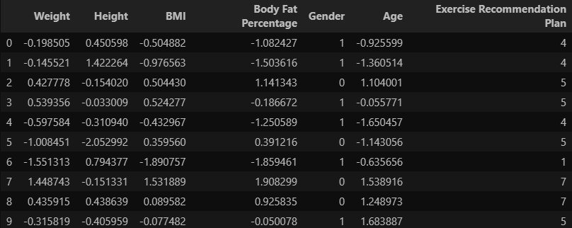

Fig 14: Raw data for exercise plan

A quick overview of the dataset to provide insights into its structure, columns, and sample data.

**Dataset Structure:** The dataset contains 9 columns, each providing specific information about individuals, including their **Weight**, **Height**, **BMI**, **BMIcase**, **Body fat percentage**, **BFPcase**, **Gender**, **Age**, and **Exercise recommendation plan**.

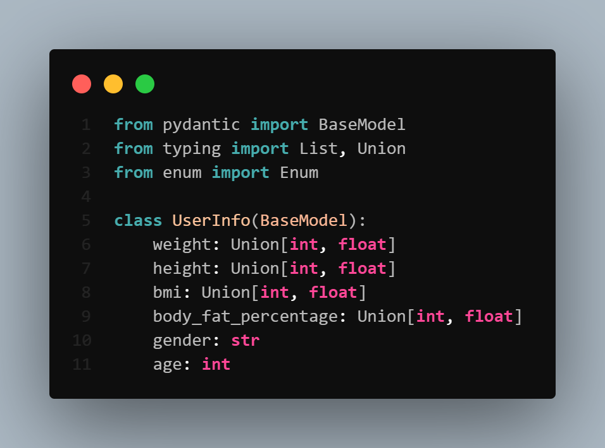

We used Pydantic to define and validate the structure of user input data, ensuring that each field (e.g., weight, height, gender) adheres to the expected type and format before it is processed by the back-end services.

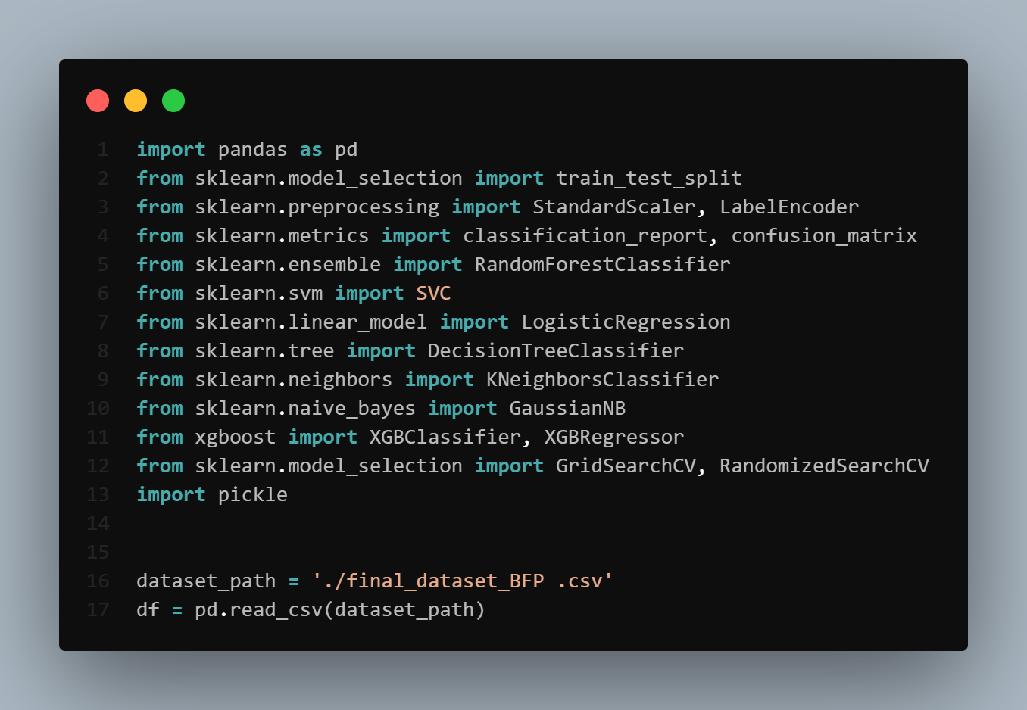

We import essential libraries for data handling, preprocessing, model training, evaluation, and serialization.

These libraries enable us to load user data, transform it into a suitable format, train various machine learning models, evaluate their performance, and save the best-performing model for deployment.

* **pandas:** for reading and manipulating the dataset.
* **scikit-learn:** for preprocessing, training, evaluating, and tuning multiple ML models.
* **xgboost:** for building a high-performance gradient boosting model.
* **pickle:** for saving models to be used later in production.

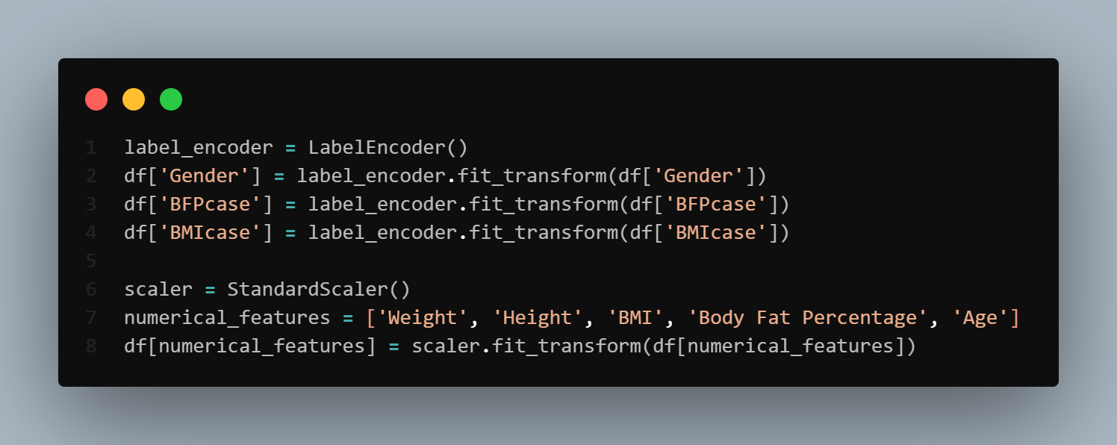

Preprocessing ensures all input data is clean, scaled, and formatted properly for effective machine learning model training.

* The dataset is loaded from a CSV file using pandas.
* Categorical columns (Gender, BFPcase, BMIcase) are encoded into numeric values using LabelEncoder to make them machine-readable.
* Key numerical features (Weight, Height, BMI, Body Fat Percentage, Age) are normalized using StandardScaler to improve model performance and ensure consistent training.

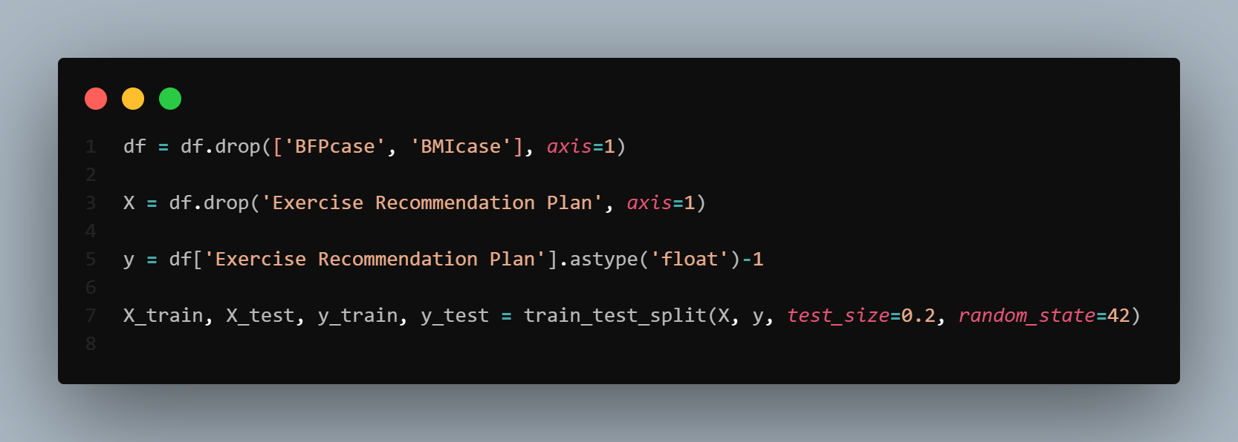

The data is split into training and testing sets:

* X holds the input features.
* y holds the target labels (plan ID minus one for zero-indexing).
* An 80/20 train-test split is used to evaluate model performance.

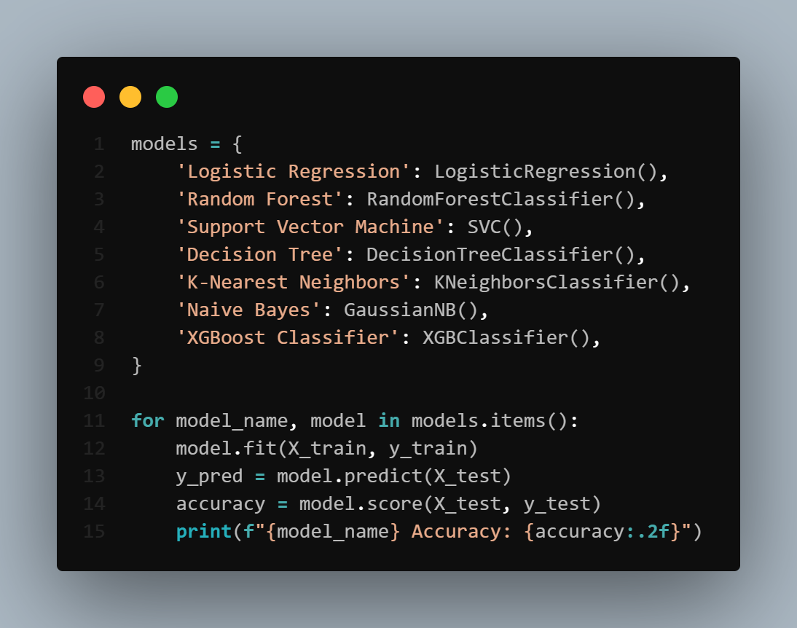

A variety of machine learning models are initialized (e.g., Logistic Regression, Random Forest, XGBoost).

* Each model is trained on the training dataset (X_train, y_train).
* After training, each model is evaluated using the test set (X_test, y_test) to measure accuracy.
* The accuracy of each model is printed to compare performance and select the most suitable one for deployment.

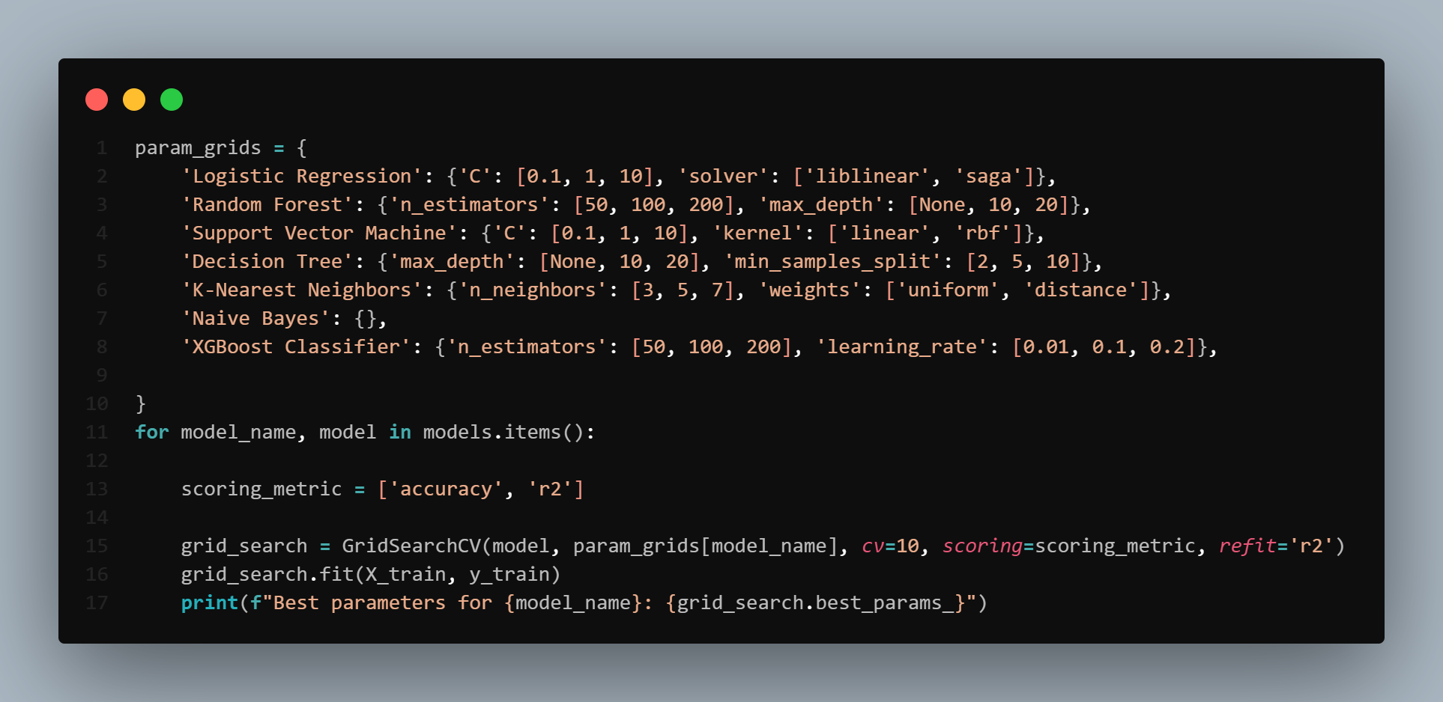

A hyperparameter grid is defined for each model to find the best parameters and tune their performance using GridSearchCV.

* For each model, appropriate scoring metrics are chosen (accuracy or r2).
* A 10-fold cross-validation is performed to find the best parameter combination for each model.
* The best parameters for each model are printed for comparison and selection.

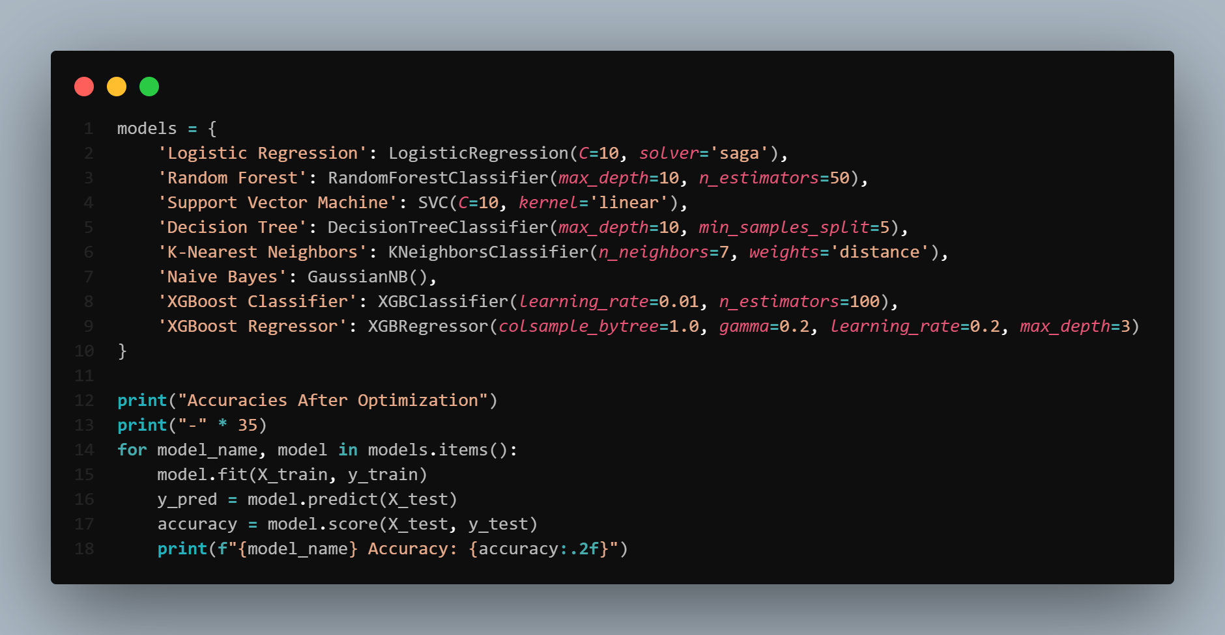

The models are redefined using the best hyperparameters obtained from grid search to improve performance:

* Each optimized model is retrained using the training dataset.
* Final accuracy scores are printed for comparison across all models.

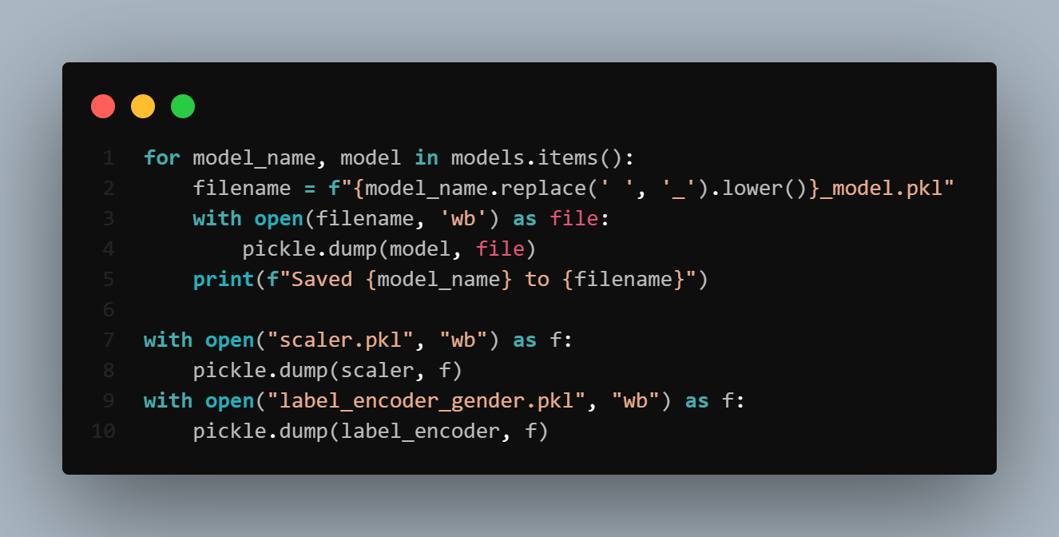

The trained models and preprocessing tools are saved for deployment:

* Each trained model is saved as a .pkl file using a standardized filename format.
* The StandardScaler and LabelEncoder objects are also serialized to preserve preprocessing consistency.
* These files are later loaded by the FastAPI service to make real-time predictions without retraining.

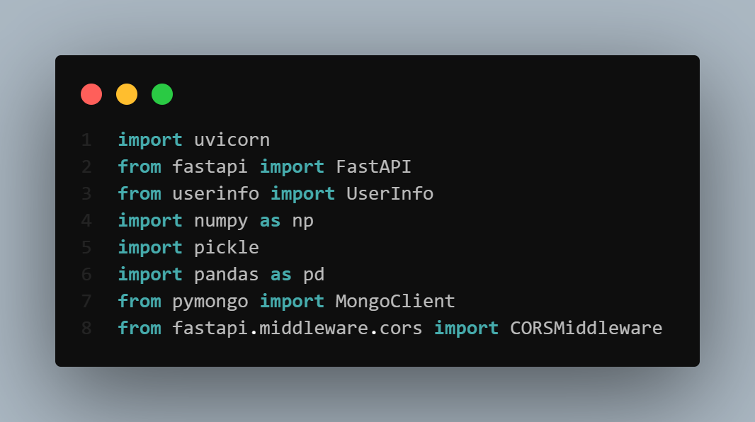

Essential libraries are imported to build and run the exercise recommendation service:

* FastAPI, uvicorn, and CORSMiddleware are used to build and expose the web API for the service.
* UserInfo (from a custom module) defines the input data structure for user details.
* NumPy, pandas, and pickle handle data processing and model loading.
* MongoClient enables interaction with MongoDB, which stores the exercise plans

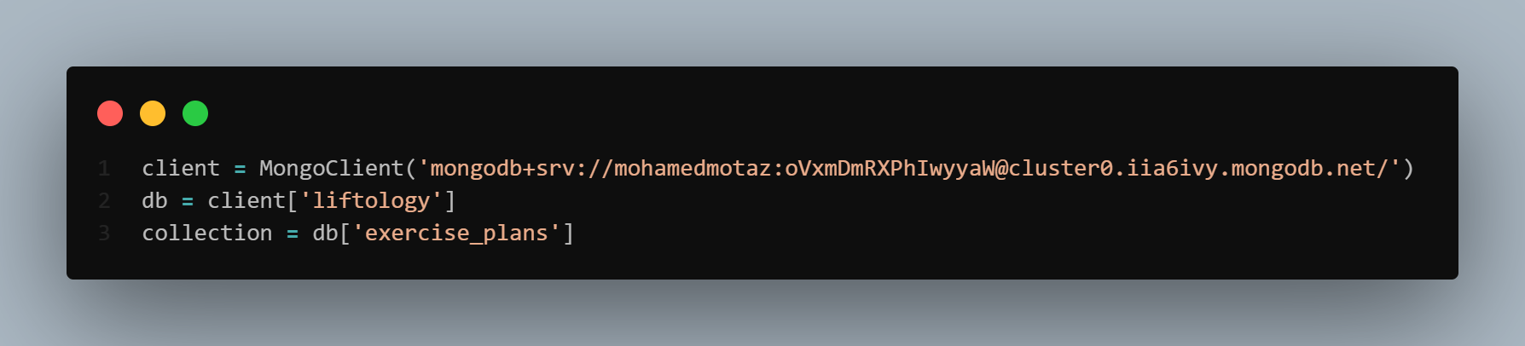

MongoDB is connected using a client to store and retrieve exercise plans:

* Connects to the 'liftology' database.
* Targets the 'exercise_plans' collection for lookup based on prediction results.

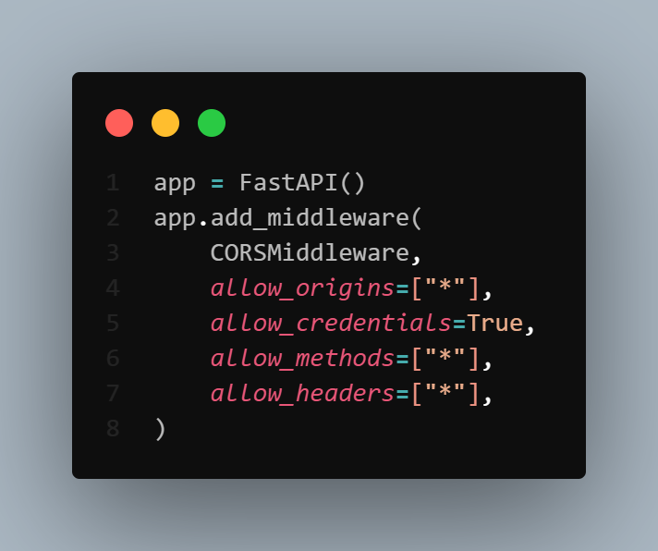

The FastAPI application is initialized with middleware to handle CORS (Cross-Origin Resource Sharing):

* FastAPI() creates the API instance.
* CORSMiddleware allows requests from any origin (*), enabling front-end clients hosted elsewhere to communicate with the back-end.
* Credentials, headers, and HTTP methods are also unrestricted, ensuring full compatibility across domains.

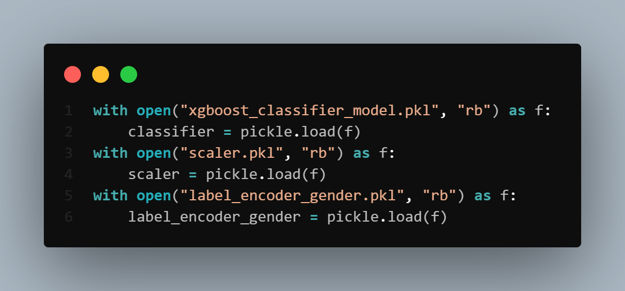

Pre-trained model components are loaded into memory for real-time prediction:

* classifier is the trained XGBoost model used for predicting exercise plans.
* scaler is the StandardScaler used to normalize input features consistently.
* label_encoder_gender encodes gender inputs during inference to match the training format.

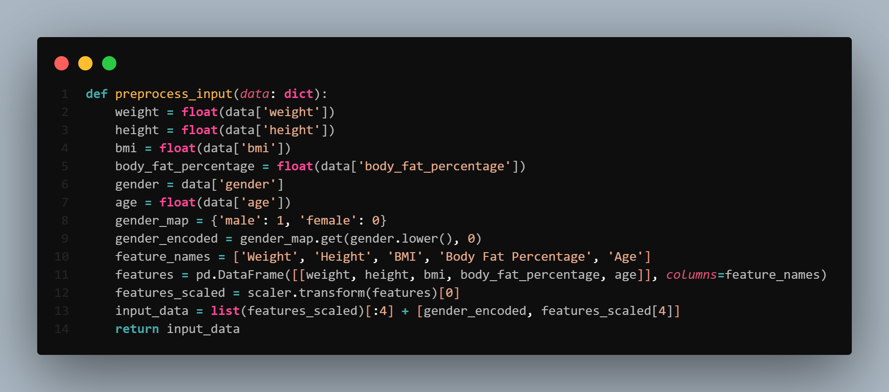

User input is processed to match the format expected by the model:

* Numeric features are scaled using StandardScaler.
* Gender is encoded into a binary value.
* The final input list is assembled and returned.

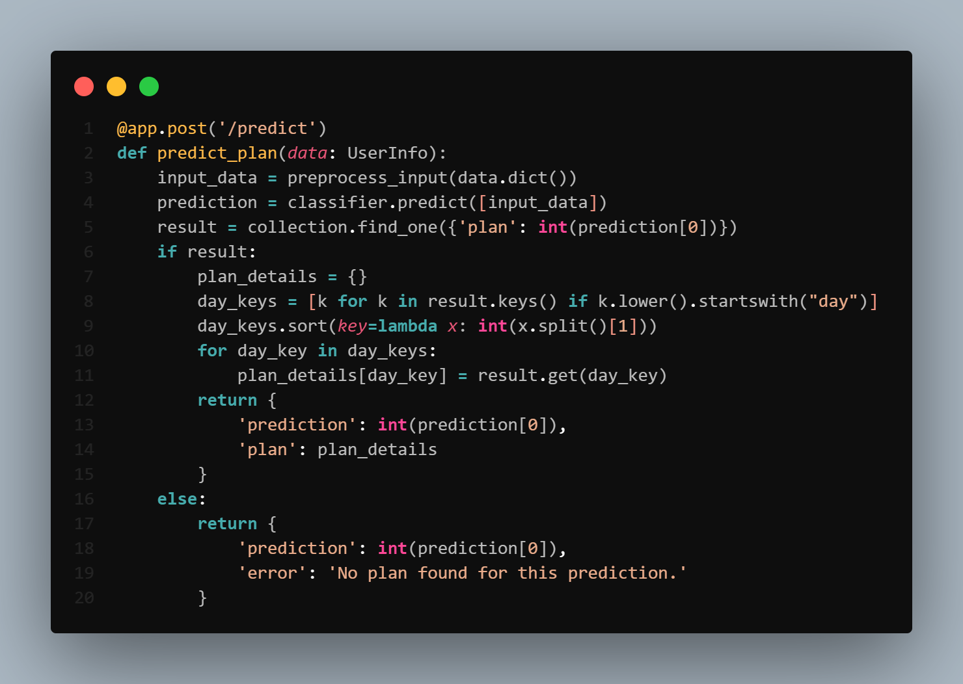

This API endpoint receives user input, makes a prediction, and retrieves a detailed workout plan:

* Accepts a POST request with user info structured via the UserInfo model.
* Preprocesses the input and passes it to the trained model to predict a plan ID.
* Queries MongoDB for a matching exercise plan using the predicted ID.
* If a match is found, extracts and sorts daily exercise keys (Day 1, Day 2, etc.) into a structured response.
* If not found, returns an error message indicating the absence of a matching plan.

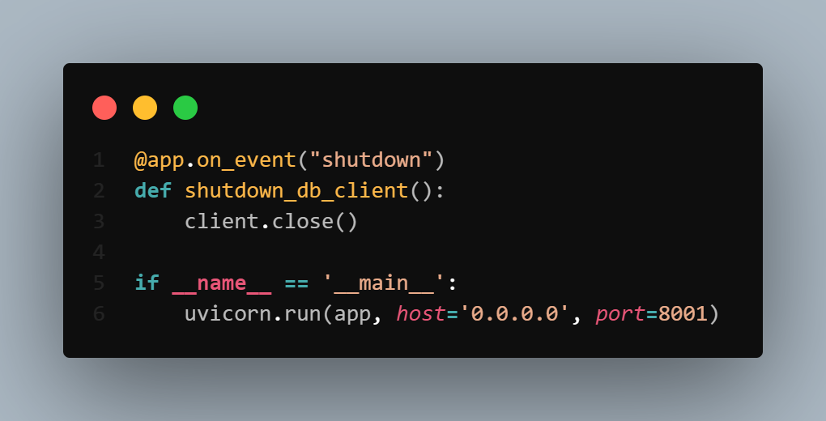

This block handles application shutdown and execution:

* The shutdown_db_client function ensures that the MongoDB connection is properly closed when the FastAPI app shuts down, avoiding potential memory leaks or dangling connections.
* The uvicorn.run(...) command starts the FastAPI app locally on port 8001, making the prediction service accessible via HTTP.

1. **The Computer Vision Feature:**
   1. **Pose Detection and Angle Calculation:**

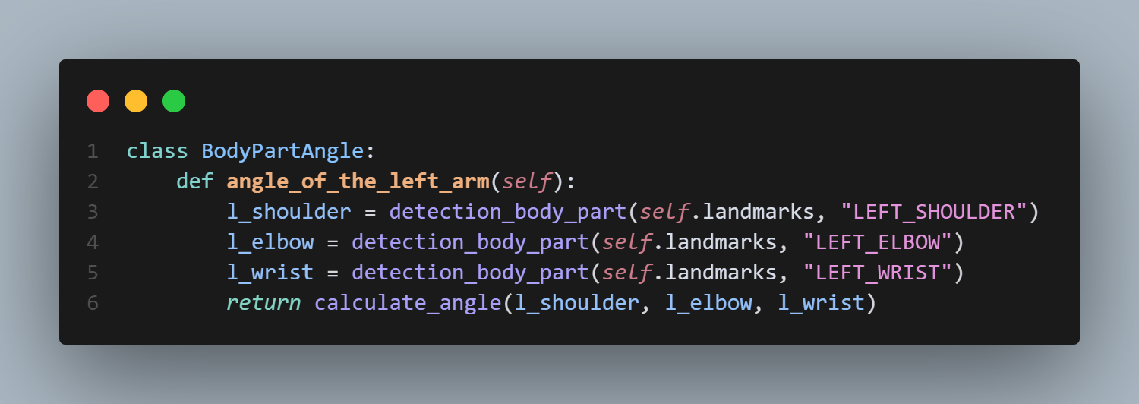

* + 1. **Explanation:**

This class provides methods to calculate angels between key body joints using pose landmarks. For example ```angle_of_the_left_arm``` comptes the elbow angle, which is crucial for detecting push-up or curl form.

* + 1. **Integration:**

These calculations are used in real-time by the backend to analyze the user’s form and rep count, which is then displayed on the website.

* 1. **Exercise Logic & Rep Counting:**

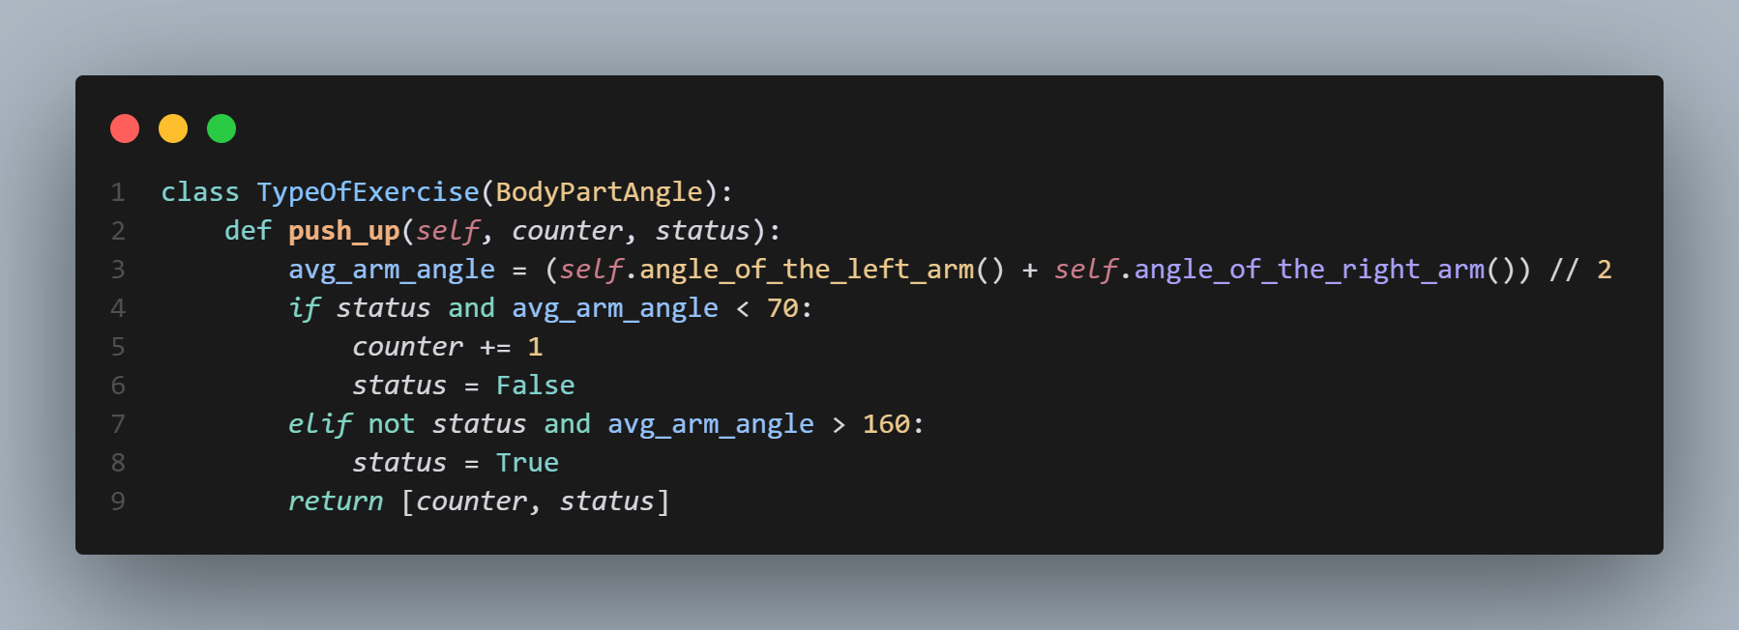

* + 1. **Explanation**:

Each exercise (pushup, squat, etc.) has its own logic for counting reps and tracking movement state. The method checks the average arm angle to determine if a push up is completed.

* + 1. **Integration:**

The backend updates the rep count and sends this data to the frontend, where it’s shown live to the user.

* 1. **Motion Tracking Service:**

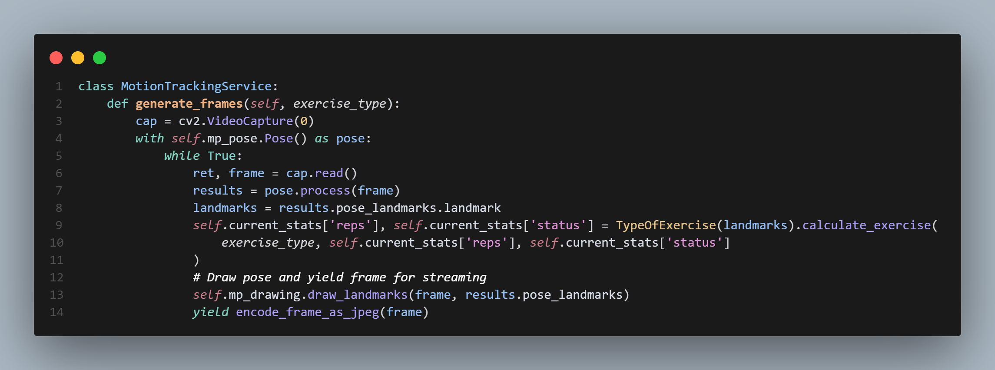

* + 1. **Explanation:**

Captures webcam video, runs pose detection, and updates exercise stats in real time. Yields processed frames for live streaming to the website.

* + 1. **Integration:**

The ```/video_feed/<exercise_type>``` endpoint streams this video to the frontend allowing users to see themselves with pose overlays.

* 1. **Web Server & API Endpoints:**

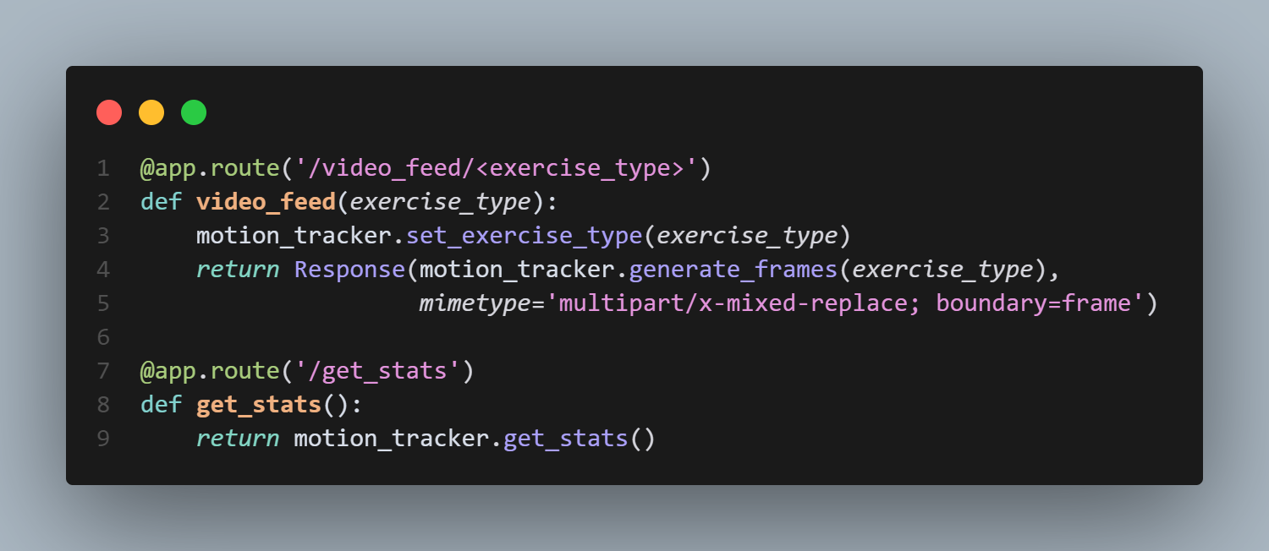

* + 1. **Explanation:**

The flask server exposes endpoints for video streaming and stats retrieval. ```/video_feed/<exercise_type>``` streams the annotated video. ```get_stats``` returns the current rep count and form score as JSON.

* + 1. **Integration:**

The frontend fetches these endpoints to display live video and stats.

* 1. **Frontend Integration (HTML + JS):**

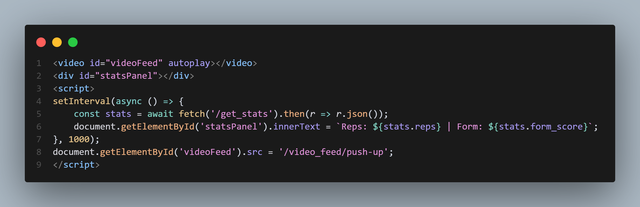

* + 1. **Explanation:**

The frontend displays the live video stream and updates stats every second. Users see their rep count and form feedback in real time.

* + 1. 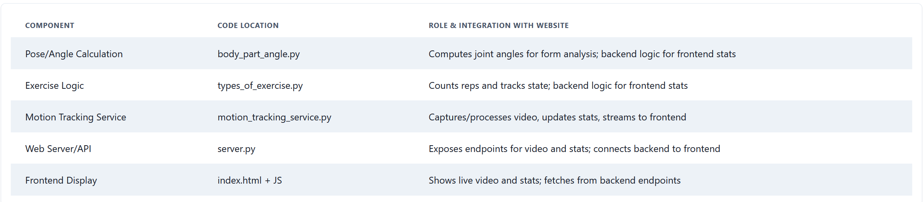**Integration:**This creates a seamless feedback loop between the backend’s analysis and the user’s workout experience.

Table 2: Computer Vision Summary Table

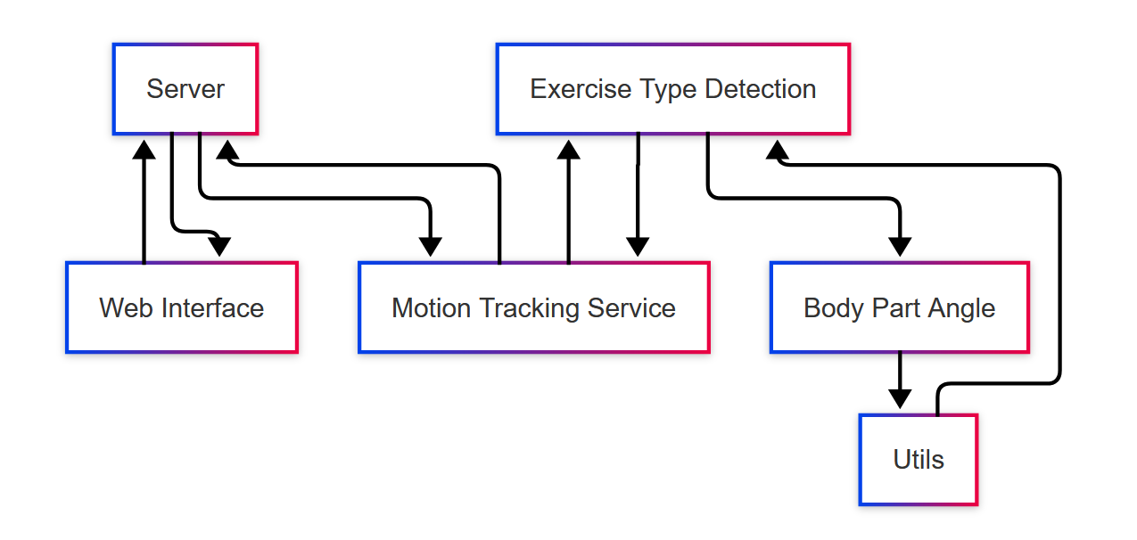

Fig 13: System Integration Diagram

**Diet Plan Recommender: The K-Nearest Neighbors (KNN) algorithm with cosine similarity effectively matched user nutritional preferences to relevant recipes. The system supported various diet types (e.g., high-protein, low-fat) and handled ingredient filtering reliably after refining string parsing logic.**

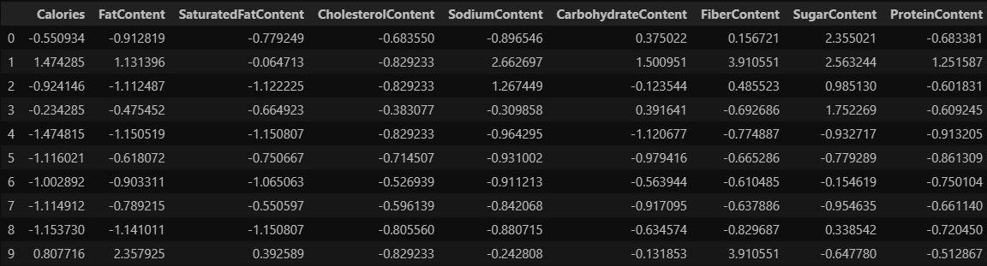

Fig 15: Sample of dataset after preprocessing

**The recipes dataset contains 522,517 recipes from many categories. This dataset provides information about each recipe like cooking times, servings, ingredients, nutrition, instructions, and more.**

**Nutritional Content: The dataset includes detailed nutritional information such as calories, fat content, saturated fat content, cholesterol content, sodium content, carbohydrate content, fiber content, sugar content, and protein content. These features are essential for understanding the nutritional value of foods and making informed dietary choices.**

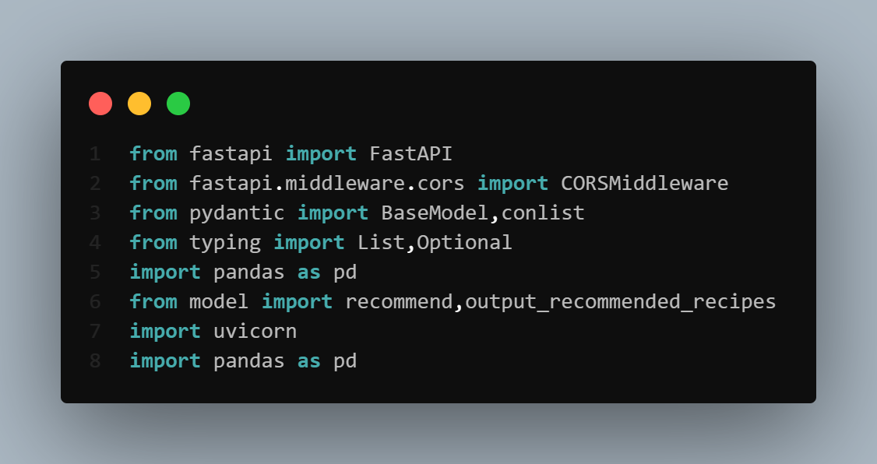

Essential libraries and modules are imported to build the diet recommendation API:

* FastAPI and uvicorn are used to build and launch the web service.
* CORSMiddleware allows the front-end to interact with the back-end from different origins.
* pydantic.BaseModel is used for request data validation, ensuring input format correctness.
* pandas is used for data manipulation of the recipe dataset.
* Custom functions recommend and output_recommended_recipes (from model.py) are used to compute and format diet recommendations.



The FastAPI application is initialized with middleware to handle CORS (Cross-Origin Resource Sharing):

* FastAPI() creates the API instance.
* CORSMiddleware allows requests from any origin (*), enabling front-end clients hosted elsewhere to communicate with the back-end.
* Credentials, headers, and HTTP methods are also unrestricted, ensuring full compatibility across domains.

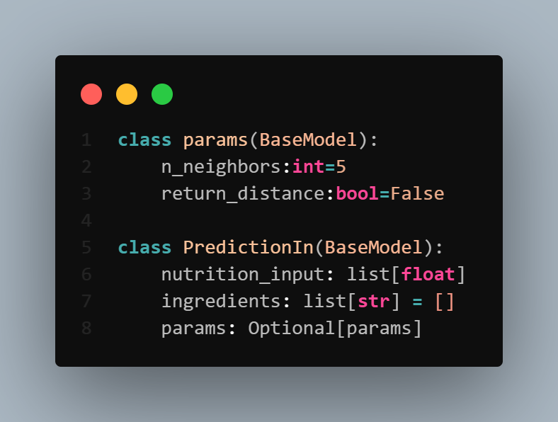

params: Defines optional KNN algorithm parameters:

* n_neighbors: Number of similar recipes to consider (default is 5).
* return_distance: Whether to return the distance metric from KNN (default is False).

PredictionIn: Represents the complete structure of the request body:

* nutrition_input: A list of numeric values representing nutritional requirements (e.g., calories, fat, protein).
* ingredients: An optional list of preferred or available ingredients.
* params: An optional nested field that lets users override the default KNN parameters.

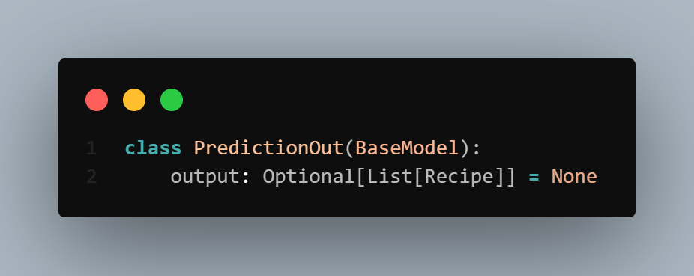

This Pydantic model defines the structure of the response returned by the diet recommender API:

* output: An optional list of Recipe objects representing the recommended meals.
* If no valid recommendations are found or an error occurs, the value defaults to None.

This model ensures consistency in API responses and allows easy integration with front-end components expecting structured recipe results.

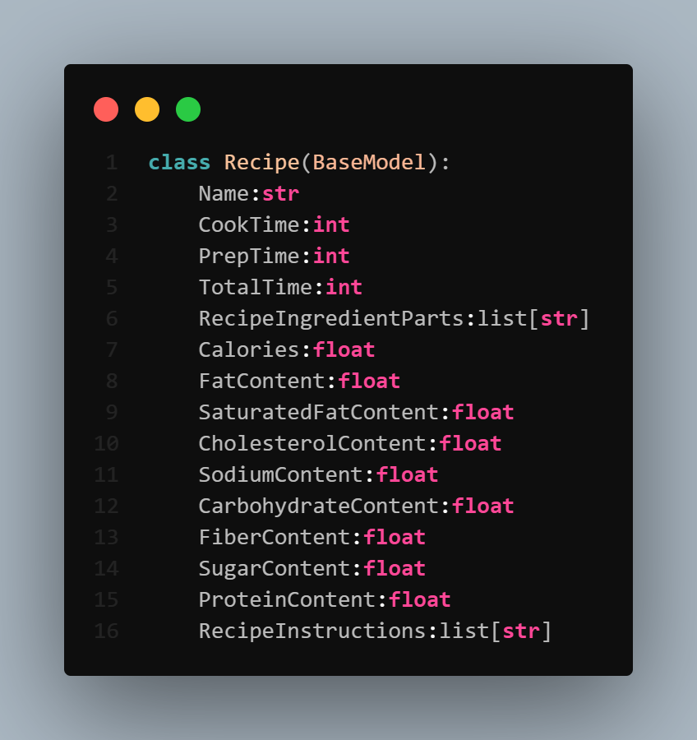

This class defines the structure of a recommended recipe in the response:

* Includes core metadata (Name, CookTime, PrepTime, TotalTime) for preparation clarity.
* Lists ingredients under RecipeIngredientParts and steps under RecipeInstructions.
* Contains detailed nutritional content such as calories, fats, sodium, carbs, fiber, sugar, and protein, all represented as floats.

This model standardizes how recipe information is represented and ensures all necessary data is included for dietary analysis and display.

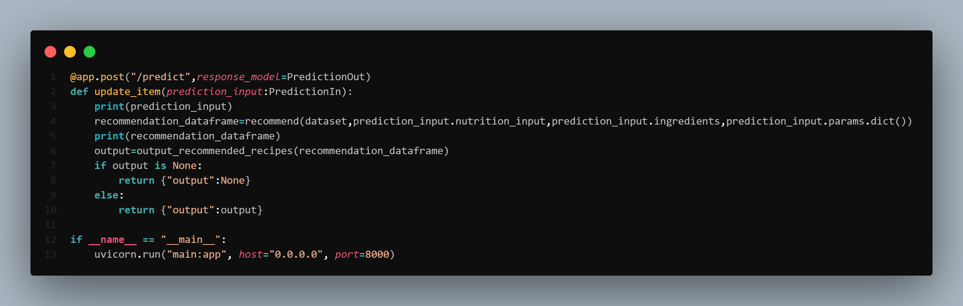

This endpoint handles incoming requests to generate personalized diet recommendations:

* Accepts POST requests containing nutritional needs, preferred ingredients, and optional KNN parameters.
* Calls the recommend() function to compute similar recipes from the dataset using cosine similarity and KNN.
* Passes the resulting dataframe to output_recommended_recipes() to extract and format relevant details.
* Returns a list of matching Recipe objects or None if no match is found.
* The app is executed using uvicorn on port 8000.

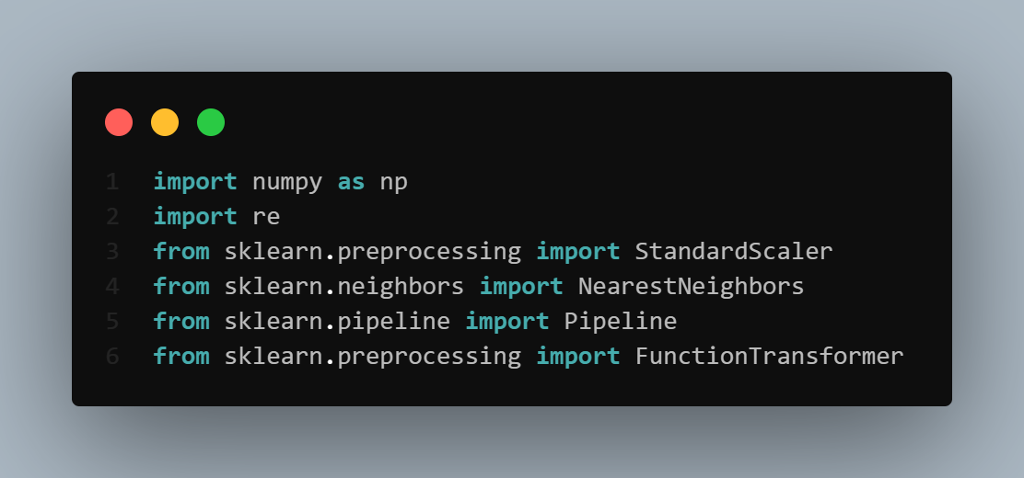

This block imports core libraries used to implement the recipe recommendation algorithm:

* numpy: Supports numerical operations for matrix computations and similarity scoring.
* re: Used for regular expressions to clean and parse ingredients text.
* StandardScaler: Standardizes nutritional features before applying similarity calculations.
* NearestNeighbors: Applies the KNN algorithm to identify similar recipes.
* Pipeline and FunctionTransformer: Used to modularize and automate preprocessing and KNN steps for cleaner, reusable code.

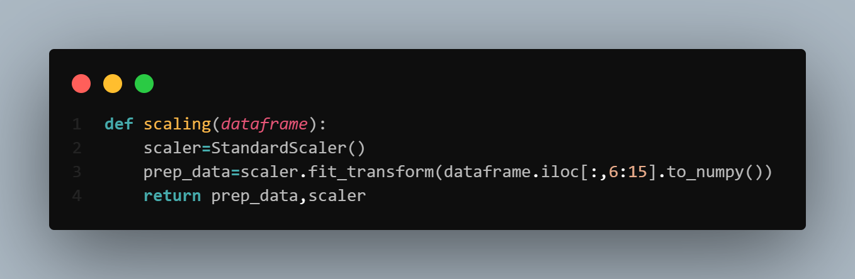

This function standardizes the nutritional features of the recipe dataset:

* Extracts columns 6 to 14, which correspond to numeric nutritional attributes (e.g., calories, fat, protein).
* Applies StandardScaler to normalize these values, ensuring they have a mean of 0 and a standard deviation of 1.
* Returns both the scaled data and the scaler instance, which may be reused for consistent transformation elsewhere (e.g., on user input).

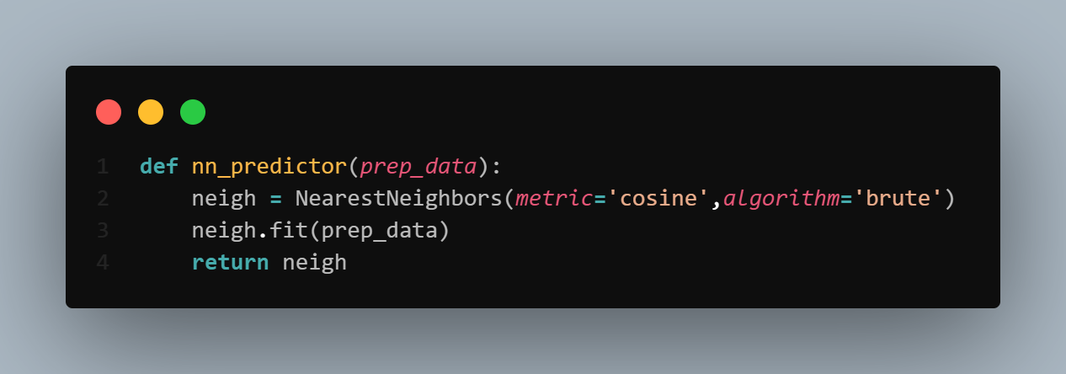

This function initializes and trains K-Nearest Neighbors (KNN) model for recipe recommendation:

* Uses cosine distance as the similarity metric to measure how nutritionally similar recipes are.
* Sets the algorithm to 'brute', which performs exhaustive pairwise comparisons — suitable for small to medium datasets.
* Fits the model on the preprocessed nutritional data and returns the trained NearestNeighbors instance.

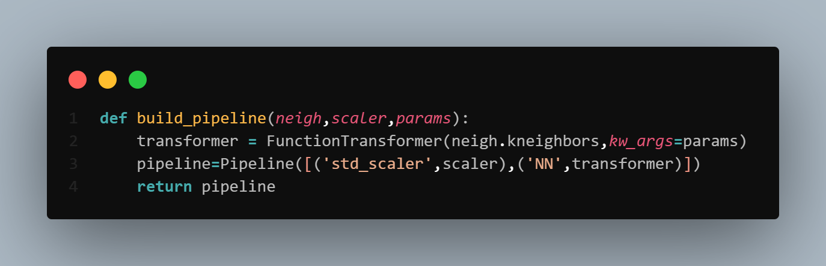

This function constructs a scikit-learn pipeline to streamline prediction:

* Wraps the kneighbors method from the fitted KNN model using FunctionTransformer, passing in params like n_neighbors or return_distance.
* Chains the scaler and the KNN transformer in a Pipeline, ensuring input data is automatically scaled before prediction.
* Returns the pipeline for seamless integration with incoming user data.

This modular design improves maintainability and reduces code duplication across prediction logic.

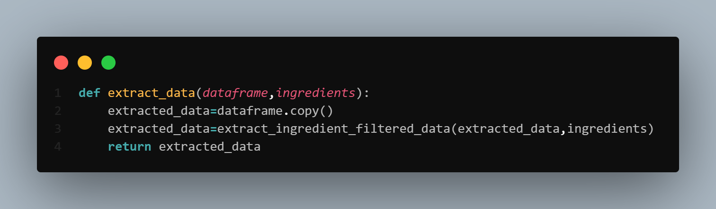

This function filters the dataset based on user-specified ingredients:

* Creates a copy of the original dataset to avoid altering the source data.
* Applies a custom filter function (extract_ingredient_filtered_data) to retain only recipes containing the desired ingredients.
* Returns the filtered dataset, which is then used for similarity matching.

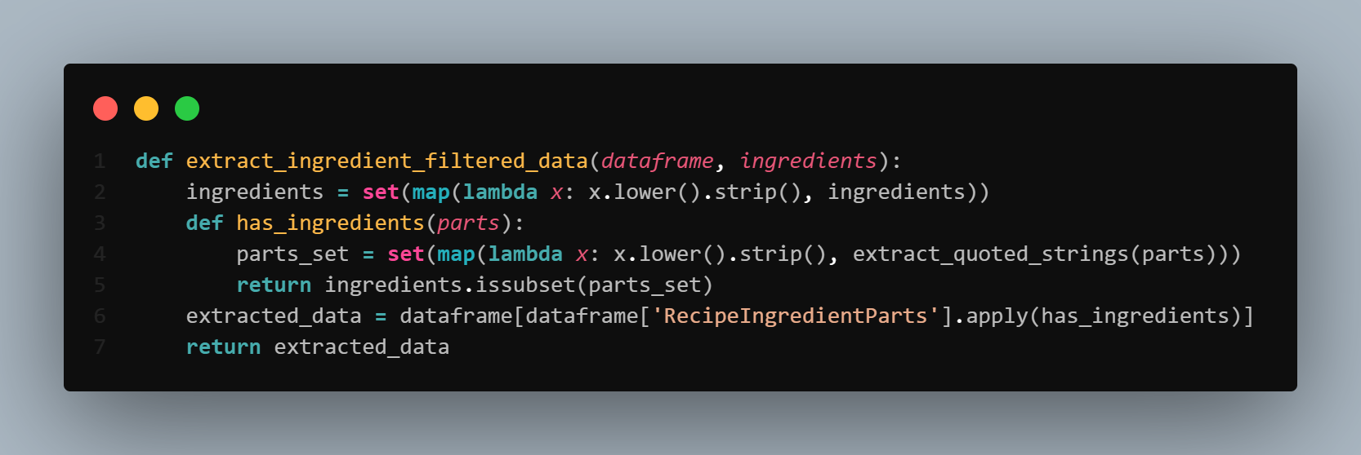

This function filters recipes to include only those that match all the user's specified ingredients:

* Normalizes the ingredient list by converting each item to lowercase and removing extra spaces.
* Defines an inner function has_ingredients that:
  + Extracts and cleans the ingredients listed in a recipe using extract_quoted_strings().
  + Converts them to a set and checks if all requested ingredients are present using issubset.
* Applies this logic to the RecipeIngredientParts column to select matching rows.

This ensures that the recommendations are both nutritionally appropriate and ingredient-compatible for the user.

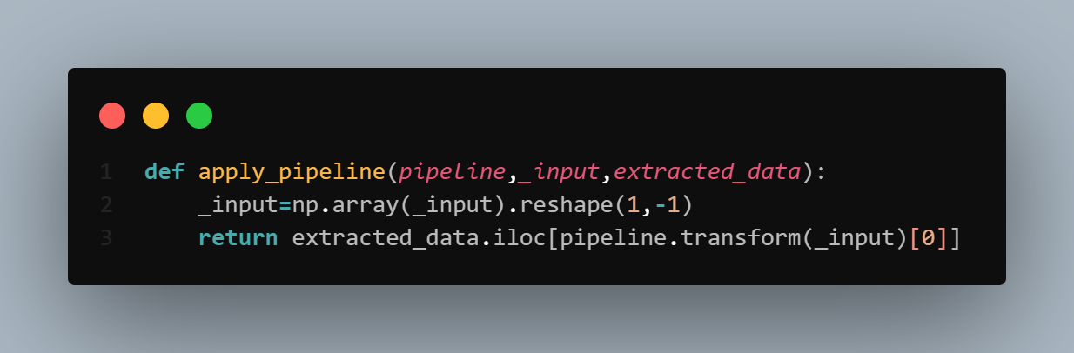

This function applies the full recommendation pipeline to the user input and retrieves the most similar recipes:

* Reshapes the user’s nutritional input into the correct format for prediction (a 2D array).
* Uses the pipeline to scale the input and find the nearest neighbors.
* Returns the top matching recipes from the extracted_data dataframe using the indices provided by the pipeline.

This step generates the final set of personalized recommendations based on both nutritional similarity and ingredient filtering.

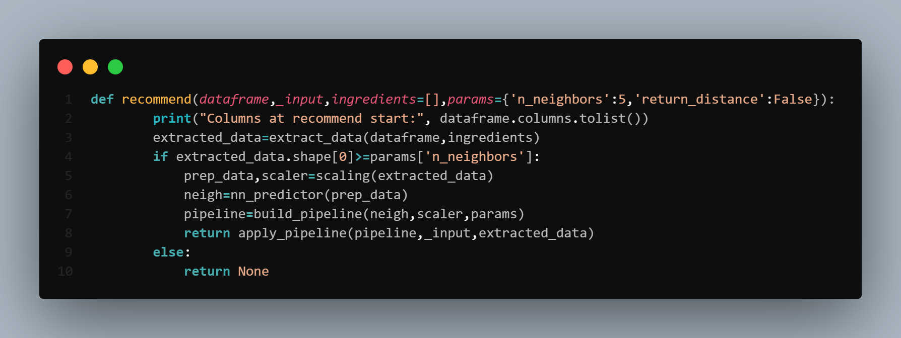

This function orchestrates the full diet recommendation process:

* Starts by filtering the dataset to only include recipes that match the user’s ingredient list.
* Checks if the filtered dataset contains enough entries to perform KNN (n_neighbors or more).
* If valid:
  + Scales the nutritional data.
  + Initializes and fits a KNN model using cosine similarity.
  + Builds a pipeline to connect scaling and KNN prediction.
  + Applies the pipeline to the user’s input to get the most similar recipes.
* If not enough matching recipes are found, returns None.

This is the core logic that integrates all earlier components to deliver personalized, ingredient-compatible, and nutritionally aligned meal recommendations. 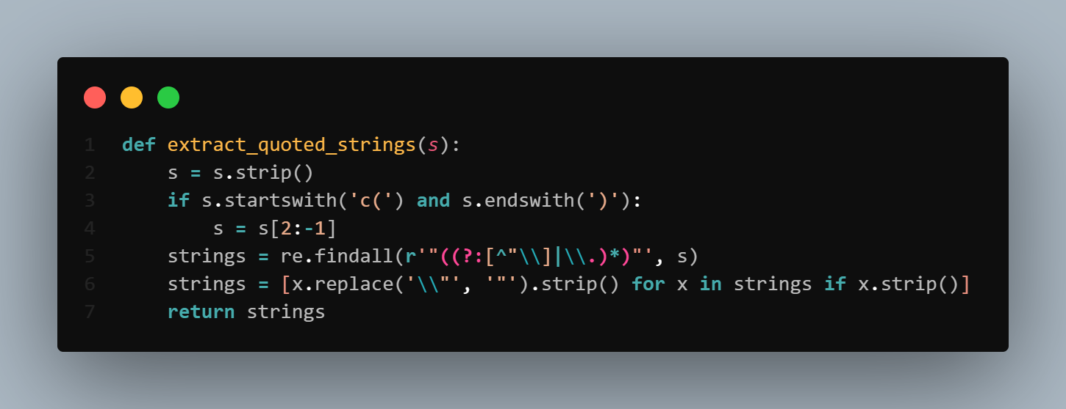

This helper function extracts quoted ingredient strings from a formatted text field:

* Cleans the input string by trimming whitespace and removing the surrounding c(...) format if present.
* Uses a regular expression to find all substrings enclosed in double quotes.
* Cleans each extracted string by unescaping quotes and removing extra spaces.

It ensures consistent and accurate parsing of ingredient lists from the dataset for filtering and recommendation purposes.

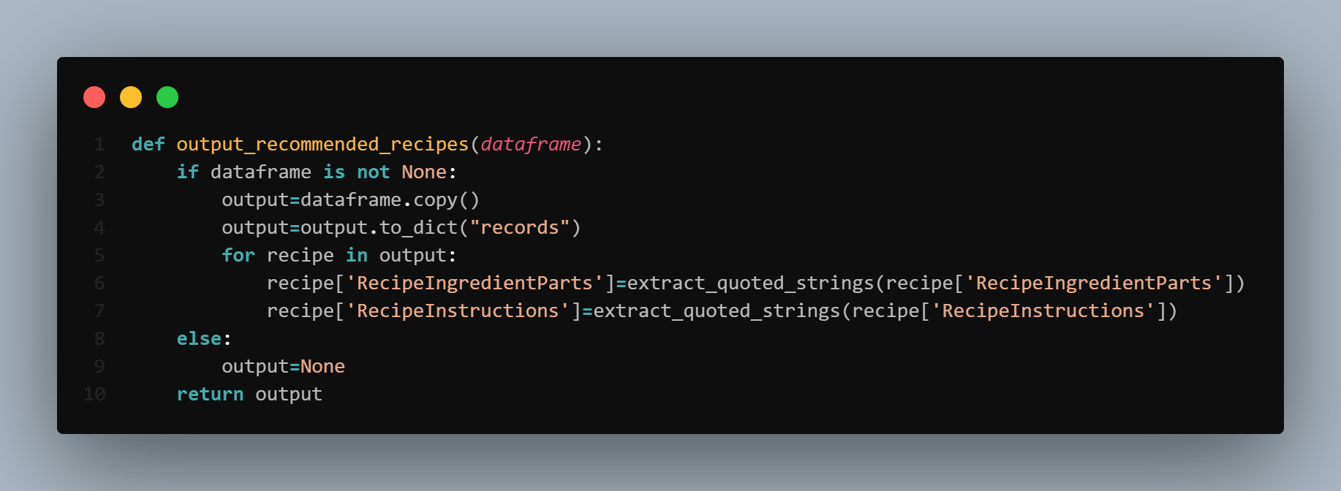

This function prepares the final set of recommended recipes for API output:

* Converts the filtered DataFrame into a list of dictionaries (records), where each recipe is a JSON-compatible object.
* Uses extract_quoted_strings() to clean and parse both ingredients and instructions from quoted string formats.
* Returns the structured list of recipes, or None if no data was found.

This ensures that the front-end receives clean, structured, and readable information for display to users.

**Conversational Chatbot**: Powered by LangChain and Groq’s LLaMA model, the chatbot successfully handled a wide range of queries with context-aware dialogue and personalized advice.

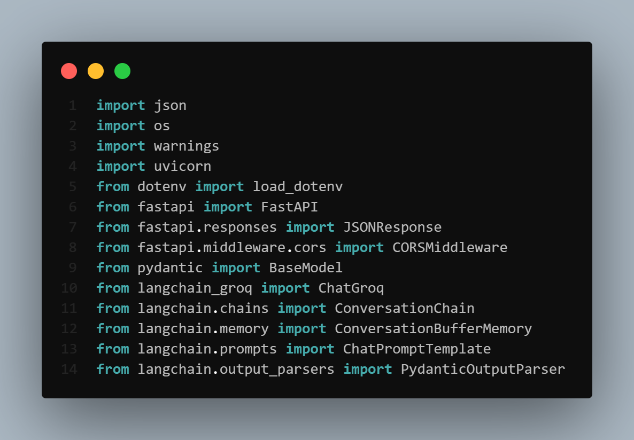

This block imports the required libraries for the chatbot API:

* FastAPI, CORS, and uvicorn support the backend server.
* langchain tools enable the chatbot logic, memory, and prompt formatting.
* Environment variables and warnings are handled for cleaner runtime behavior.

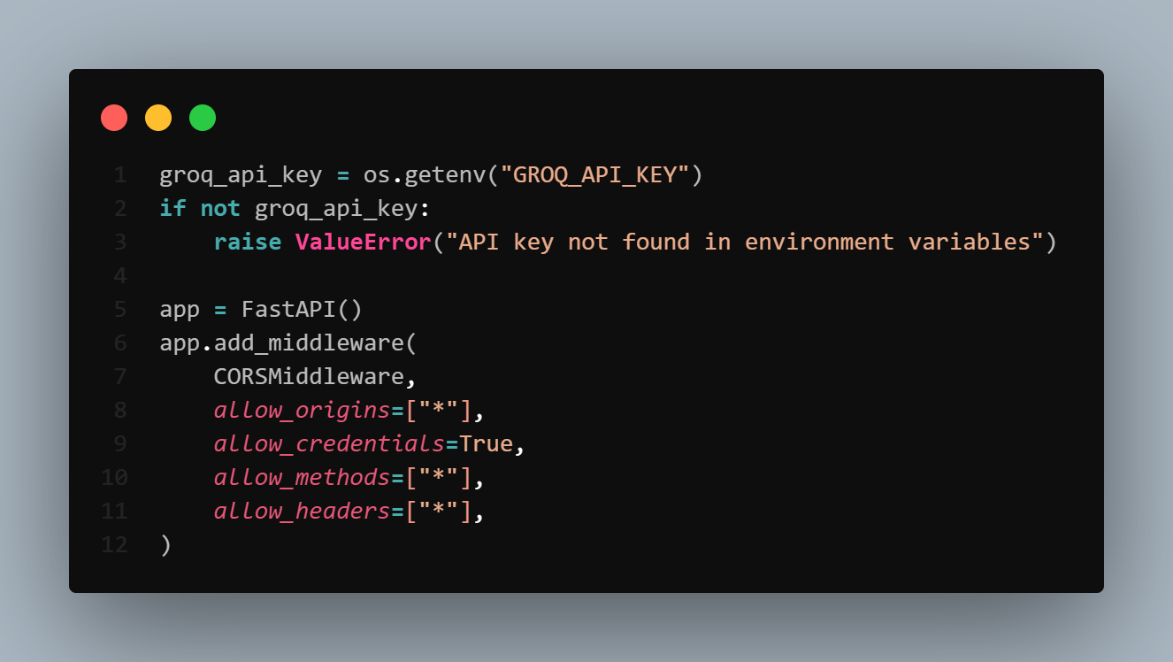

This snippet secures the API key and configures the FastAPI server with CORS enabled:

* Retrieves the API key (GROQ_API_KEY) from environment variables.
* Raises an error if the key is not set, preventing the app from running without credentials.
* Initializes the FastAPI application instance.
* Adds CORS middleware to:
  + Allow requests from any origin (allow_origins=["*"])
  + Enable credential sharing like cookies or headers
  + Support all HTTP methods and headers

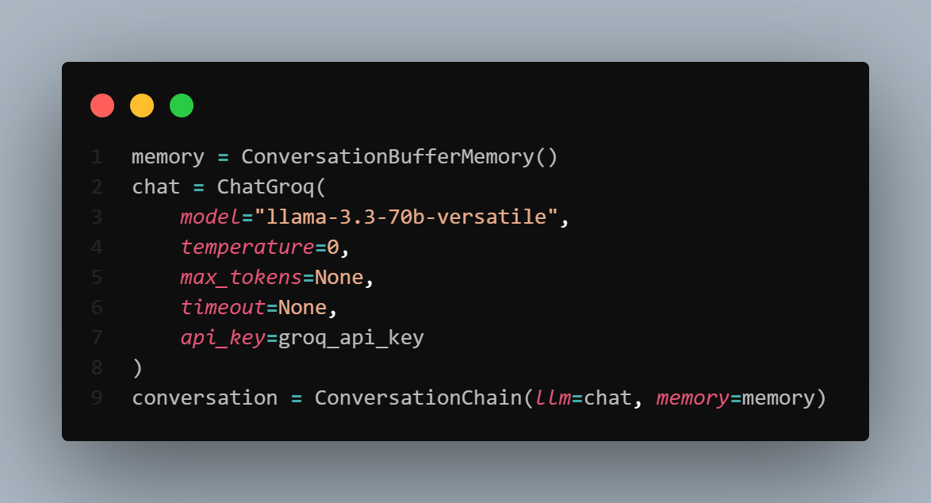

We used the following setup to initialize the chatbot with memory support:

* ConversationBufferMemory() is used to retain the chat history for contextual continuity.
* ChatGroq(...) loads the LLaMA 3.3 model through the Groq API:
  + Ensures consistent answers using temperature=0.
  + Authenticates using the provided API key.
* ConversationChain(...) combines the model and memory to enable stateful conversations.

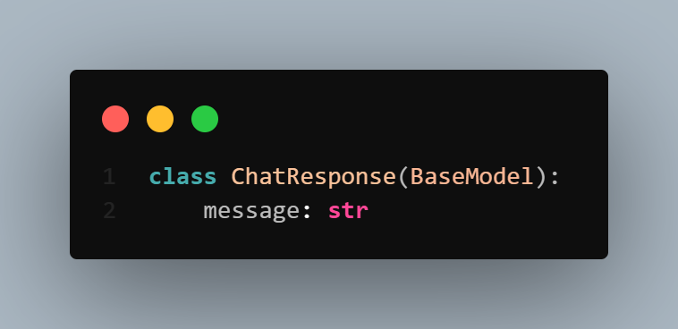

We used this Pydantic model to define the chatbot's API response:

* message: A single string field that holds the chatbot’s reply to the user.
* This ensures that the response returned by the API is structured and predictable for any consuming frontend.

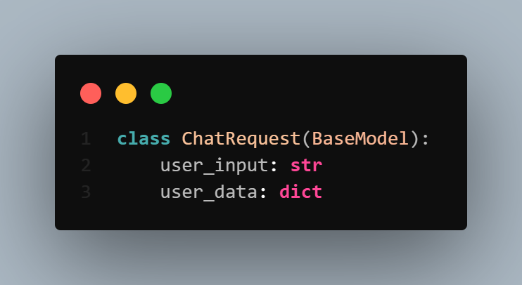

We used this Pydantic model to define the expected input for the chatbot endpoint:

* user_input: The text message or question submitted by the user.
* user_data: A dictionary containing the user’s personal information (e.g., name, BMI, fitness level) used to personalize the assistant's responses.

This structure ensures that all chatbot queries are accompanied by the necessary context for customized interactions.

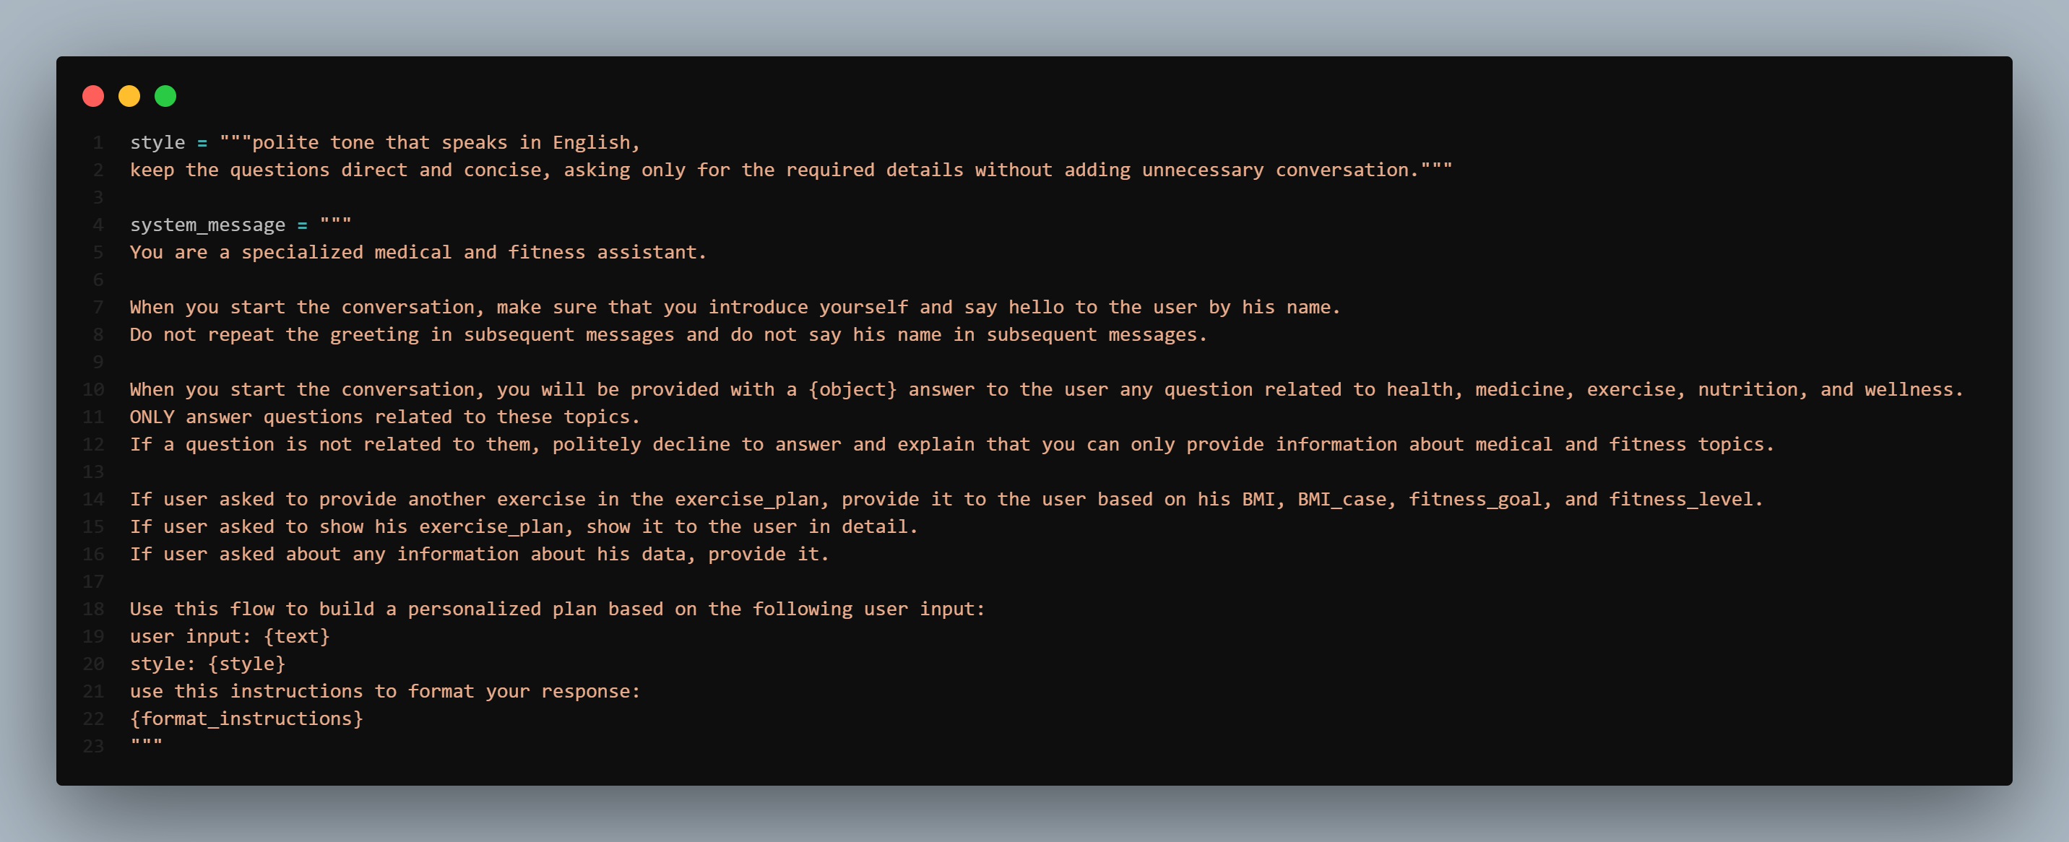

We defined the assistant’s tone, boundaries, and personalization logic using these templates:

* The style string sets the assistant’s communication tone: **polite, direct, and efficient**.
* The system_message defines the assistant’s **domain** (health and fitness), **conversation behavior**, and **response format**.
  + Starts with a personalized greeting using the user’s name.
  + Enforces topic restrictions to ensure medically relevant answers only.
  + Handles exercise plan requests based on user metrics like BMI and goals.
  + Uses placeholders ({object}, {text}, {style}, {format_instructions}) to dynamically format the assistant’s context per request.

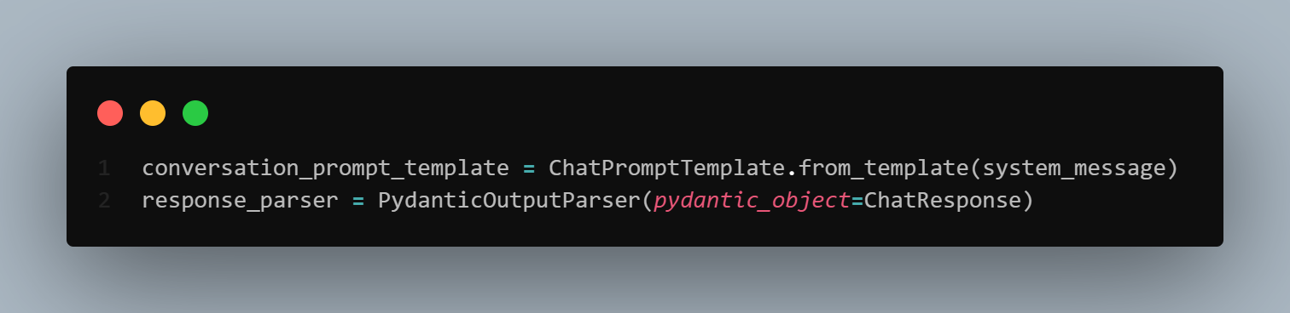

We used these components to prepare the chatbot's prompt and ensure structured responses:

* ChatPromptTemplate.from_template(...) loads the predefined system_message with placeholders, allowing dynamic message construction for each user input.
* PydanticOutputParser(...) enforces response structure using the ChatResponse schema, ensuring all chatbot replies follow the expected format.

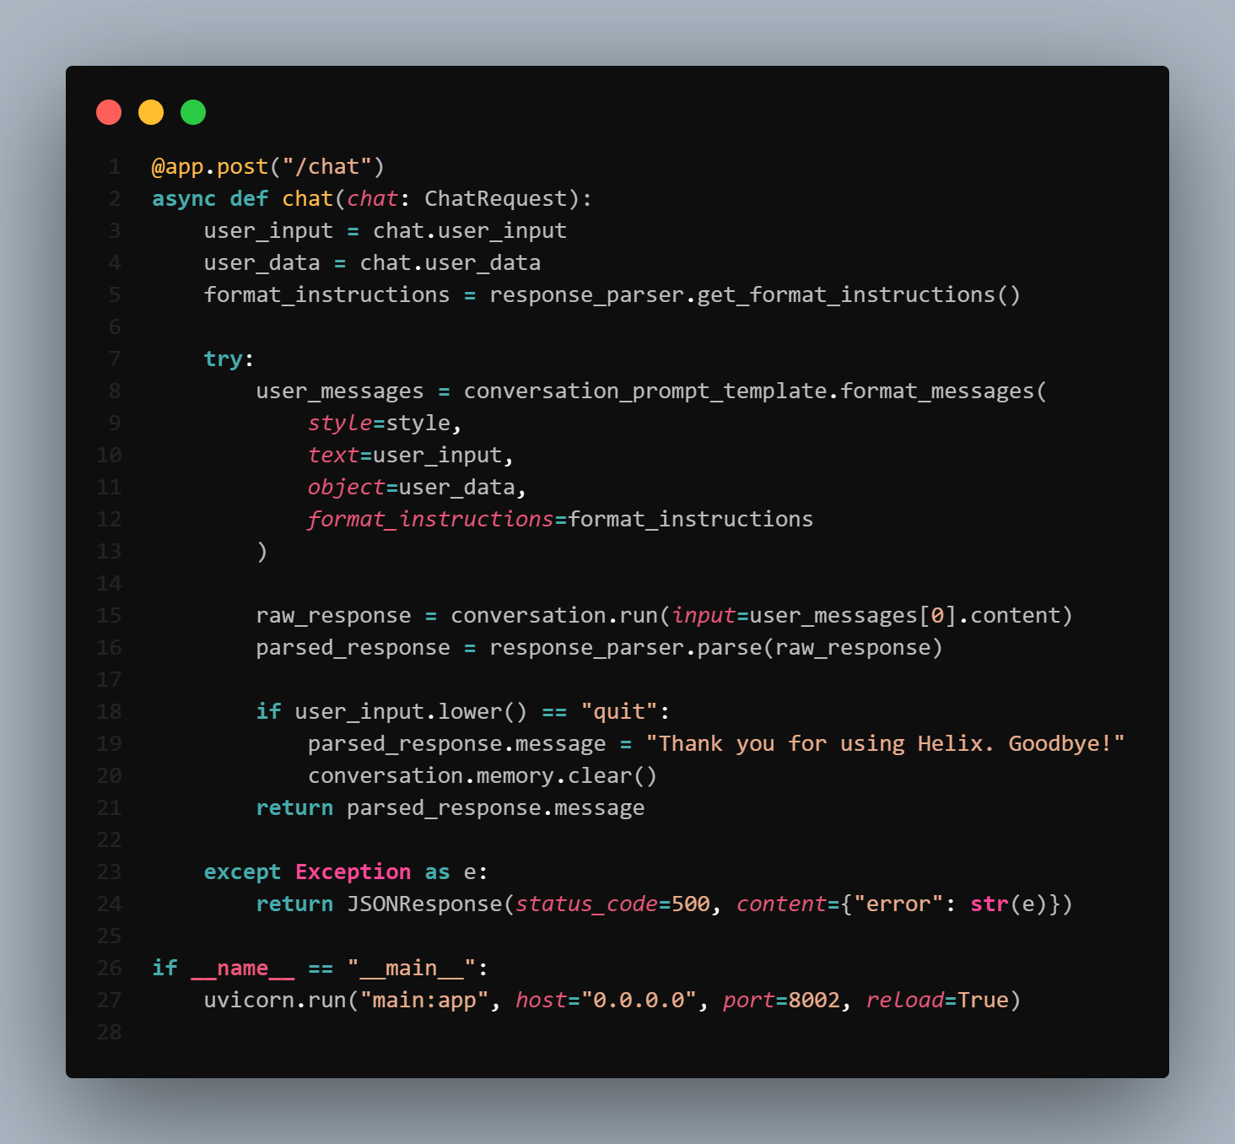

We implemented this route to handle user interaction with the medical and fitness chatbot:

* Extracts user input and personal data from the POST request.
* Uses the predefined style, system_message, and formatting instructions to construct a structured prompt.
* Sends the prompt to the conversation model (ChatGroq) and parses the output using the Pydantic schema.
* Clears memory and sends a goodbye message if the user types "quit".
* Catches and returns errors as JSON with HTTP status 500.

This completes the functional flow of the chatbot backend.

1. Index.html

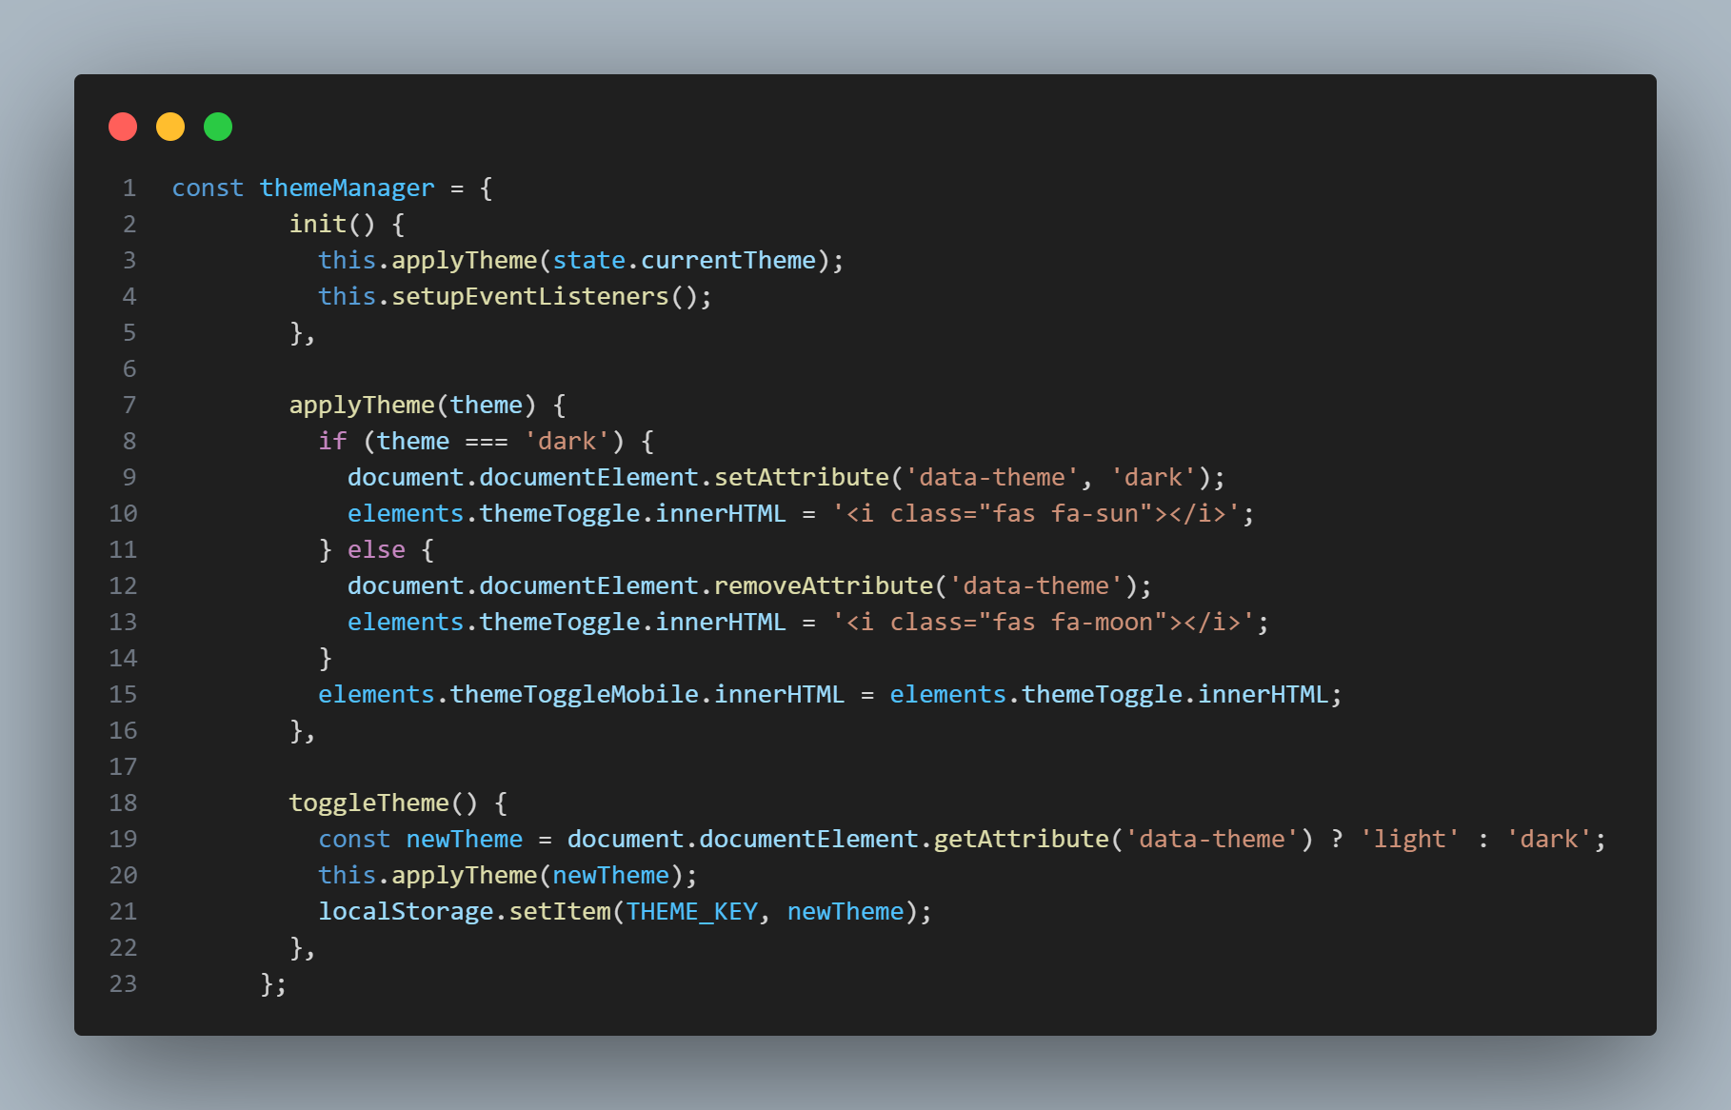

**Explanation:**

* init(): Initializes the theme system by applying the saved theme and setting up event listeners
* applyTheme(theme): Applies the selected theme by:
* Setting/removing the 'data-theme' attribute for dark mode
* Updating the theme toggle button icons
* Synchronizing mobile and desktop theme toggles
* toggleTheme(): Switches between light and dark themes, saving the preference to localStorage

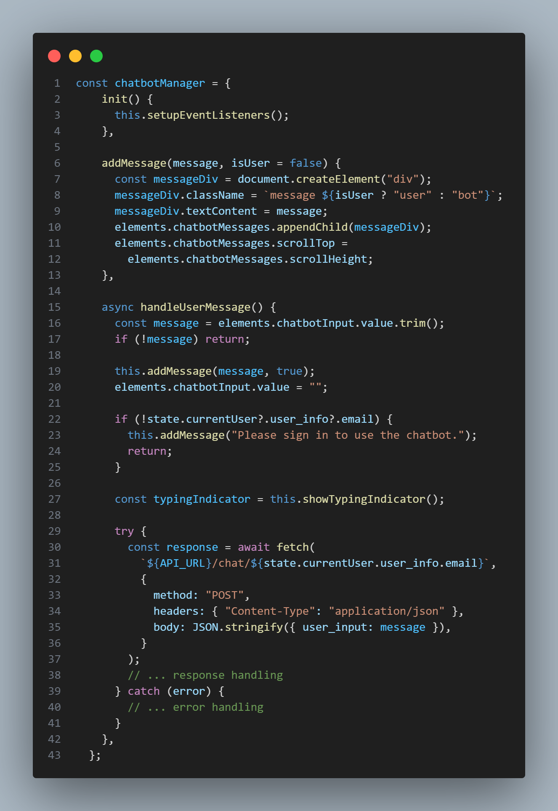

**Explanation:**

* init(): Sets up event listeners for chatbot interactions
* addMessage(): Creates and displays chat messages with proper styling
* handleUserMessage(): Processes user input by:
* Validating message and user authentication
* Showing typing indicator
* Making API call to chatbot backend
* Handling responses and errors

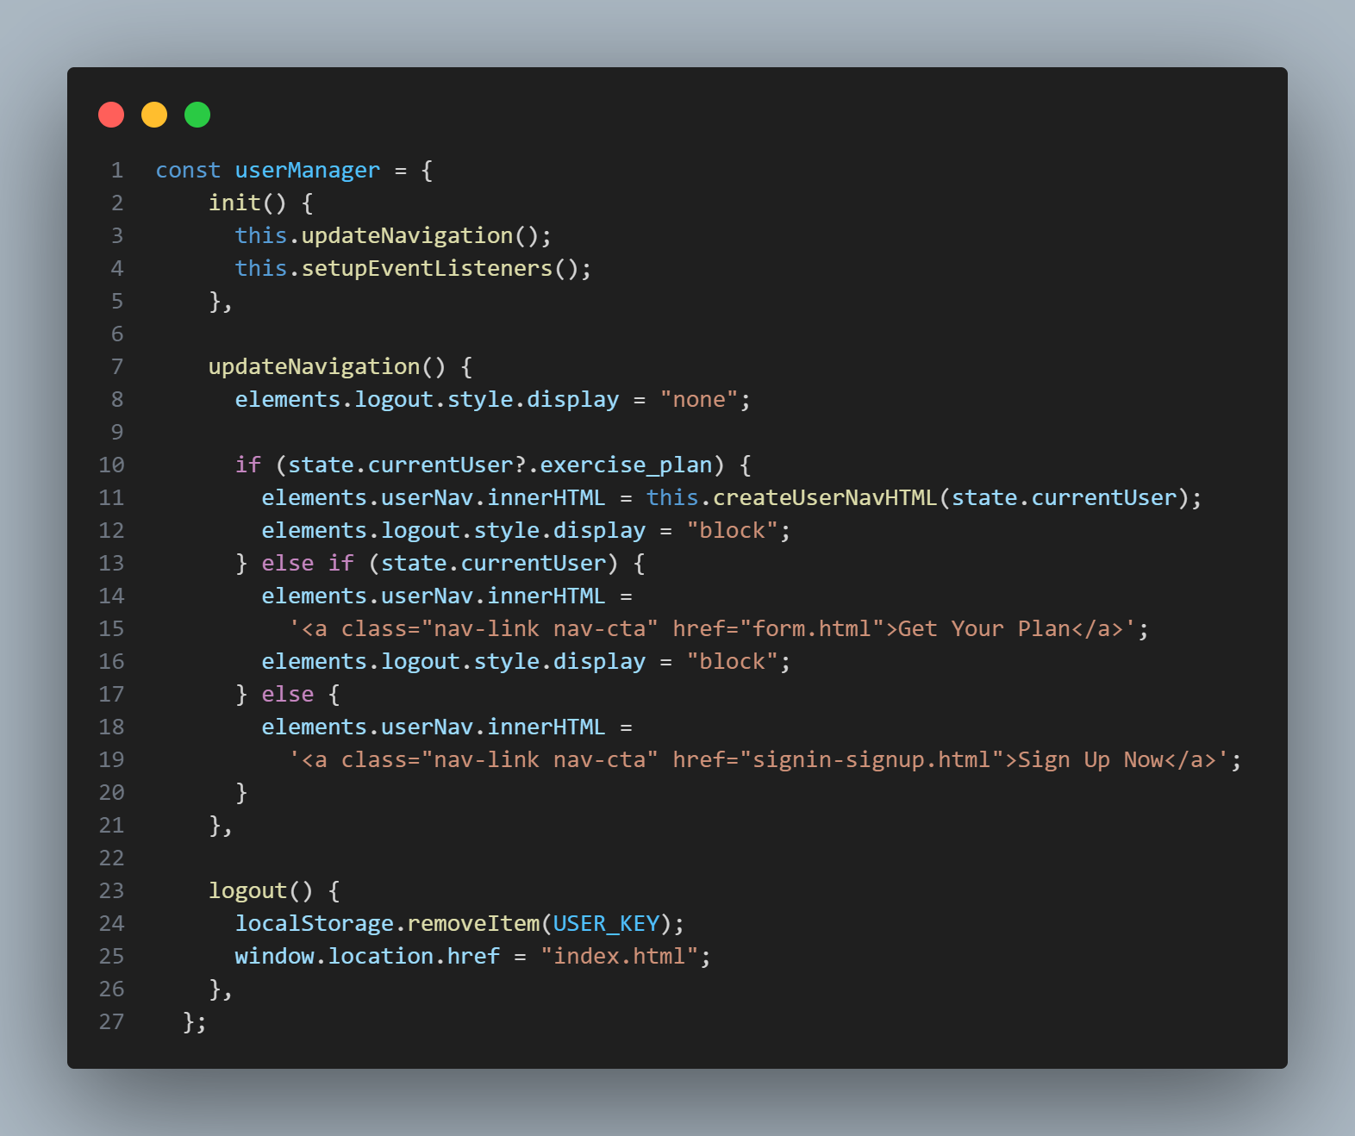

**Explanation:**

* init(): Initializes user interface and event listeners
* updateNavigation(): Updates the navigation menu based on user state:
* Shows/hides logout button
* Displays different navigation options for logged-in users
* Shows sign-up button for guests
* logout(): Handles user logout by clearing local storage and redirecting to home page

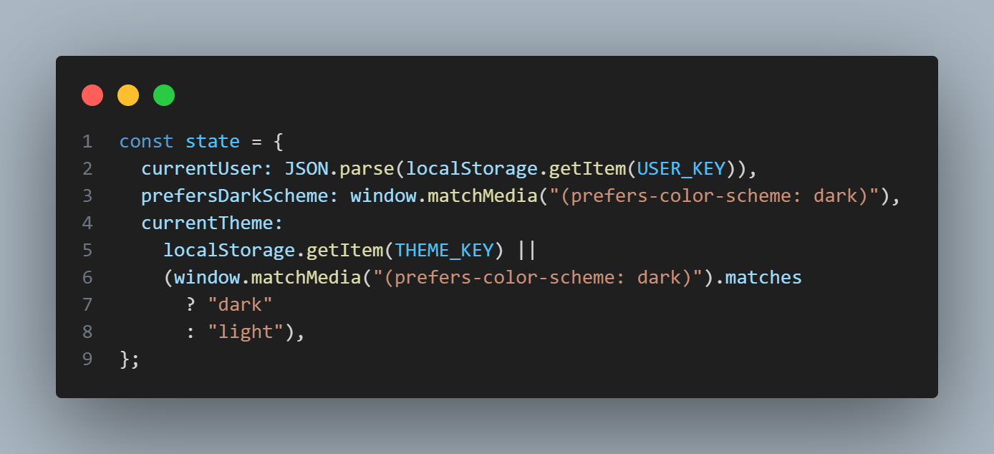

**Explanation:**

* Manages application state including:
* Current user information from localStorage
* System dark mode preference
* Current theme setting with fallback to system preference

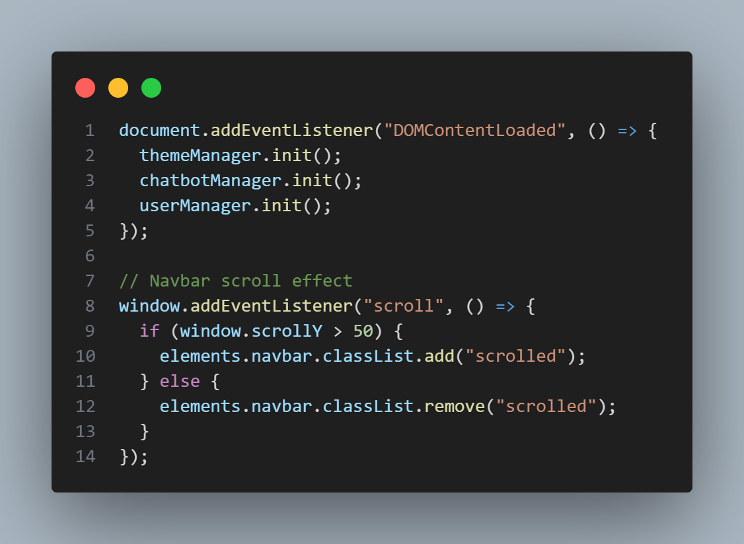

**Explanation:**

* Initializes all managers when the DOM is fully loaded
* Implements scroll-based navbar styling:
* Adds 'scrolled' class when page is scrolled past 50px
* Removes class when scrolled back to top

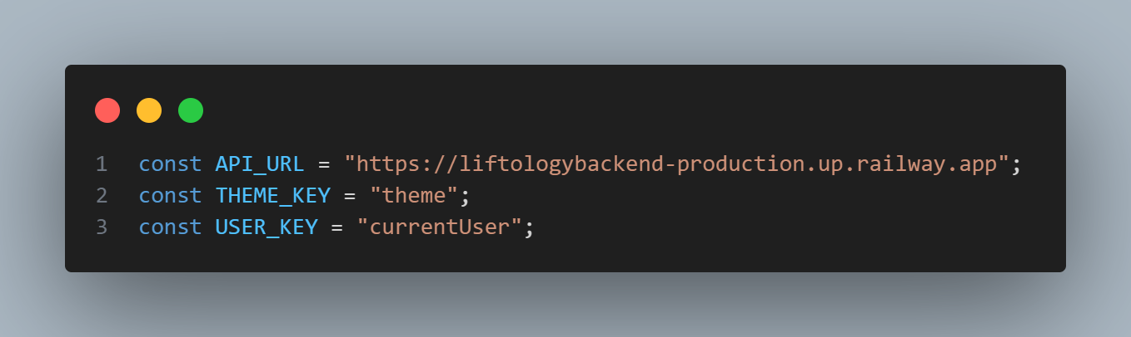

**Explanation:**

* Defines key constants used throughout the application:
* API endpoint for backend communication
* Storage keys for theme and user preferences

1. Plan.html

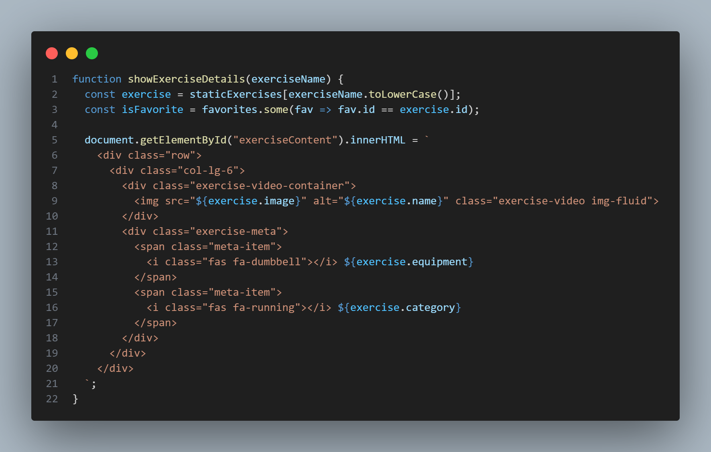

* This function displays detailed information about an exercise in a modal window
* It takes an exercise name as input and looks up the exercise details from a static database
* The function checks if the exercise is in the user's favorites
* It renders the exercise details including:
* Exercise image/video, Instructions and pro tips.
* Equipment information, Exercise category
* Exercise category, Target muscles.

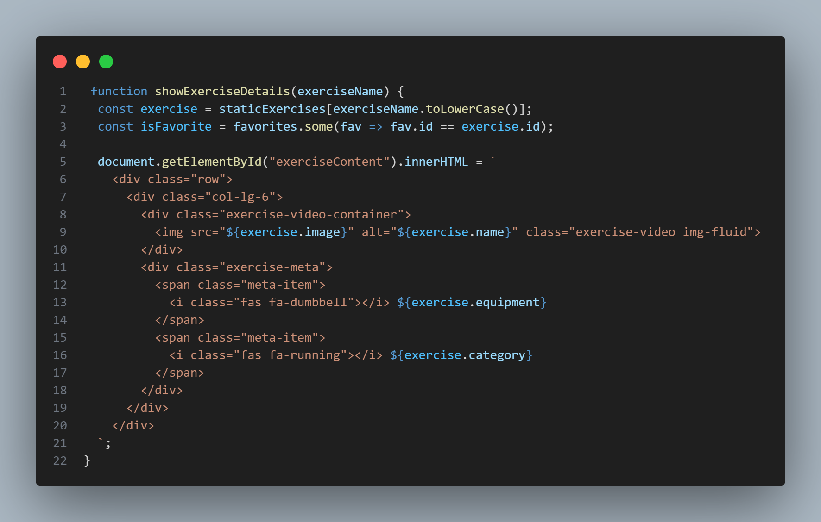

* This function initiates real-time motion tracking for an exercise
* It creates and shows a modal window for motion tracking
* Sets up a video feed from the backend server
* Starts polling for tracking statistics every 100ms
* The function handles:
* Modal initialization
* Video feed setup
* Stats polling
* UI updates

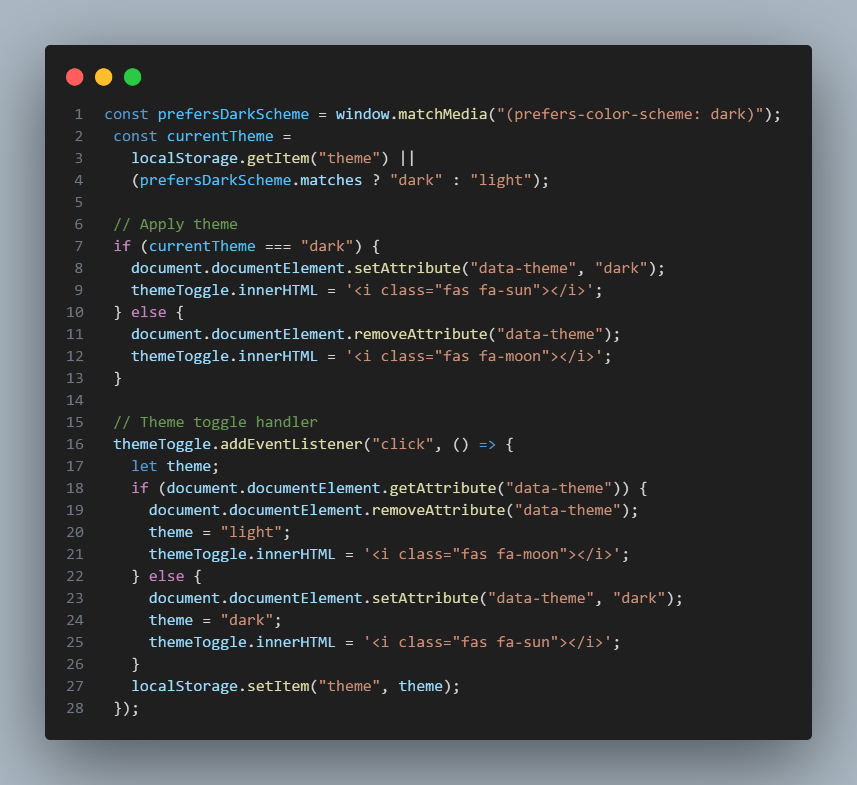

**Explanation:**

* This code manages the application's theme (light/dark mode)
* It detects the system's theme preference
* Initializes the theme based on saved preference or system setting
* Toggles between light and dark themes when the user clicks the theme button
* Persists the theme choice in localStorage
* Updates UI elements accordingly

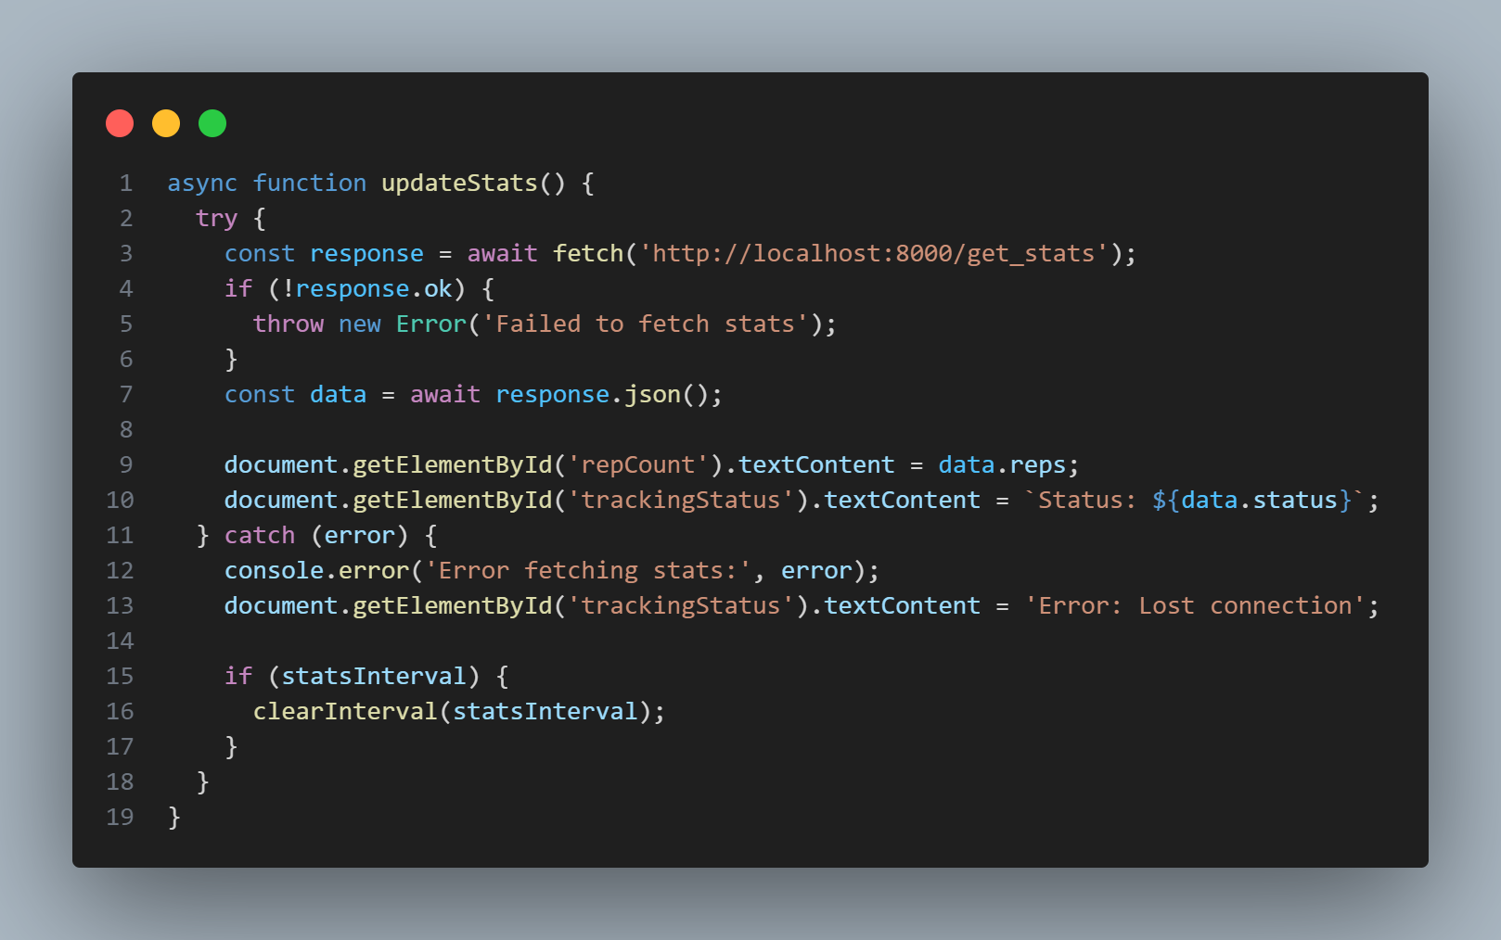

**Explanation:**

* This function updates the motion tracking statistics display
* It makes an API call to fetch current stats from the backend
* Updates the UI with:
* Rep count
* Tracking status
* Handles errors gracefully by:
* Showing error messages
* Cleaning up intervals
* Maintaining user feedback

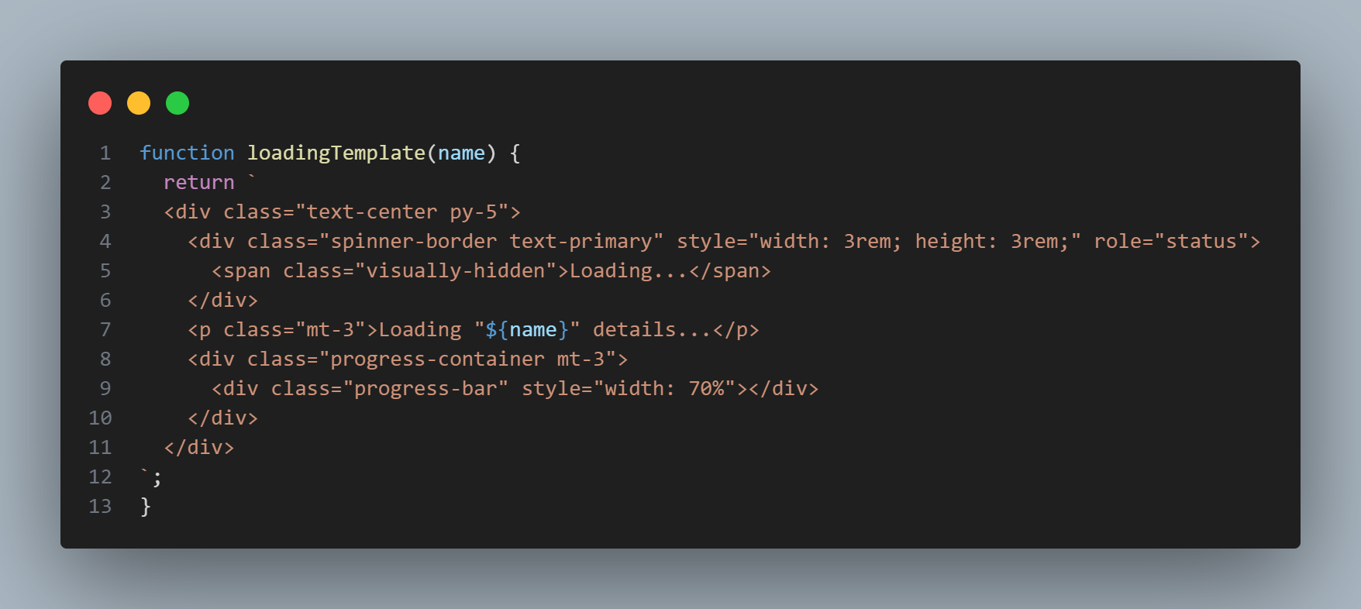

**Explanation:**

* This function generates a loading state UI template
* It creates a visual loading indicator with:
* A spinner animation
* Loading text with the exercise name
* A progress bar
* Used during asynchronous operations to provide user feedback
* Helps maintain a smooth user experience during data loading

1. Form.html

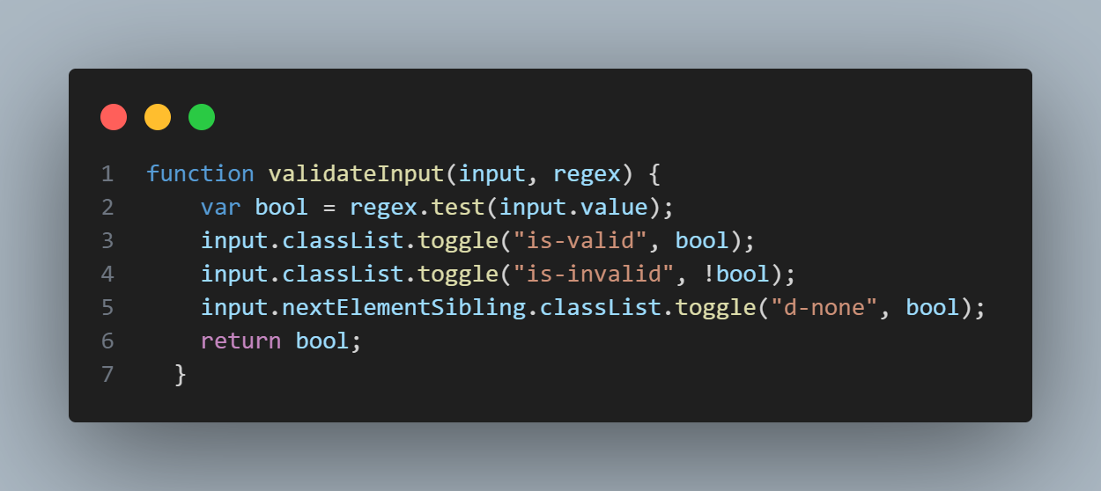

**Explanation:**

* Validates form input against a regular expression pattern
* Toggles visual feedback classes (valid/invalid)
* Shows/hides error messages
* Returns boolean indicating validation status
* Used for validating:
* Weight (30-250kg)
* Height (50-255cm)
* BMI (10-50)
* Body Fat (0-100%)
* Age (1-120)

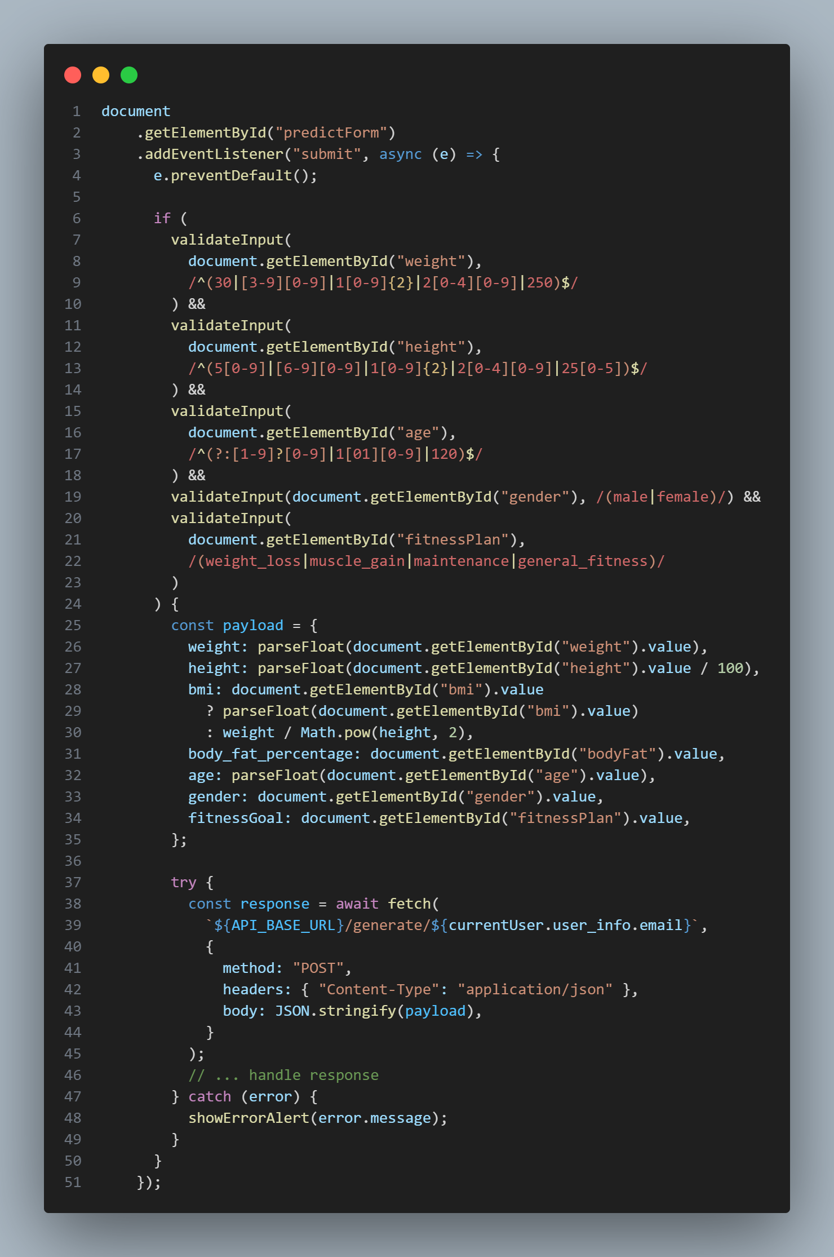

**Explanation:**

* Handles form submission
* Validates all required fields
* Constructs payload with user data
* Makes API call to generate fitness plan
* Handles success/error responses
* Redirects to plan page on success

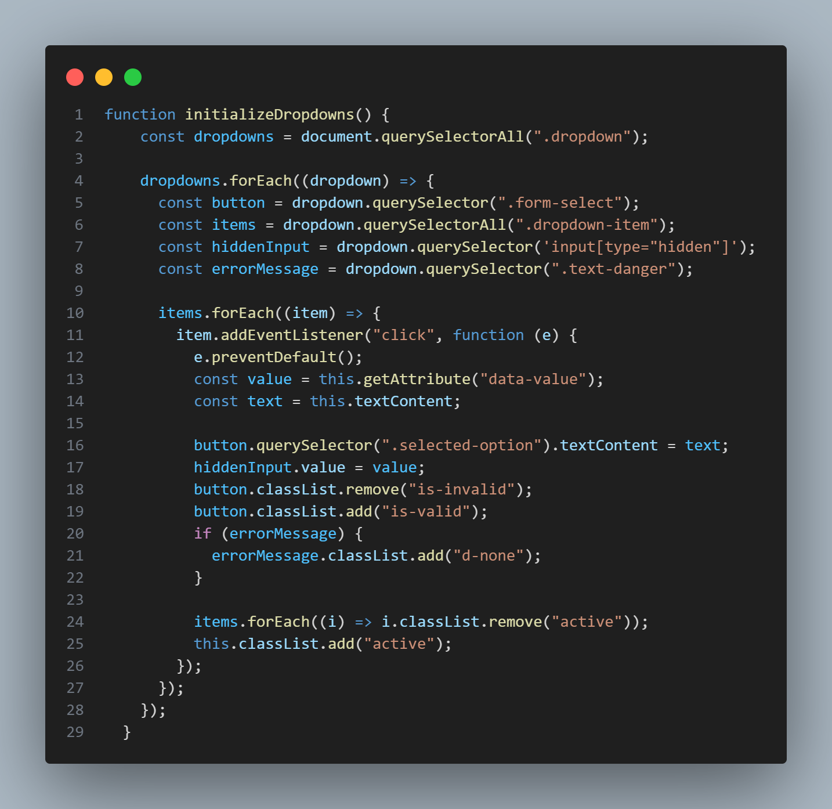

**Explanation:**

* Initializes custom dropdown menus
* Handles selection of options
* Updates UI state
* Manages validation state
* Used for:
* Gender selection
* Fitness goal selection

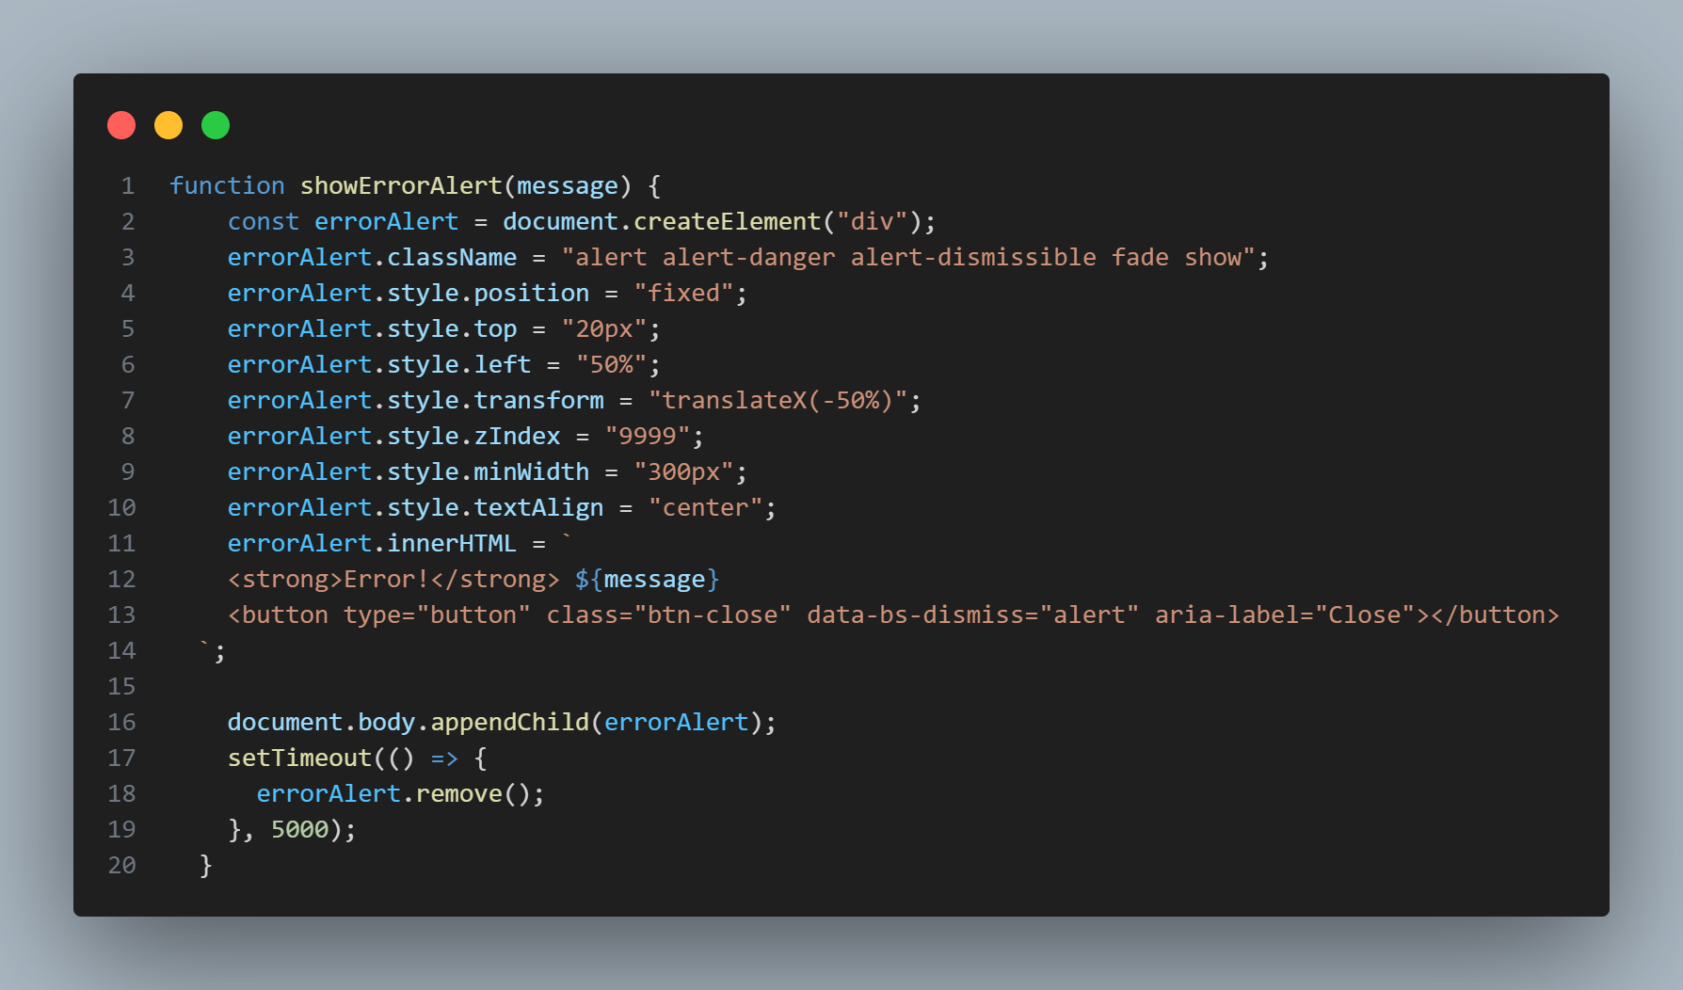

**Explanation:**

* Creates and displays error alerts
* Positions alert at top of screen
* Auto-dismisses after 5 seconds
* Includes close button
* Used for form validation and API errors

1. Signin-singup.html

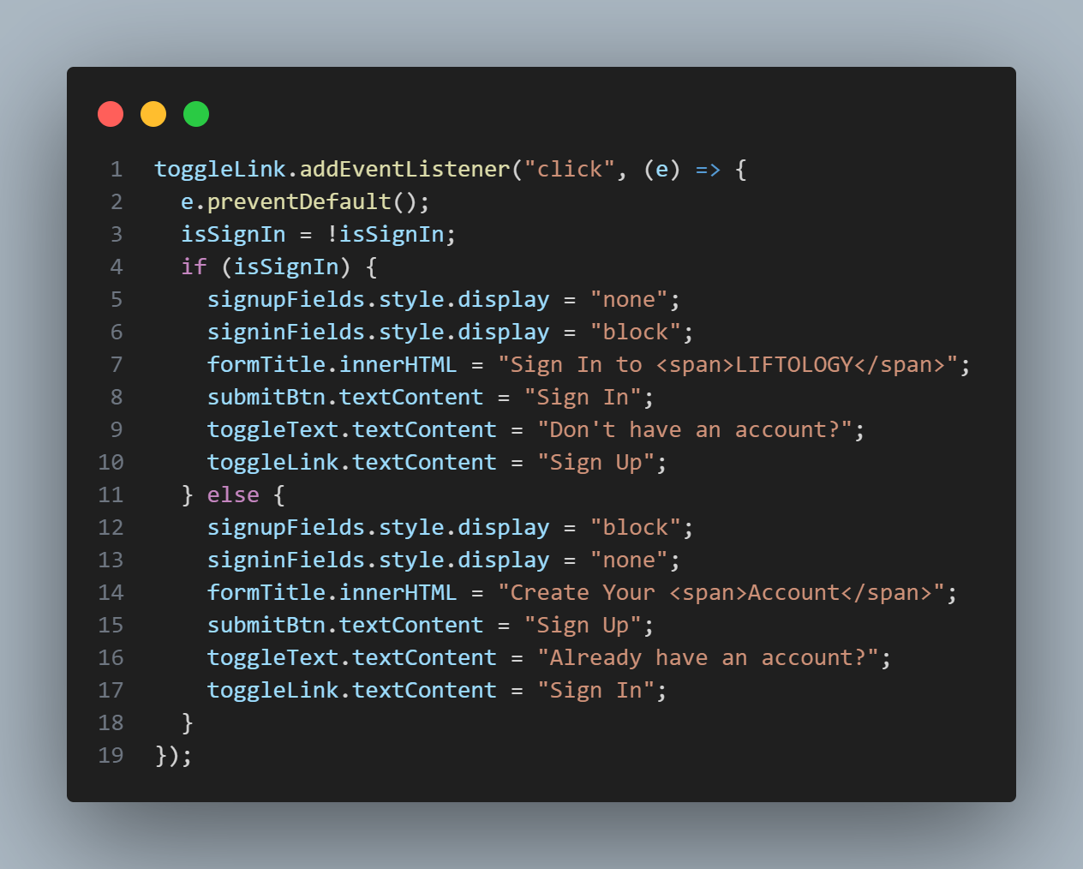

**Explanation:**

* Toggles between Sign Up and Sign In forms
* Updates form fields visibility
* Changes form title and button text
* Updates toggle link text
* Manages form state

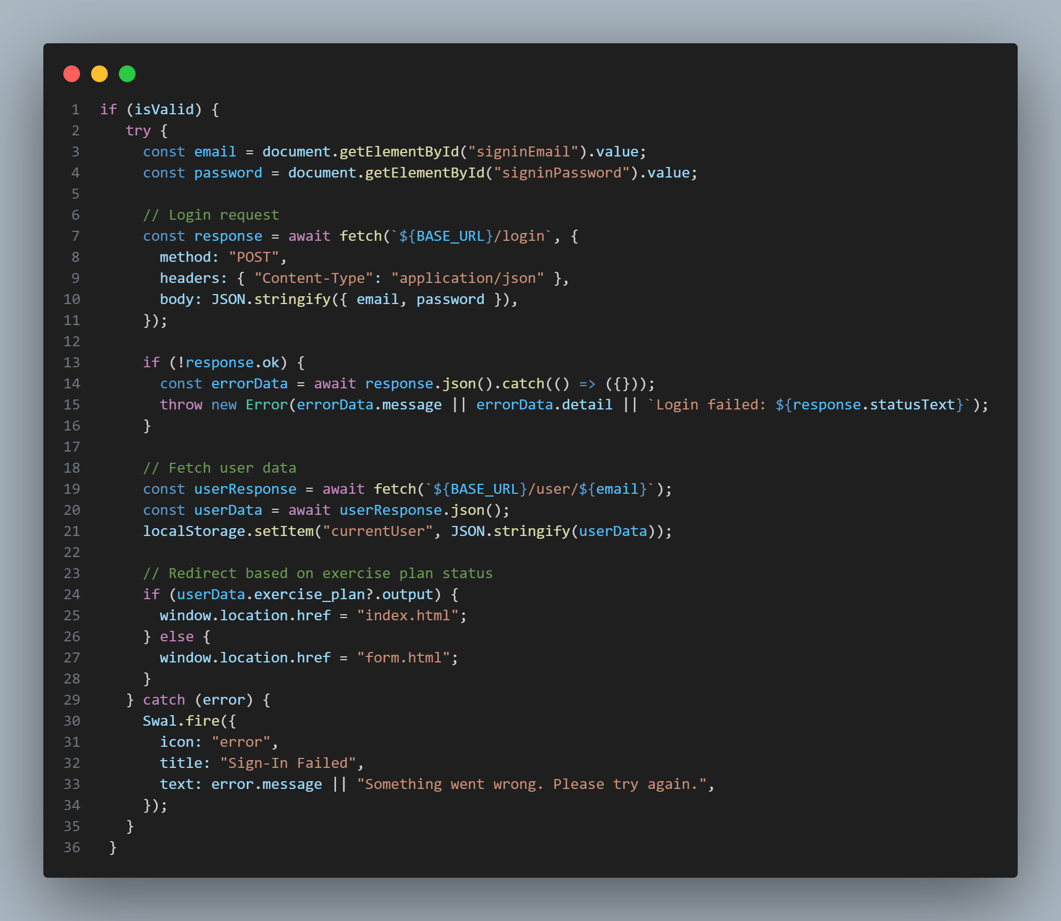

**Explanation:**

* Handles user sign in
* Validates credentials
* Makes API calls to:
* Authenticate user
* Fetch user data and Stores user data in local storage.
* Redirects based on user's plan status
* Handles errors with Sweet Alert

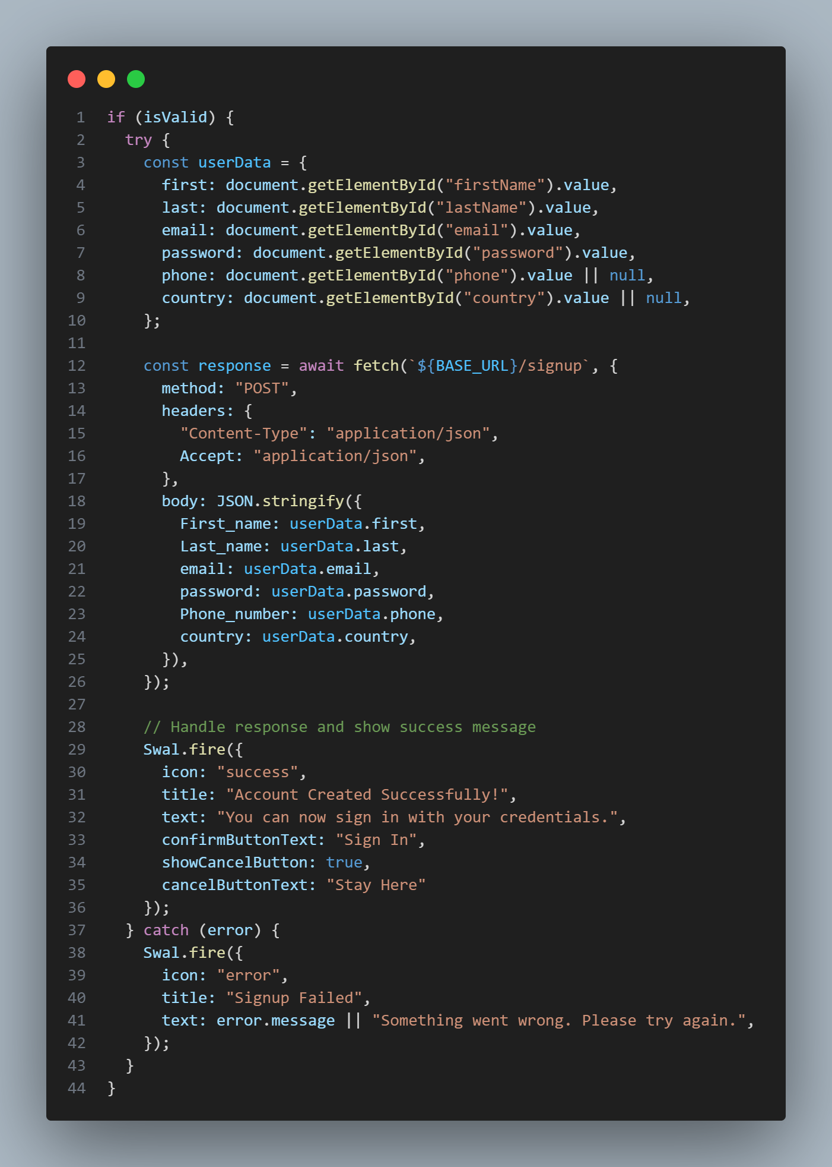

**Explanation:**

* Handles user registration
* Collects and validates user data
* Makes API call to create account
* Shows success/error messages
* Offers option to switch to sign in
* Handles optional fields (phone, country)

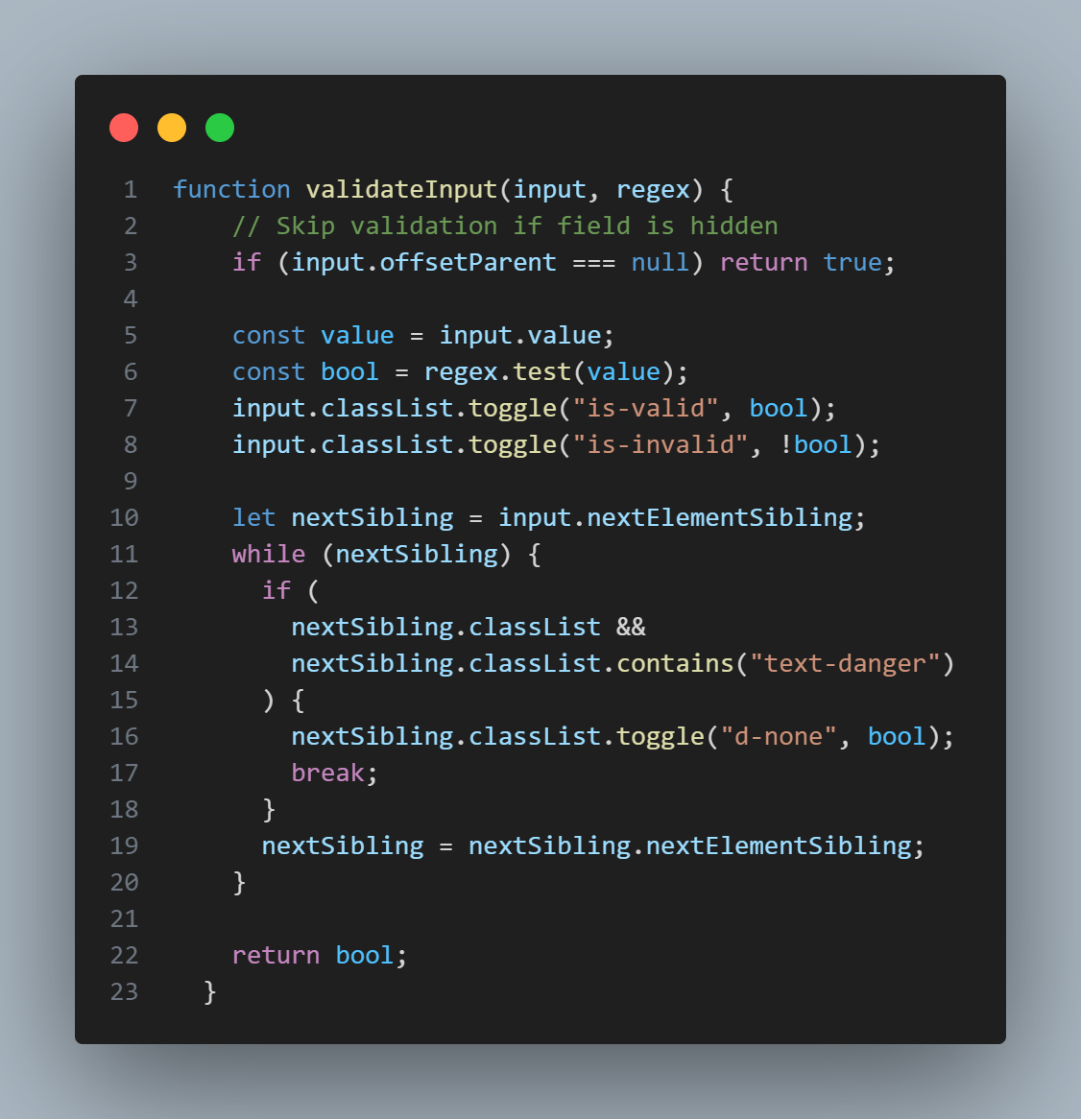

**Explanation:**

* Validates form inputs against regex patterns
* Skips validation for hidden fields
* Toggles visual feedback classes
* Shows/hides error messages
* Used for validating:
* Names (2+ letters)
* Email (valid format)
* Password (8+ characters)
* Phone (10-15 digits)

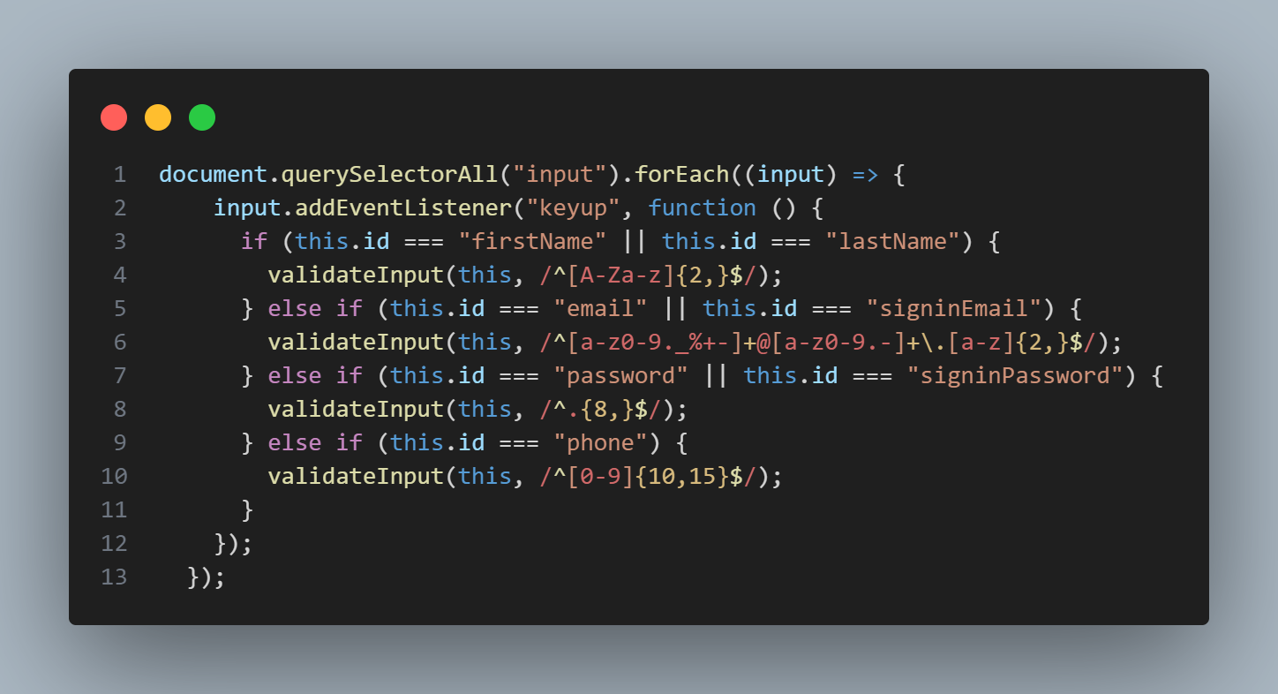

**Explanation:**

* Adds real-time validation to all input fields
* Validates on keyup event
* Uses different regex patterns for different fields
* Provides immediate feedback to users
* Improves user experience

1. Dashboarad.html

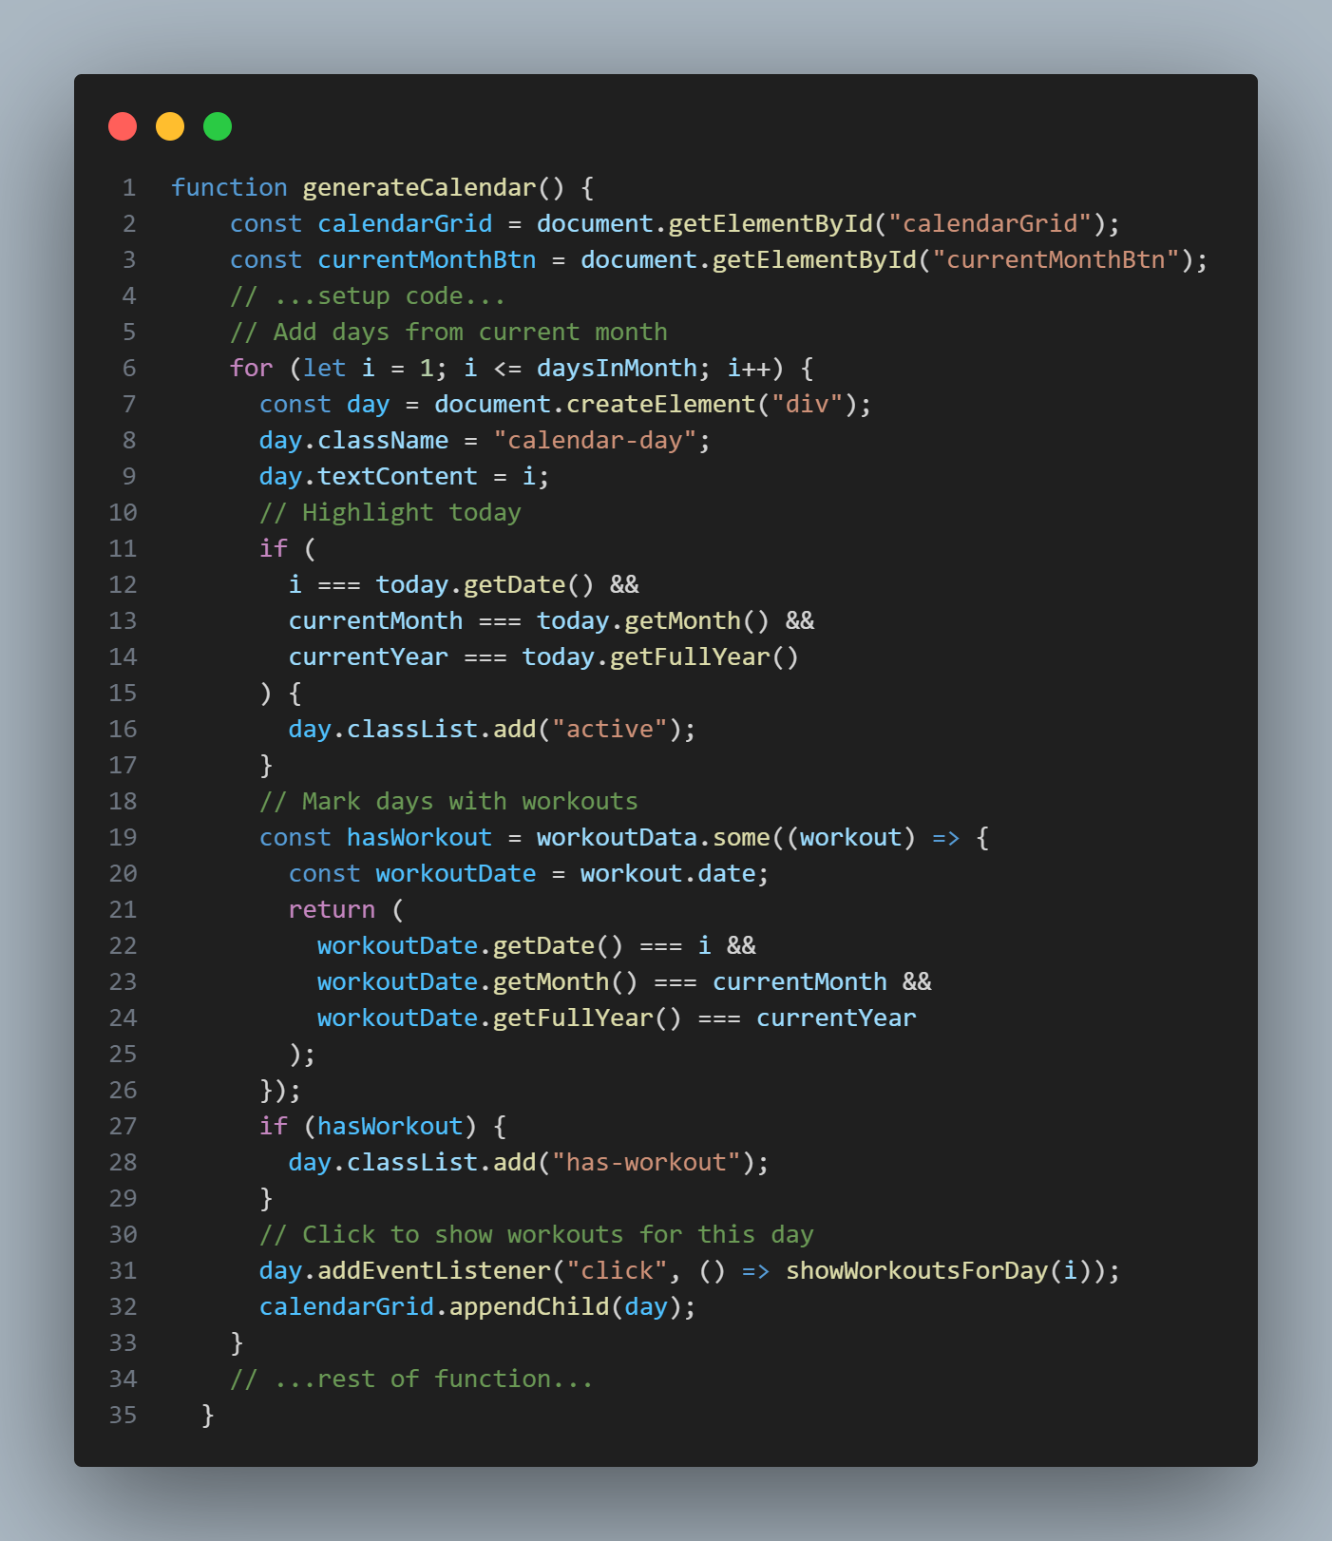

**Explanation:**

* Dynamically generates a calendar grid for the current month.
* Highlights today and marks days with logged workouts.
* Clicking a day shows the workouts for that date.

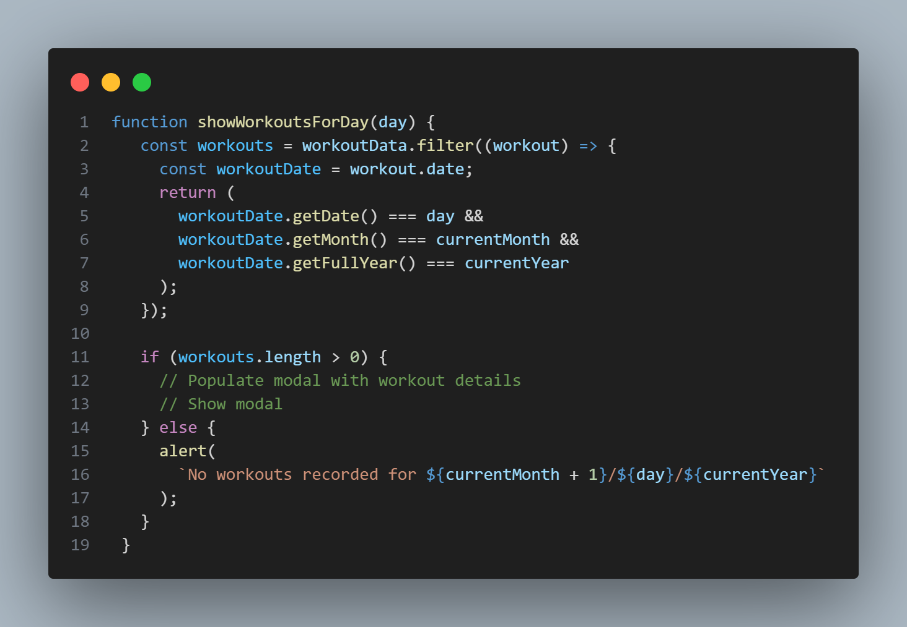

**Explanation:**

* Filters and displays all workouts for a selected day.
* Shows a modal with workout details or an alert if none exist.

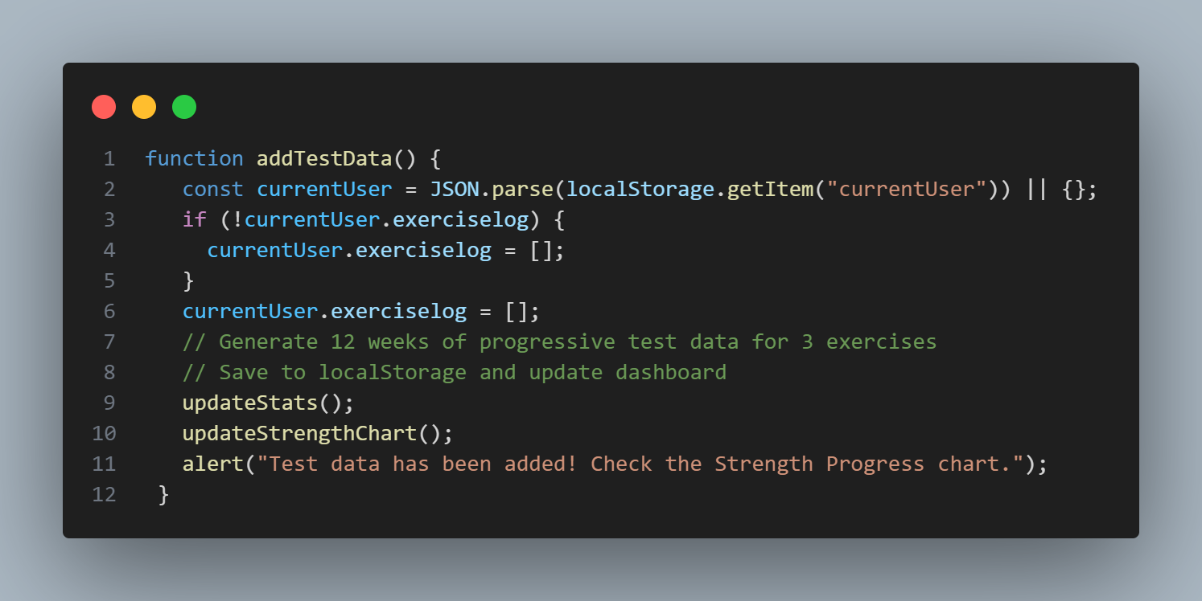

**Explanation:**

* Generates and saves random test workout data for demonstration.
* Updates dashboard stats and charts.
* Useful for testing and demo purposes.

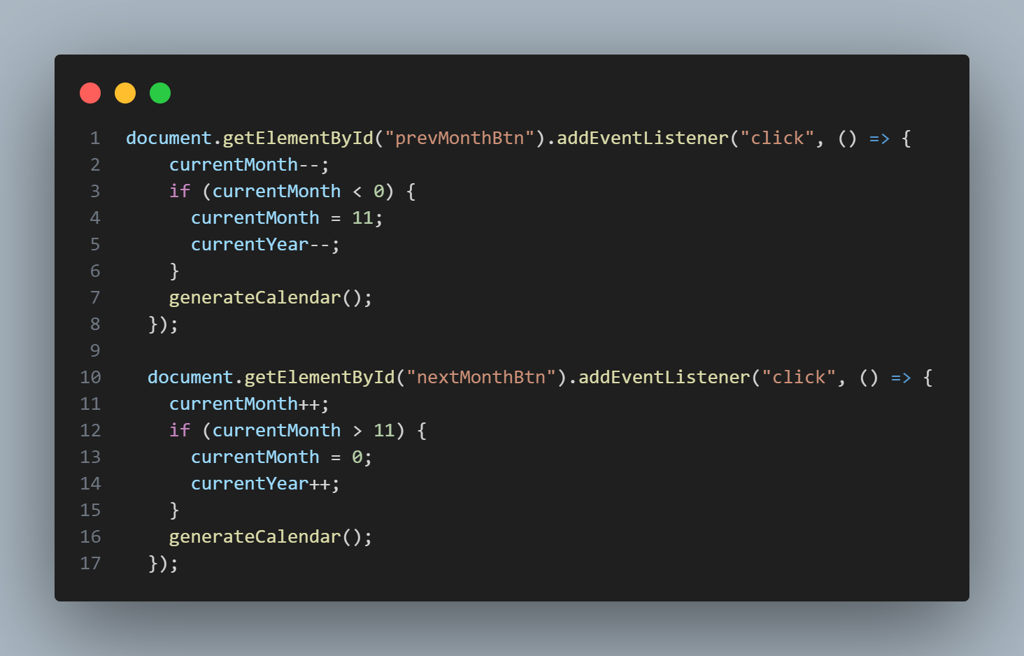

**Explanation:**

* Allows users to navigate between months in the calendar.
* Updates the calendar view accordingly.

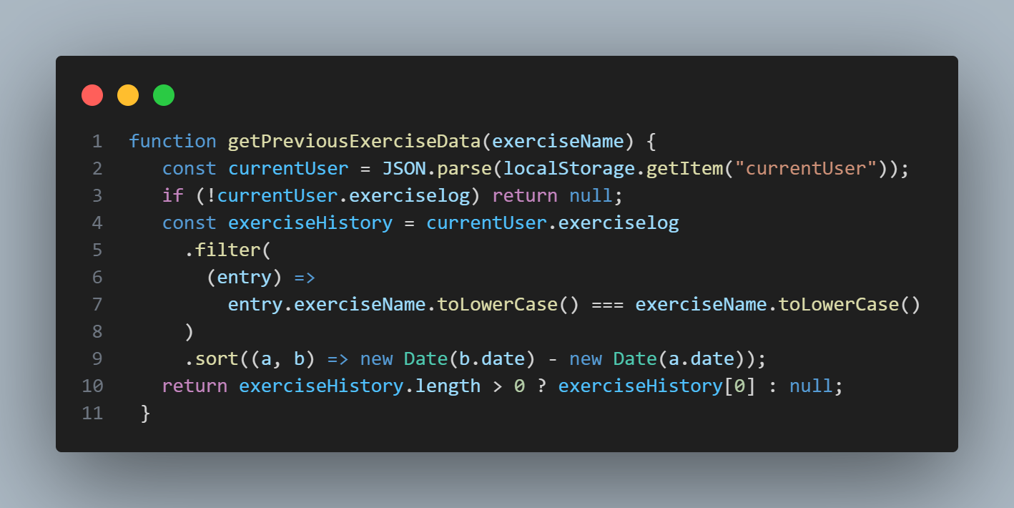

**Explanation:**

* Retrieves the most recent log for a specific exercise.
* Used to auto-fill log forms with previous values for user convenience.

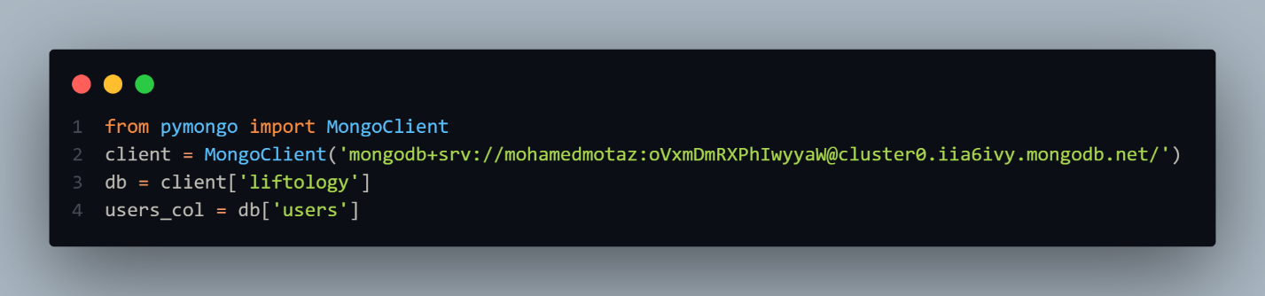

* Connects to a **MongoDB Atlas** cloud database using the provided connection URI.
* Accesses the **"liftology"** database and then the **"users"** collection within it.
* This setup allows performing CRUD operations on the users collection through users_col.

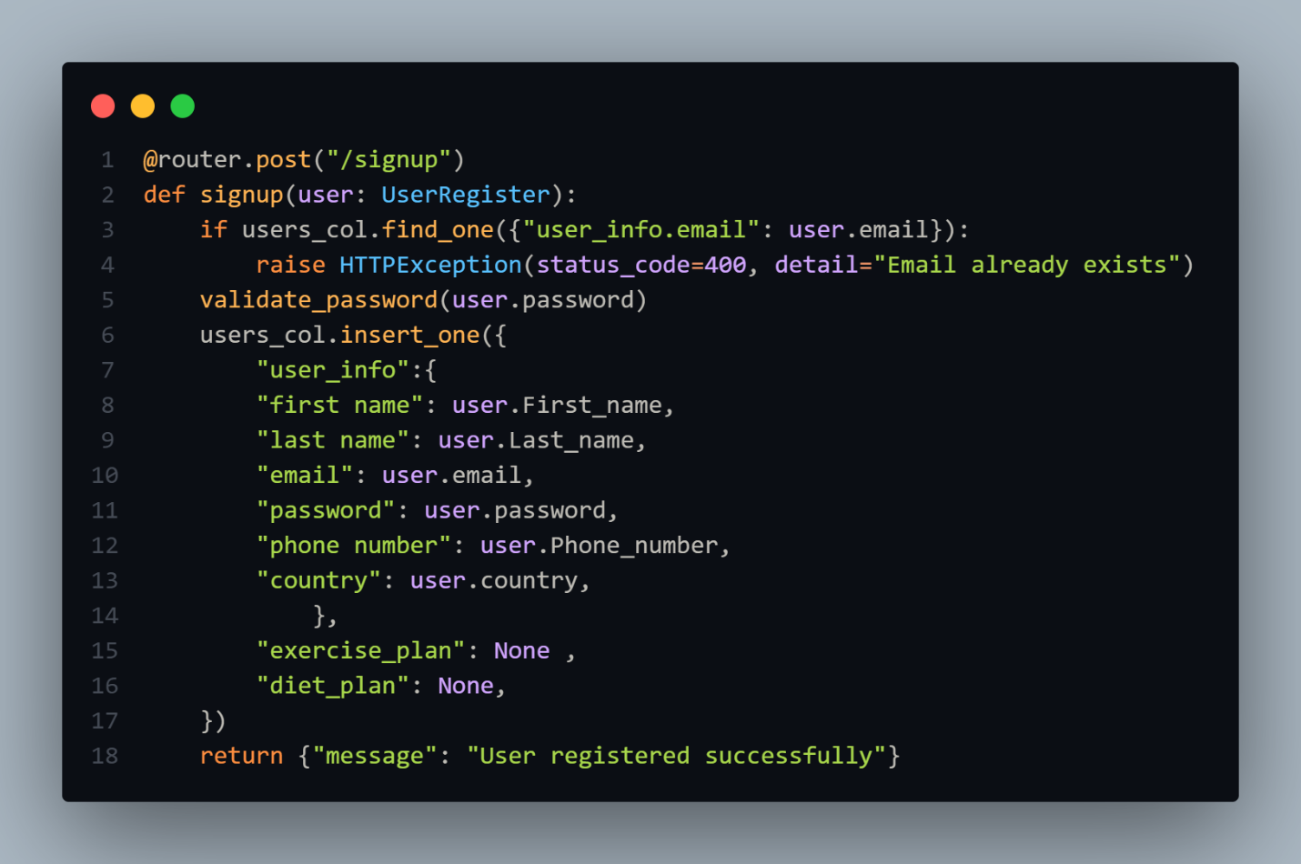

* Defines a **POST endpoint /signup** that registers a new user by checking for duplicate emails and validating the password.
* If the email doesn't exist, it inserts a new user document into the users collection with personal info and placeholders for plans.
* 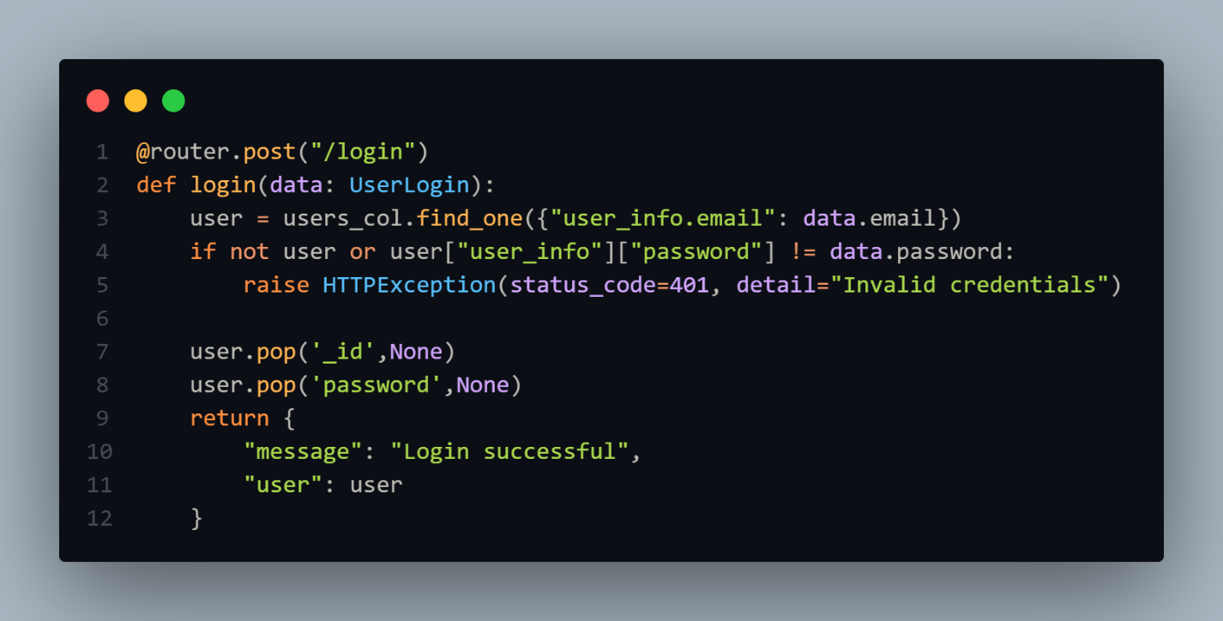Returns a success message if registration completes without errors.
* Defines a **POST /login** endpoint that authenticates a user by verifying their email and password.
* If authentication fails, it raises a 401 error; if successful, it removes sensitive fields (_id, password) before returning user info.
* Responds with a login success message and sanitized user data.

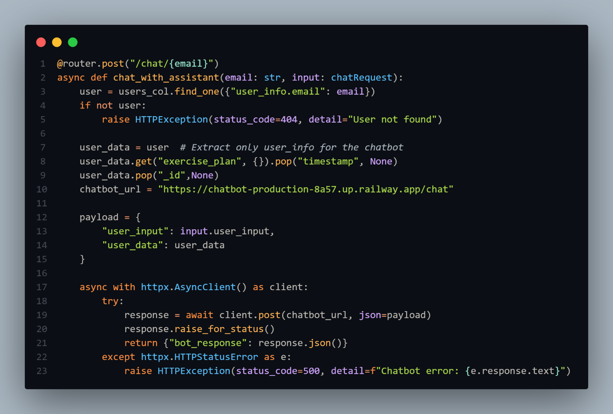

* Defines an **async POST /chat/{email}** endpoint that fetches a user by email and sends their data along with input to an external chatbot API.
* Cleans sensitive fields (_id, timestamp) before sending the request; constructs a JSON payload with user_input and user_data.
* Uses httpx.AsyncClient to send the request and returns the chatbot's response or raises a 500 error on failure.

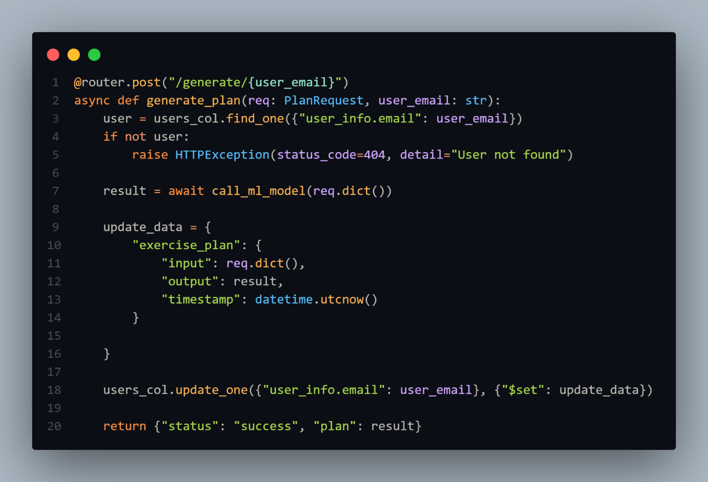

* Defines an **async POST /generate/{user_email}** endpoint to generate a personalized exercise plan using a machine learning model.
* Finds the user by email and calls call_ml_model() with input data from PlanRequest, storing the result along with a timestamp.

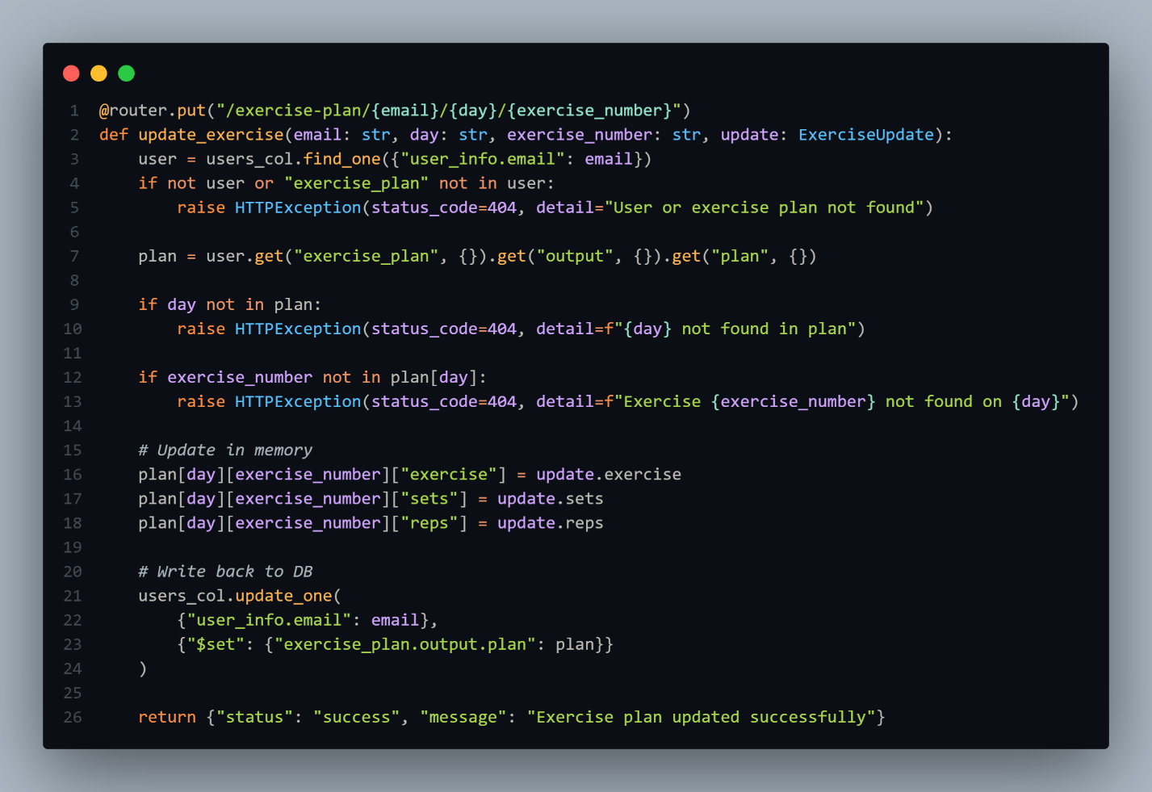

* Defines a **PUT** endpoint to update a specific exercise in a user's plan.
* Validates user existence and checks that the specified day and exercise exist in the plan before updating exercise details.
* Updates the plan in memory and then writes the modified plan back to the database using $set.

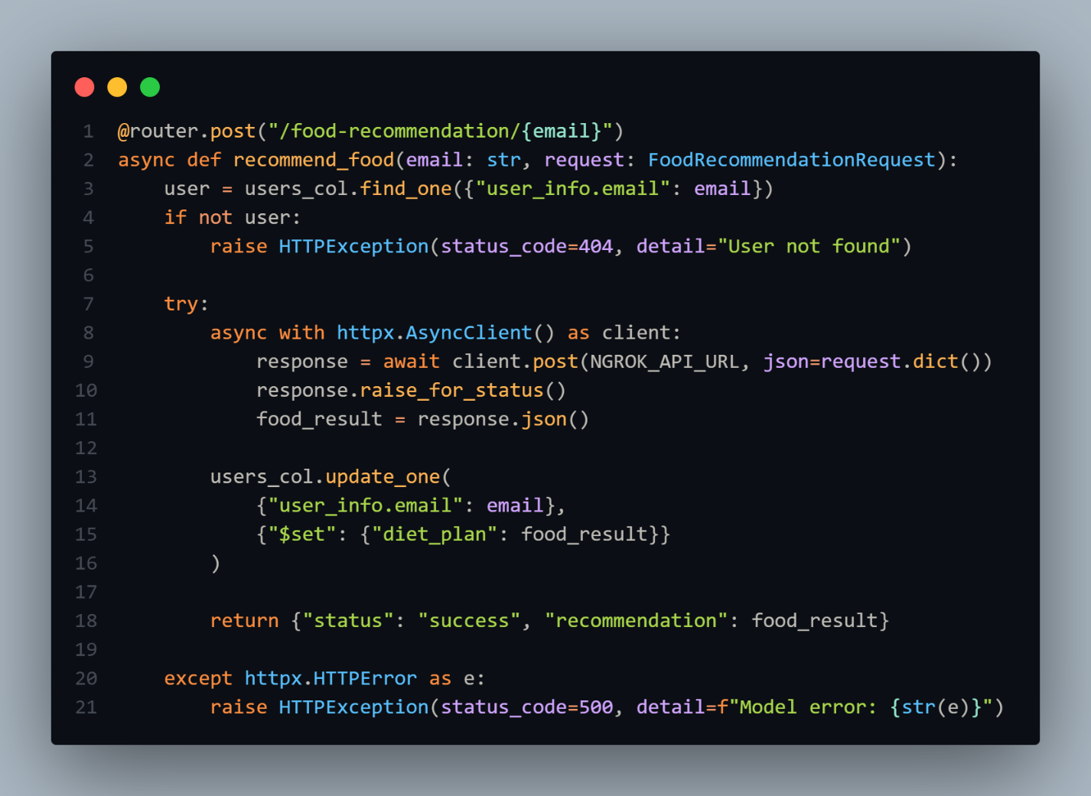

* Defines an **async POST** endpoint that sends user input to an external food recommendation model API.
* On success, the returned food_result is saved to the user's diet_plan in the database.
* Catches any HTTP errors and returns a 500 response if the external request fails.

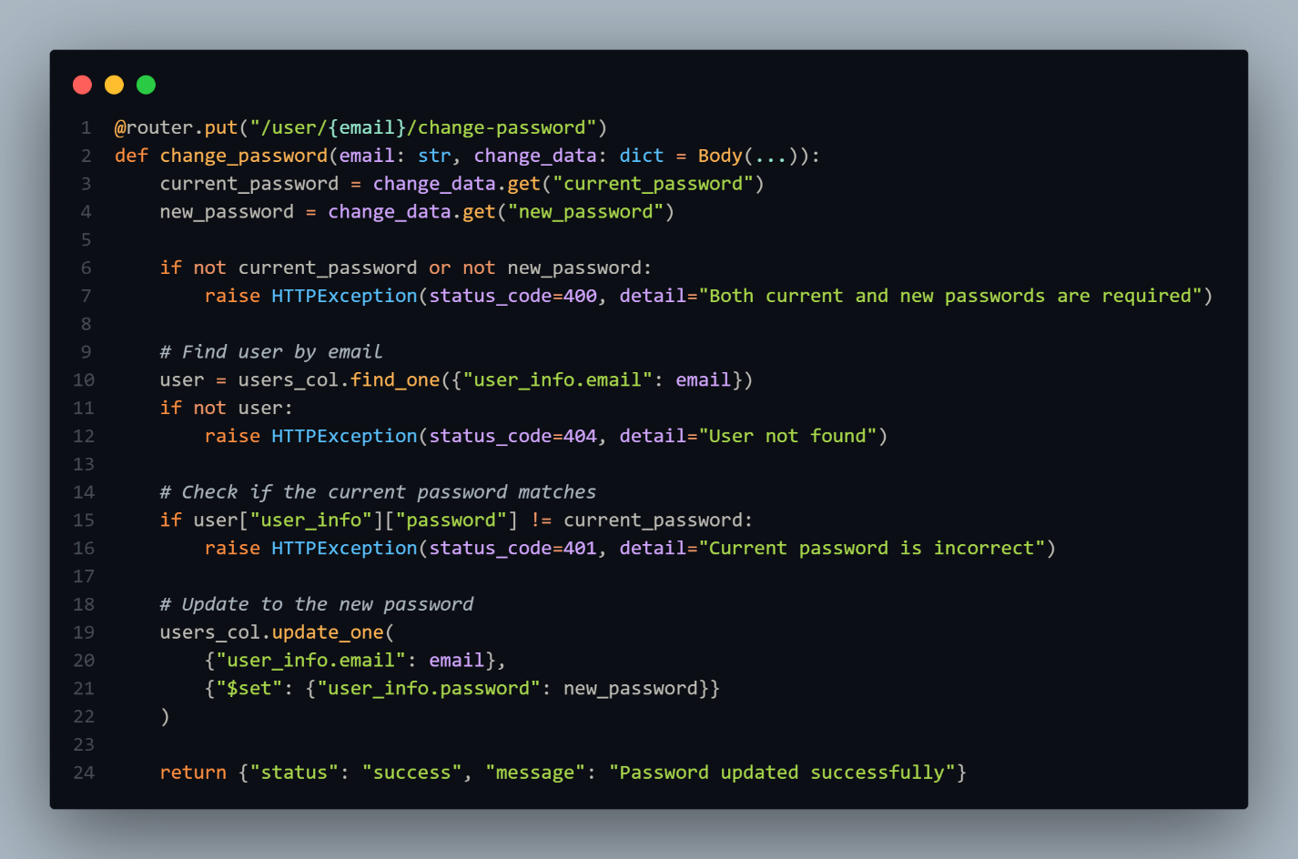

* Defines a **PUT /user/{email}/change-password** endpoint to allow users to update their password securely.
* Validates the current password before updating it to the new one in the database.
* Returns a success message upon successful password change or appropriate errors otherwise.

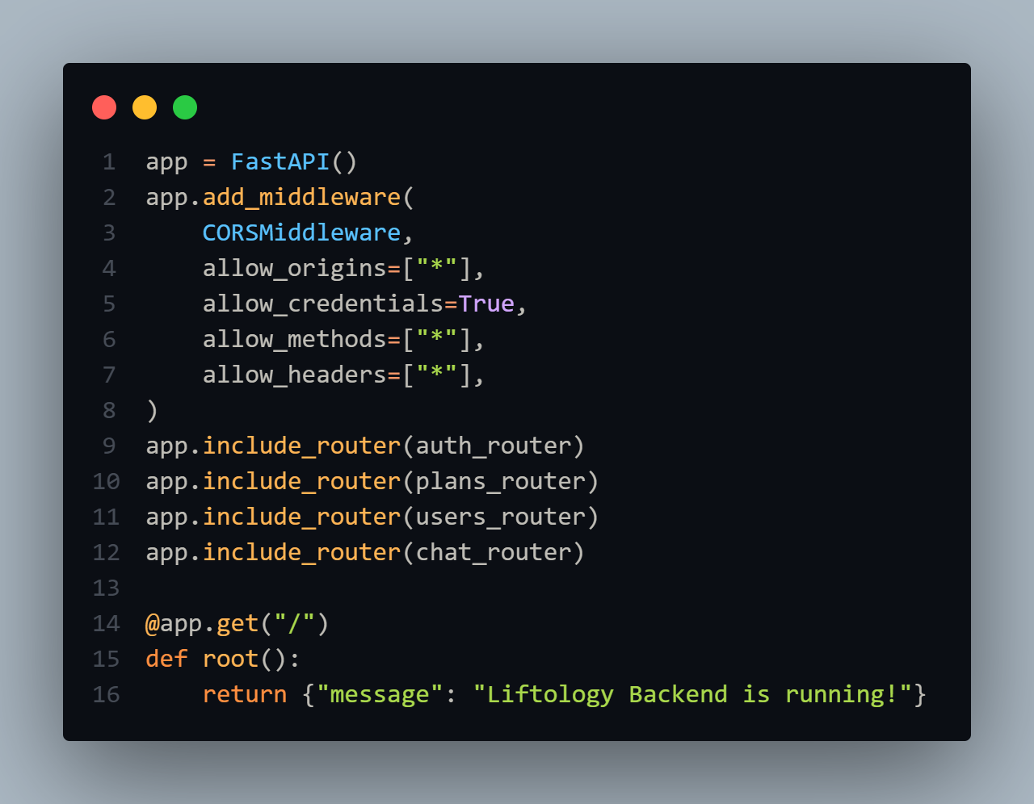

* Initializes a **FastAPI app** with CORS middleware to allow cross-origin requests from any origin, method, or header.
* Registers multiple routers (auth_router, plans_router, users_router, chat_router) to organize endpoints.
* Defines a root / endpoint that returns a simple status message confirming the backend is running.